TRADE OF
VEHICLE BODY REPAIR

PHASE 2

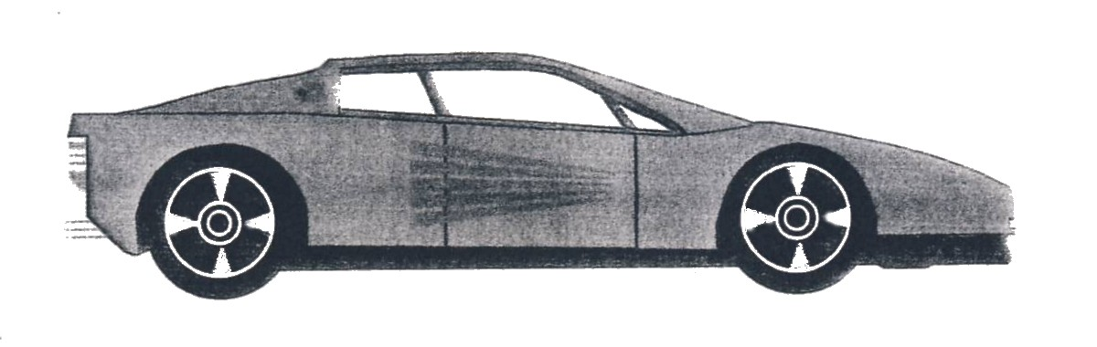

Module 1

UNIT: 2

Induction

Produced by

In cooperation with subject matter expert:
Maurice Stack
Some material courtesy of CDX Global and
FENC – Further Education National Consortium.
© SOLAS 2014
Table of Contents
Introduction
Structure of Apprenticeship 1
1.0 Vehicle Body Repair 4
1.1 Trade Description 4
1.2 Core skills 4
1.3 Specialist Skills 5
1.4 Vehicle Body Repair Operations 5
1.5 Common Skills 5
2.0 Skills 6
2.1 Core Skills 6
2.2 Specialist Skills 6
2.3 Personal skills 6
3.0 Health, Safety, Fire Drill and Behaviour Guidelines 7
3.1 Introduction: 7
3.2 Information covered 8
3.3 Activity 8
3.4 Outcomes 8
3.5 Identifying hazards 9
3.6 Preparation and safety 10
3.7 Symbol Signs 14
3.8 Wall Chart Signs 16
3.9 Fire Signs 18
3.10 Safety in the Workshop 19
3.11 Using a fire extinguisher 22
3.12 Fighting a fire 24
3.13 Fire classifications 25
3.14 Fire extinguisher types 25
3.15 Fire extinguisher suitability 26
4.0 Use of fixed equipment 27
4.1 Using a two-post hoist 27
4.2 Operation of a four post hoist: 29
4.3 Using an engine hoist 31
4.4 Using a floor jack 34
5.0 Personal Safety and Protection 37
5.1 Personal Protection Equipment (PPE) 37
5.2 Personal protection - Protective clothing 39
5.3 Outerwear 39
5.4 Safety Boots 40
5.5 Headgear 41
5.6 Hand protection 41
5.7 Eye protection 44
5.8 Ear protection 48
6.0 Self-Assessment 51

INTRODUCTION
Structure of Apprenticeship
During the period of Apprenticeship each apprentice will undertake alternating phases of on-the-job and off-the-job training and development.
Each Apprentice will spend a maximum of 40 weeks in off-the-job training in an approved training location. The rest of the time will be spent in on-the-job training and development of the necessary skills.

PHASE 1 22 Weeks | On-The-Job Training and Work Experience
PHASE 2 20 Weeks | Off-The-Job Training and Development | Modular Assessment
PHASE 3 | On-The-Job Training and Work Experience | Competence Assessment
PHASE 4 10 weeks | Off-The-Job Training and Development | Modular Assessment
PHASE 5 | On-The-Job Training and Work Experience | Competence Assessment
PHASE 6 10 Weeks | Off-The-Job Training and Development | Modular Assessment
PHASE 7 | On-The-Job Training and Work Experience | Competence Assessment

Fetac Advanced Diploma Certification.

Fetac Advanced Diploma Certification Process
Throughout the period of apprenticeship, each apprentice will undergo a range of assessments to establish competence, monitor progress and identify areas requiring additional skill development.
On successful completion of the required assessments, each apprentice will be awarded the Fetac Advanced Diploma.

Assessment and Certification Model
SOLAS has established a national system for apprenticeship training, assessment and certification. The system is based on standards derived from industry and surveys carried out by SOLAS.
Two types of assessment will be used to form the basis of certification:

- Fetac Modular Assessment
- Competence Assessment

Fetac Modular Assessment
Fetac Modular Assessment will be carried out during the off-the-job phases. It involves coursework assessment and standardized and supervised practical, multi-choice and short-answer tests. Coursework assessment consists of exercises and projects carried out with access to all available resources.
The Assessment Programmes for each Phase are set out in a separate manual and will be implemented by the off-the-job training providers.

Competence Assessment
Competence Assessment will be carried out during the on-the-job phases. Competence is defined as the application of skills, knowledge and attitudes in order to perform tasks or combinations of tasks to industrial and commercial standards under operational conditions.

The workplace assessment will be carried out by the workplace supervisor/assessor. An assessment specification and a detailed workplace assessment checklist are provided in each of the on-off-job phases.

Only those apprentices who can demonstrate achievement of the relevant industry standards in both on-the-job (competence assessment) and off-the-job (modular assessment) will be awarded a Fetac Advanced Diploma certification.

1.0 Vehicle Body Repair
1.1 Trade Description
A vehicle body repairer is a skilled worker within the motor trade which involves the repair and/ or replacement of damaged panels due to collision or corrosion, chassis replacement or straightening/jigging. Preparation and the respray of panels/total resprays, carry out all glass and glazing requirements, rust proofing, steering geometry and estimating crash repairs.

1.2 Core Skills
Safe use of the following machinery and tools:
Power and treadle guillotine | Box pan folding machine
Bending rolls | Grinding machine
Pedestal drill | Vacuum sanders
Metal nibblers | Spray booth/oven
Alignment jigs | Steering geometry gauges
Mig welding plant | Spray painting equipment
Hoists and lifts | Body jacks
Vehicle body repair tools | Body dozer/Porto power
Air compressor | Spot welders
Plastic hot gun | Brazing and spot welding
Riveting grinding, sanding | Filing safety procedures, rust repairs

1.3 Specialist Skills
Motor vehicle re-finishing | Steering geometry and alignment
Estimating | Chassis alignment and jigging
Sunroof fitting | Windscreen/door glass fitting and sealing
Rust proofing

1.4 Vehicle Body Repair Operations
Damage assessment, removal of body sealers and deadeners, dismantling and assembly of motor vehicles, dismantling and assembly of motor vehicle wiring, roughing out, planishing, metal finishing, lead loadings, filling, hot and cold shrinking, chassis and body alignment, panel alignment, body and seam sealing, windscreen and door glass, spray painting, steering alignment, mig welding, oxy-acetylene brazing and mig brazing.
1.5 Common Skills
Use and care of hand tools, use and care of measuring equipment,
use and care of machinery, general house keeping, use of plastic, use of glass, storage and care of materials.
Jointing: | Selection and use of proper hand tool and materials in the use of riveting: | Oxy-acetylene brazing Mig welding Spot welding Plastic welding Soldering Various adhesives
Spray painting: | Identification and selection of materials used for spray painting: | Feathering Sanding Spray painting techniques Safety procedures

2.0 Skills
2.1 Core Skills
The range of skills and knowledge which are specific and are required by all craft workers of the trade.

2.2 Specialist Skills
Those skills which are identified with an industry/trade and are applied in specialist sectors within that industry/trade. Mastery of these skills allows craft workers to specialize in particular areas of industry as key personnel.

2.3 Personal Skills
The skills which apply to all trades and incorporate the practical application of abilities such as:

- Communications
- Customer Relations
- Adaptability
- Ability to work as a team member
- Ability to work independently
- Initiative
- Problem Solving
- Planning
- Information Gathering
- Quality
- Language
- Report Writing

Mastery of these skills enables craft worker to enrich their relationships with their colleagues and clients and is essential for progression to higher levels of responsibility, promotion and job satisfaction.

3.0 Health, Safety, Fire Drill and Behaviour Guidelines
3.1 Introduction:
Learning Outcome:
Describe the health, safety, responsibilities of all personnel, fire drill procedures and course participant personal behaviour guidelines that apply to the Training Centre/premises.
Describe the structure of the Phase 2 Apprentice Vehicle Body Repair training centre.
Because of the unique nature of each Training centre this element of the course will be delivered in accordance with the local conditions and rules governing health and safety, local safety statement and identification of hazards. The fire alarm sound will be demonstrated as part of the fire drill in the particular centre where the course is located.
Emergency exit route, designated safe areas, location and function of Safety Statements, are all specific to the location and will be covered in the induction programme for the centre where the course is located.
Demonstrate the location and use and limitations of the appropriate fire extinguisher for an identified fire incident.
Describe the procedures to be followed in accident or emergency events.
Demonstrate the operation and safety controls of the automotive workshop ‘fixed’ equipment.
Describe the vehicle parking arrangements of the training centre workshop that comply with emergency fire evacuation procedures.
Assemble in location for VBR.
Identification of hazards, their removal and reduction are all part of an on going process in each training location. Copies of hazard statements are located in the training areas and will be brought to the attention of the apprentices during the induction programme.

3.2 Information Covered
- Code of Behavior Booklet
- Booklet on Noise
- Booklet on Safety and Hygiene
- Fire Instructions: Evacuation Plan and Layout
- Information Trainees/ Apprentices based in Training Centre
- Suggested Reading
- DVD/ Video
3.3 Activity
By the end of this unit each apprentice will be able to:-
State the attendance, safety, fire drill procedures that apply to the training establishment.
Select correct tool, type/sizes for different applications.
Identify various workshop layouts and machine type.
State the recommended fire extinguisher type for the use with the following fires, ‘carbonaceous’, ‘liquid fuel’ and ‘electrical’

3.4 Outcomes
- Training centre layout. Location of evacuation assembly points.
- Location and use of fire fighting equipment.
- Attendance and time keeping procedures.
- Safety procedures.
- Identification of basic workshop equipment.
- Accident reporting.
- Tools, types and sizes.
- Workshop cleaning routine – cleaning roster.
- Identification and marking/ engraving tool kit.
- Care of tools and equipment.
- Location and identification of special tools, equipment and consumables.
- Booklet on noise, safety and hygiene, and fire instructions
- General information for trainees based in training.

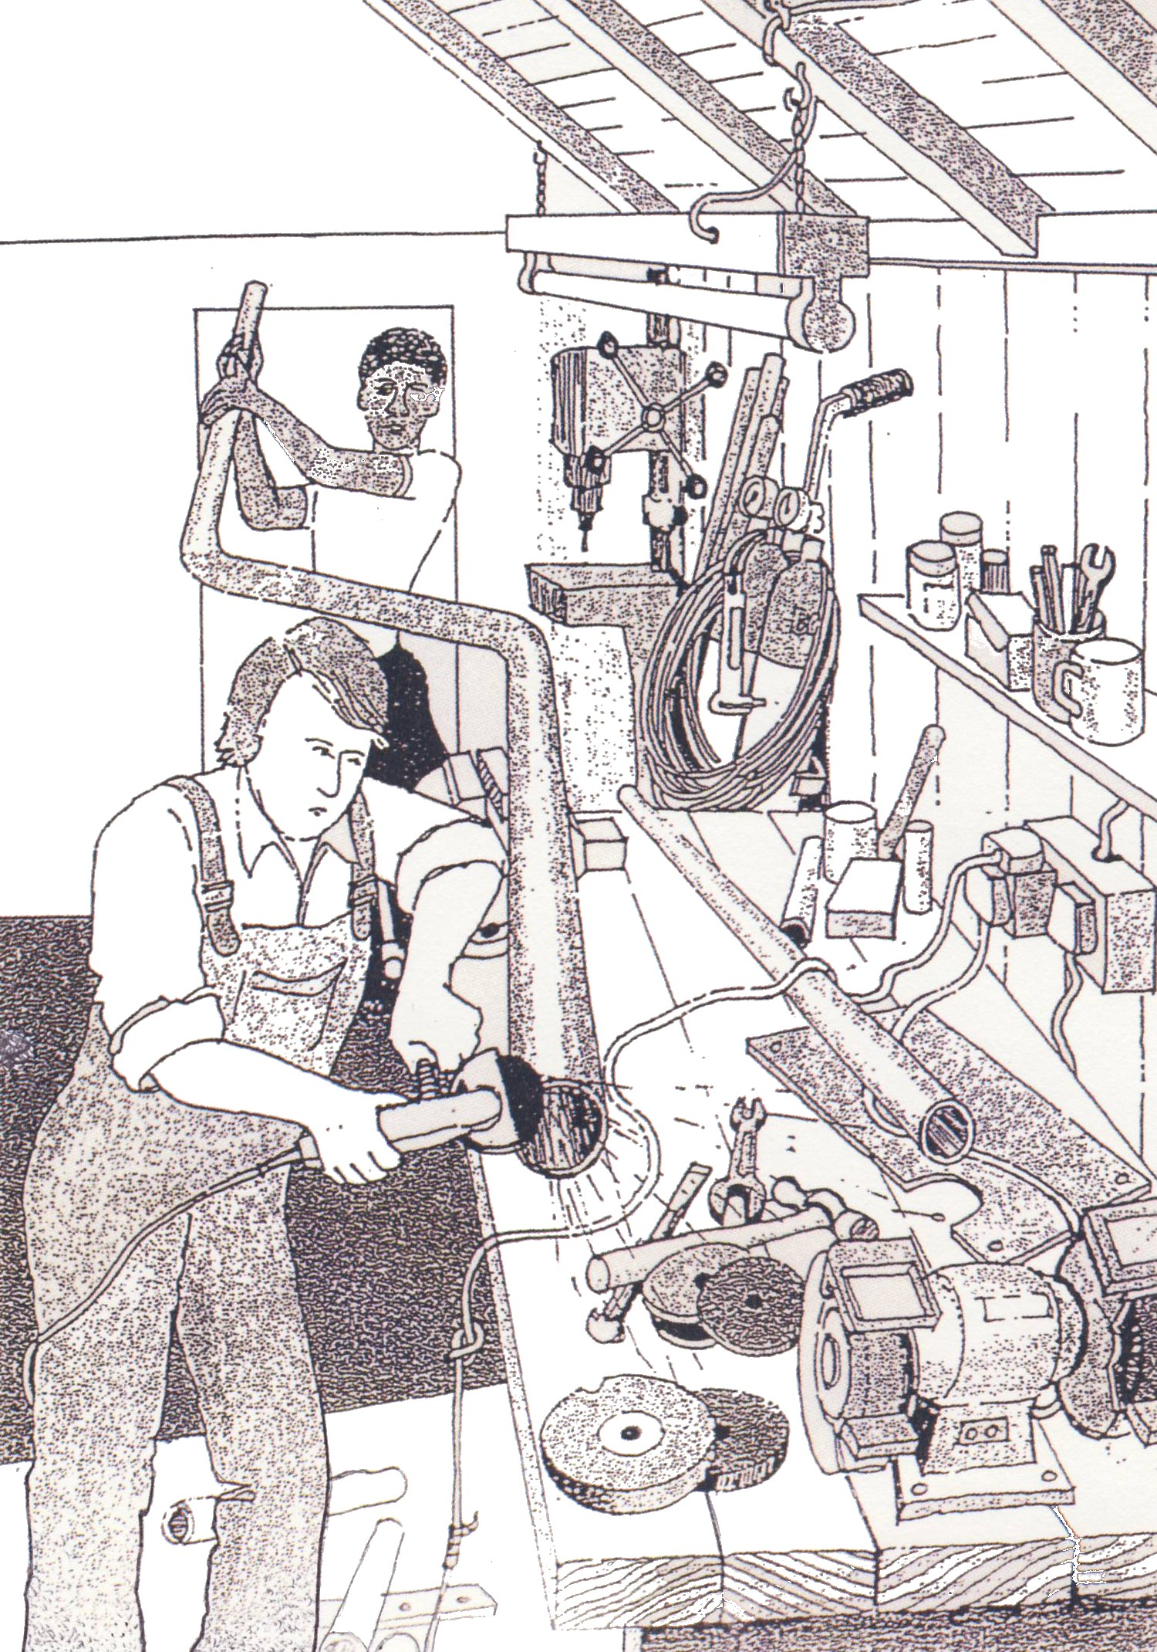
3.5 Identifying Hazards

Figure 1.

Suggested Exercise – Identify unsafe workshop practices.

3.6 Preparation and Safety
Objective
- Follow workplace procedures for hazard identification and avoidance.
Safety check
- Make sure that you understand and observe all legislative and personal safety procedures when carrying out the following tasks. If you are unsure of what these are, ask your instructor.
Points to note
- A workshop is a hazardous environment. To make people more aware of specific workshop hazards, legislative bodies, such as the International Safety Organization (ISO), have developed a series of safety signs. These signs are designed to give adequate warning of an unsafe situation.
- Each sign has four components:
  - Signal word
  - Background color
  - Text
  - Pictorial message
- There are three signal words:

Danger: This indicates an immediately hazardous situation, which, if not avoided, will result in death or serious injury. "Danger" is usually indicated by white text with a red background.

Warning: This indicates a potentially hazardous situation, which, if not avoided, could result in death or serious injury. The sign is usually in black text with an orange background.

Caution: This indicates a potentially hazardous situation, which, if not avoided, may result in minor or moderate injury. It may also be used to alert against unsafe practices. This is usually in black text with a yellow background.


Read all safety signs carefully and follow their instruction.
The signs must be kept in good condition at all times.
Replace any missing or damaged signs.

The following pages show a variety of Safety Signs that are commonly found in a workshop.





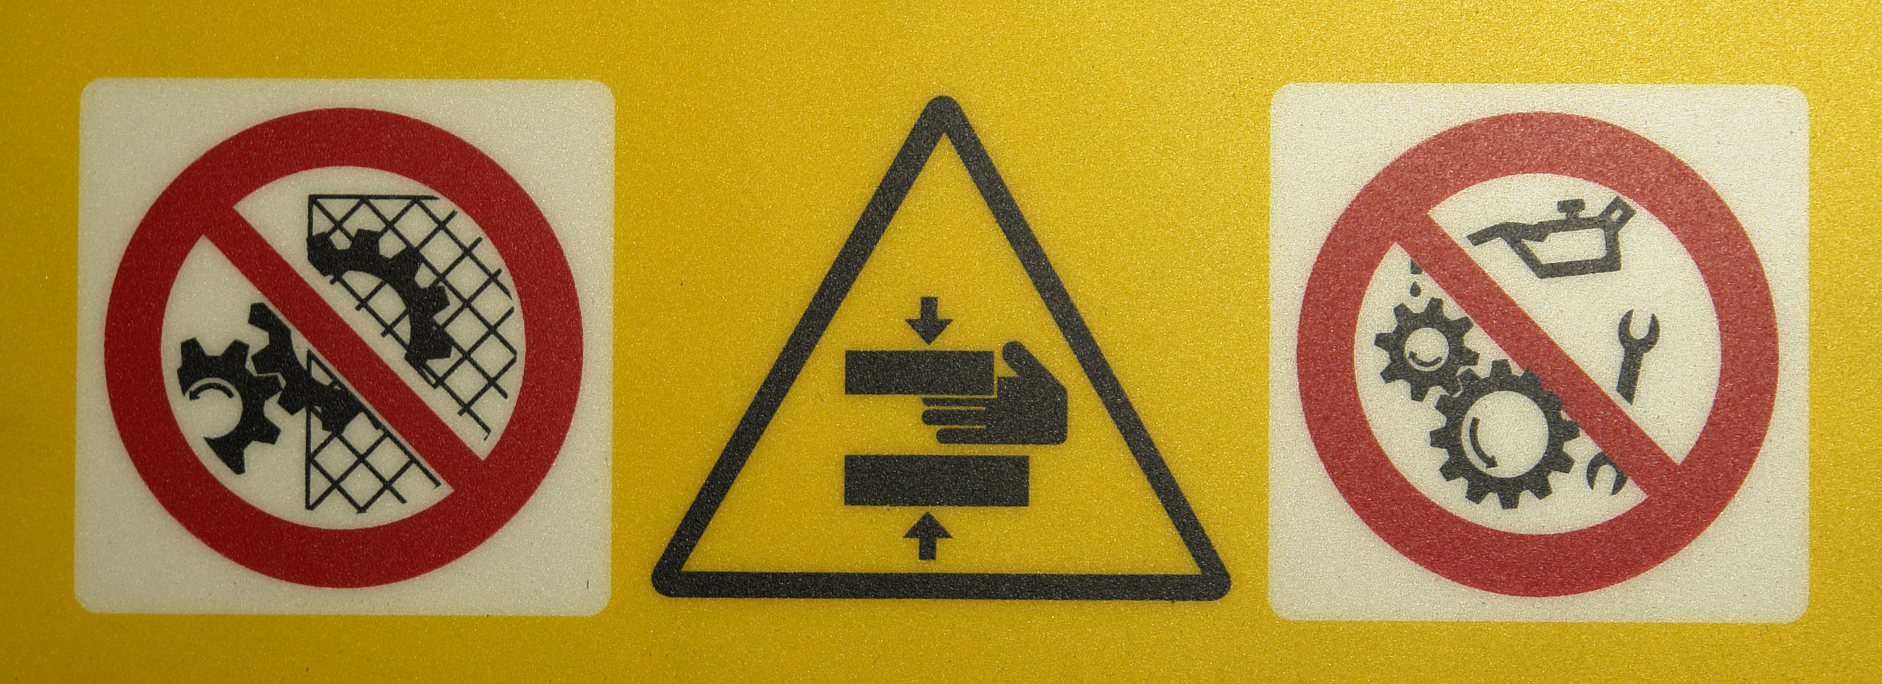



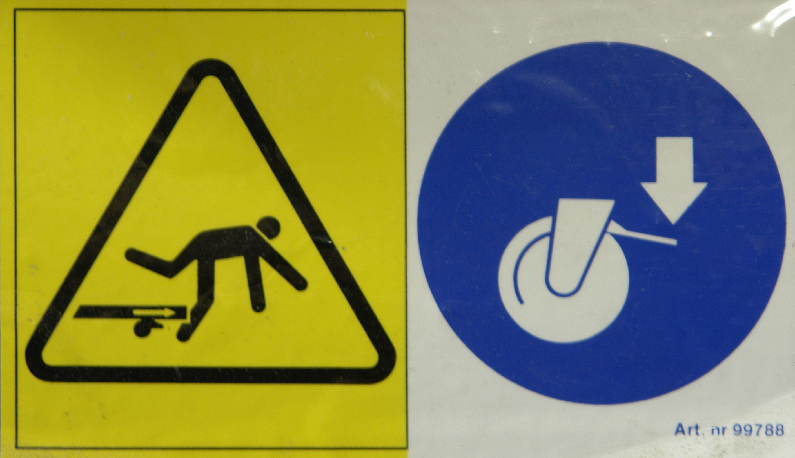










3.7 Symbol Signs
- The sign will sometimes include an explanatory text that is intended to provide additional safety information.
- Some signs are designed to convey a personal safety message. These signs suggest the use of safety glasses or hearing protection when in the area.


- In symbol signs, a pictorial message appears alone or is combined with an explanatory text. This allows the safety message to be conveyed to people who are illiterate or who do not understand the local language.
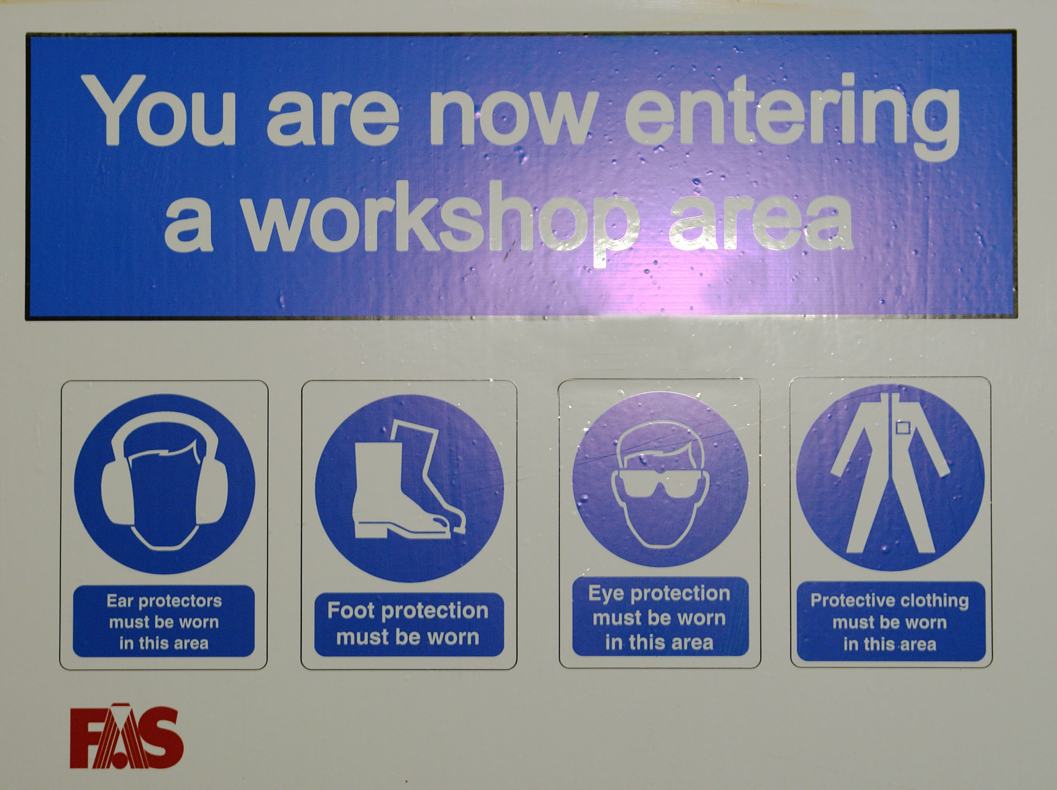


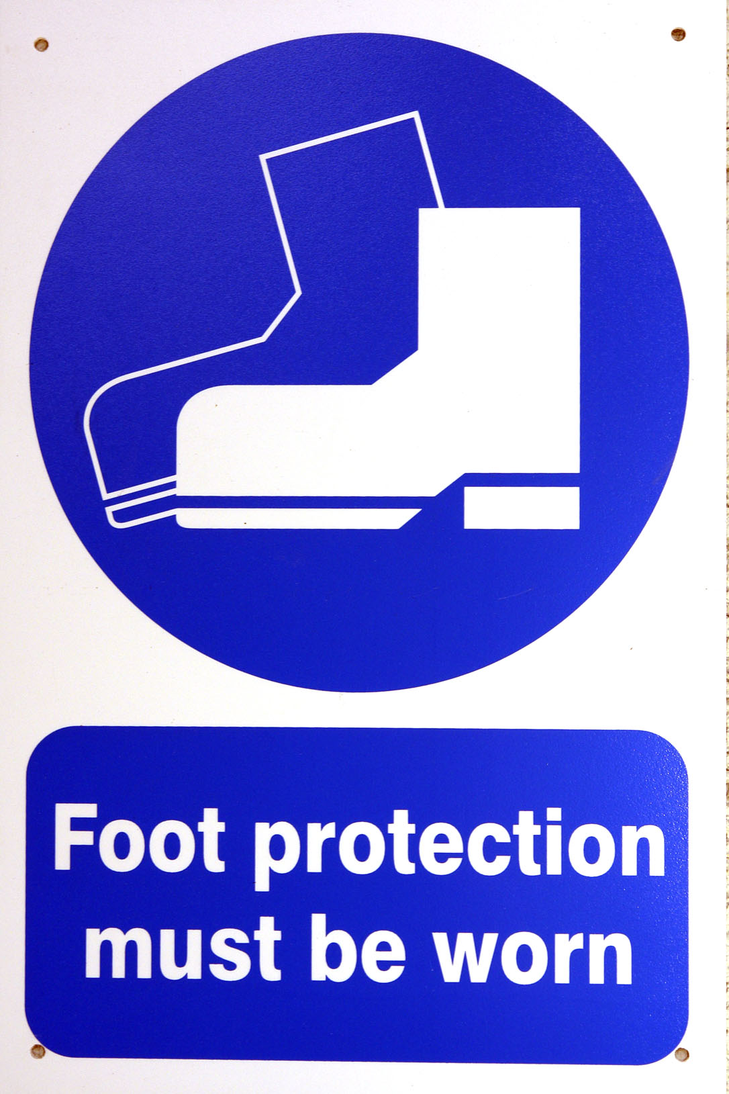


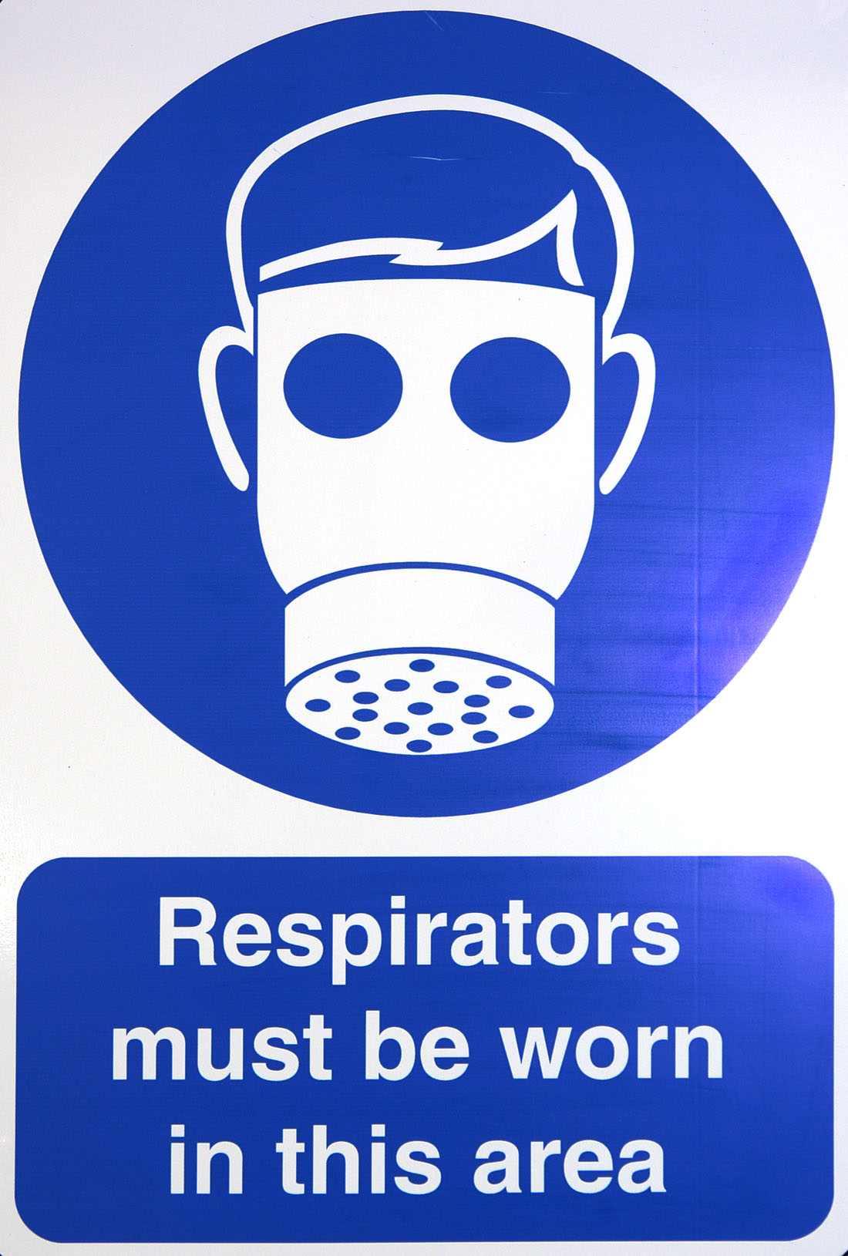



3.8 Wall Chart Signs
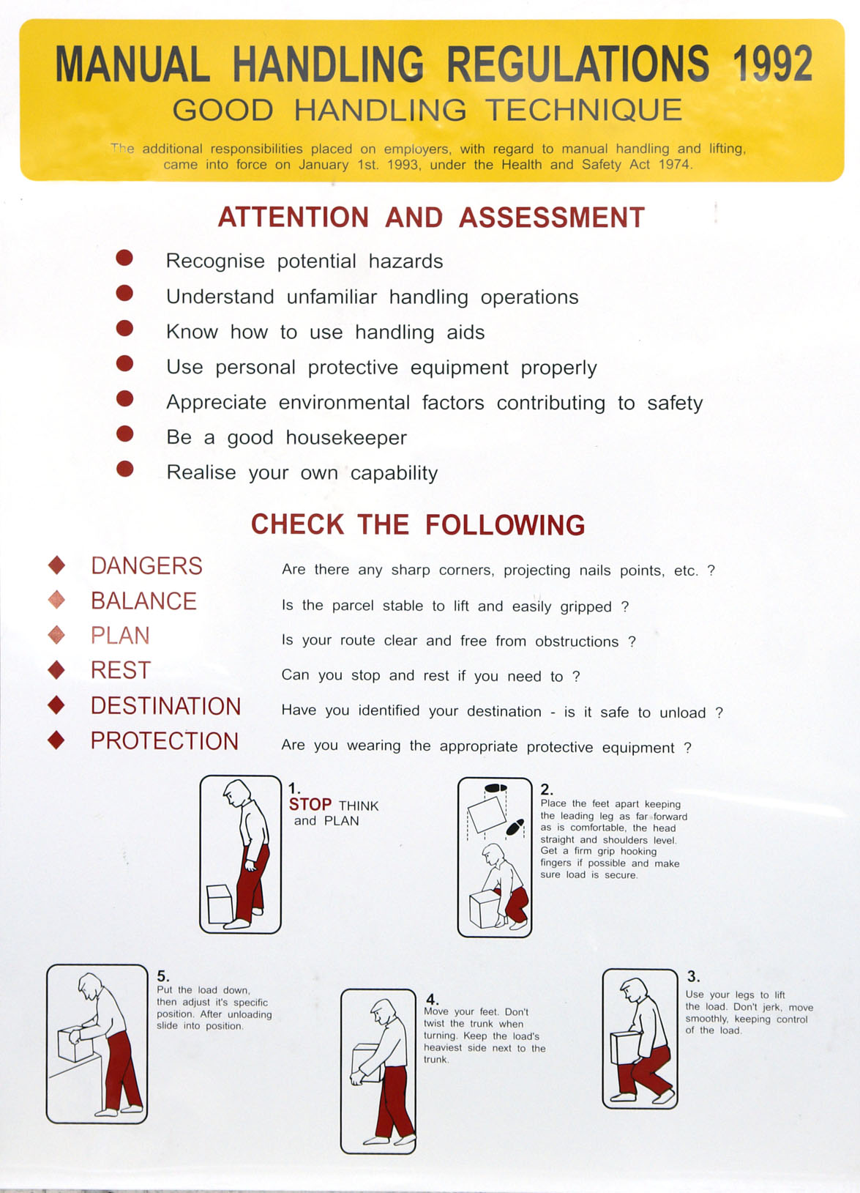
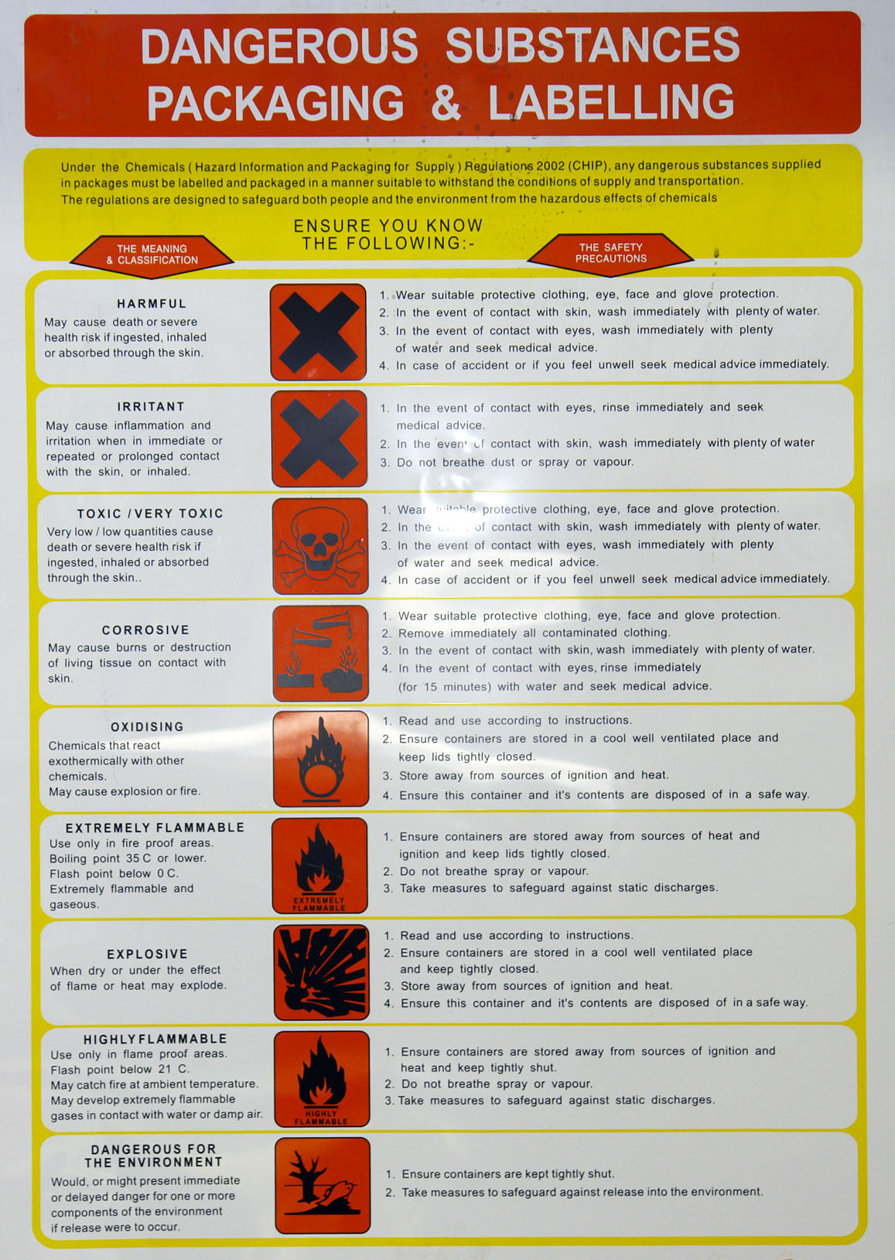

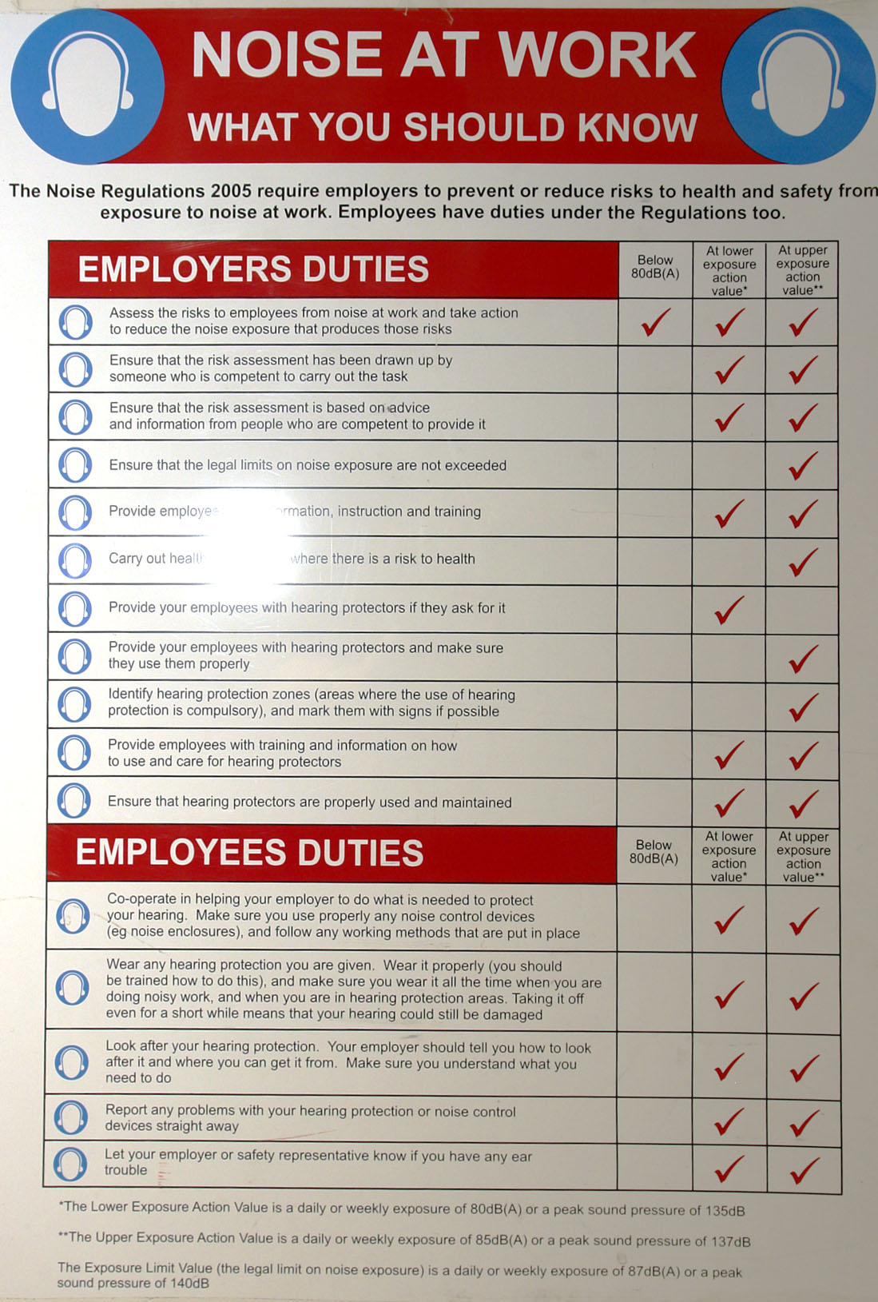
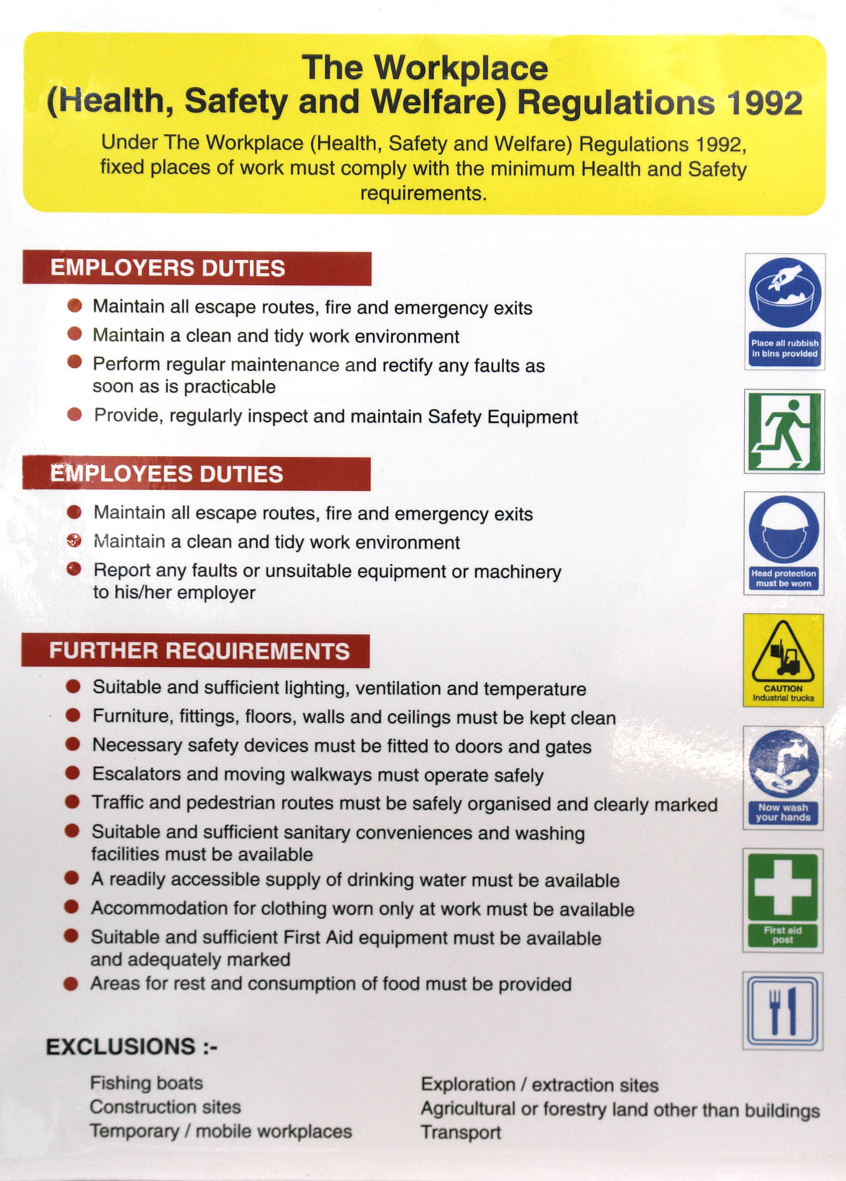

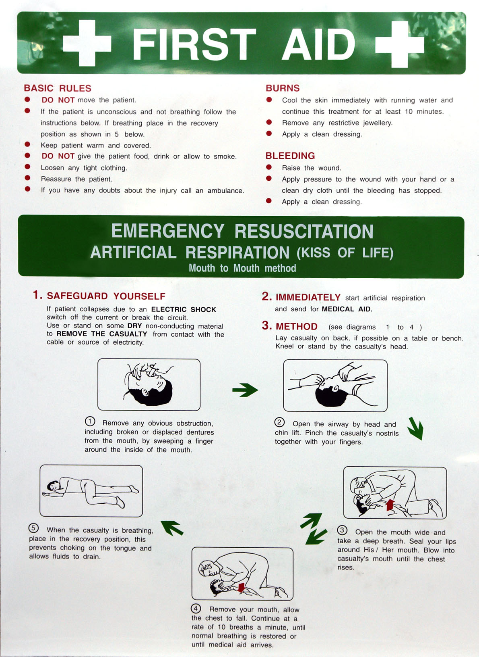

In the event of an accident however small, it must be reported to your instructor immediately who will take the correct course of action.
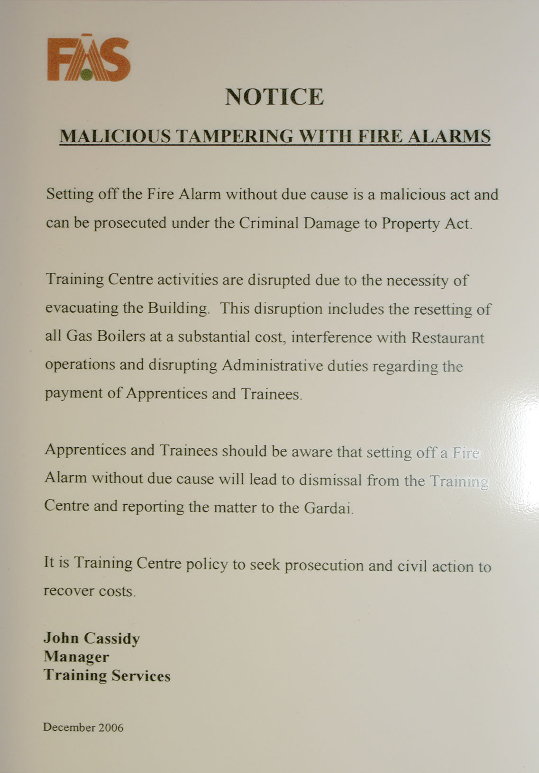

3.9 Fire Signs
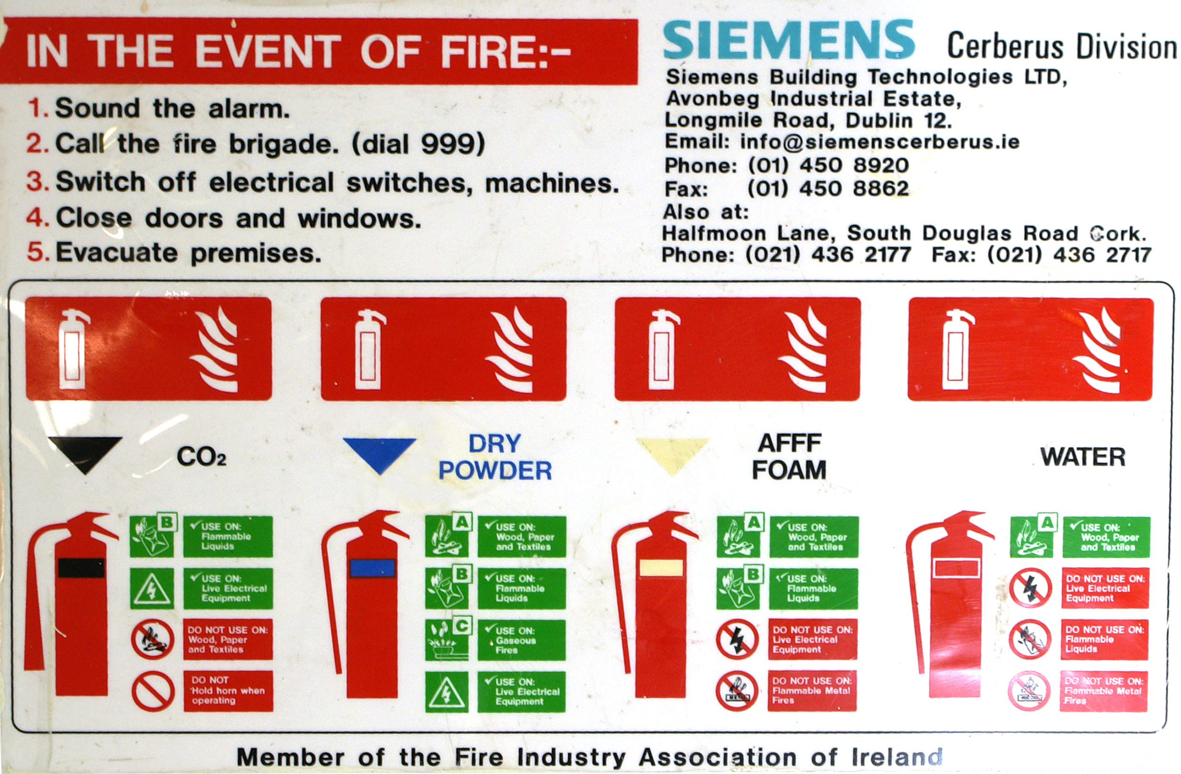

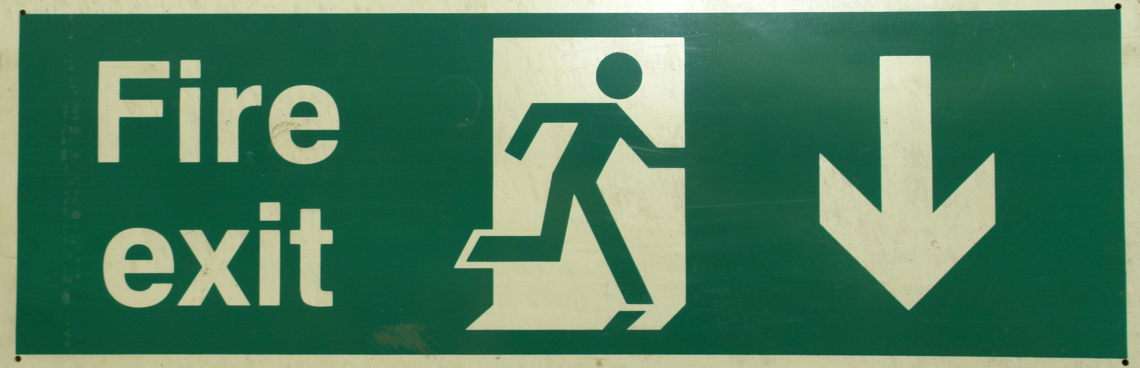
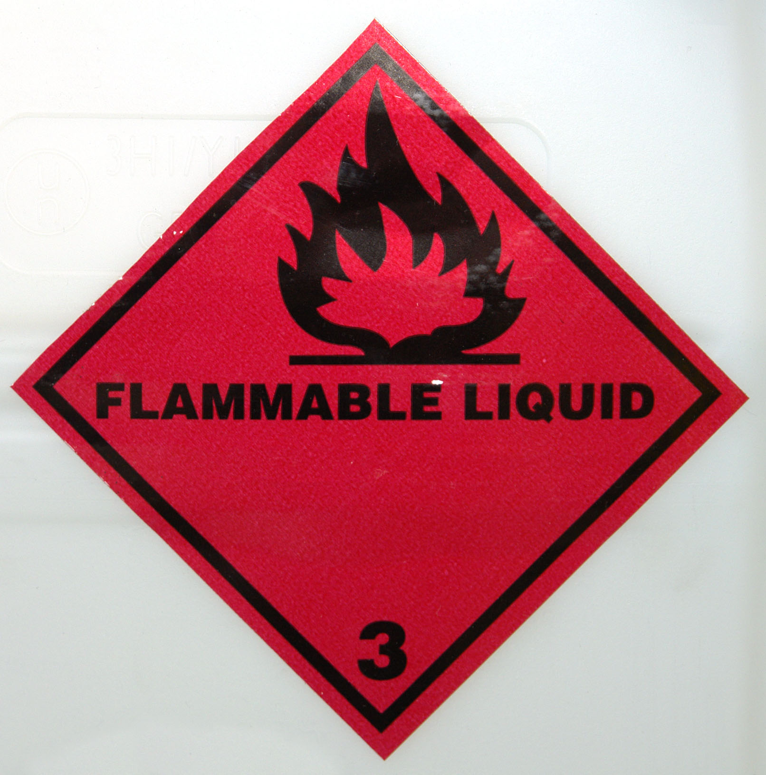
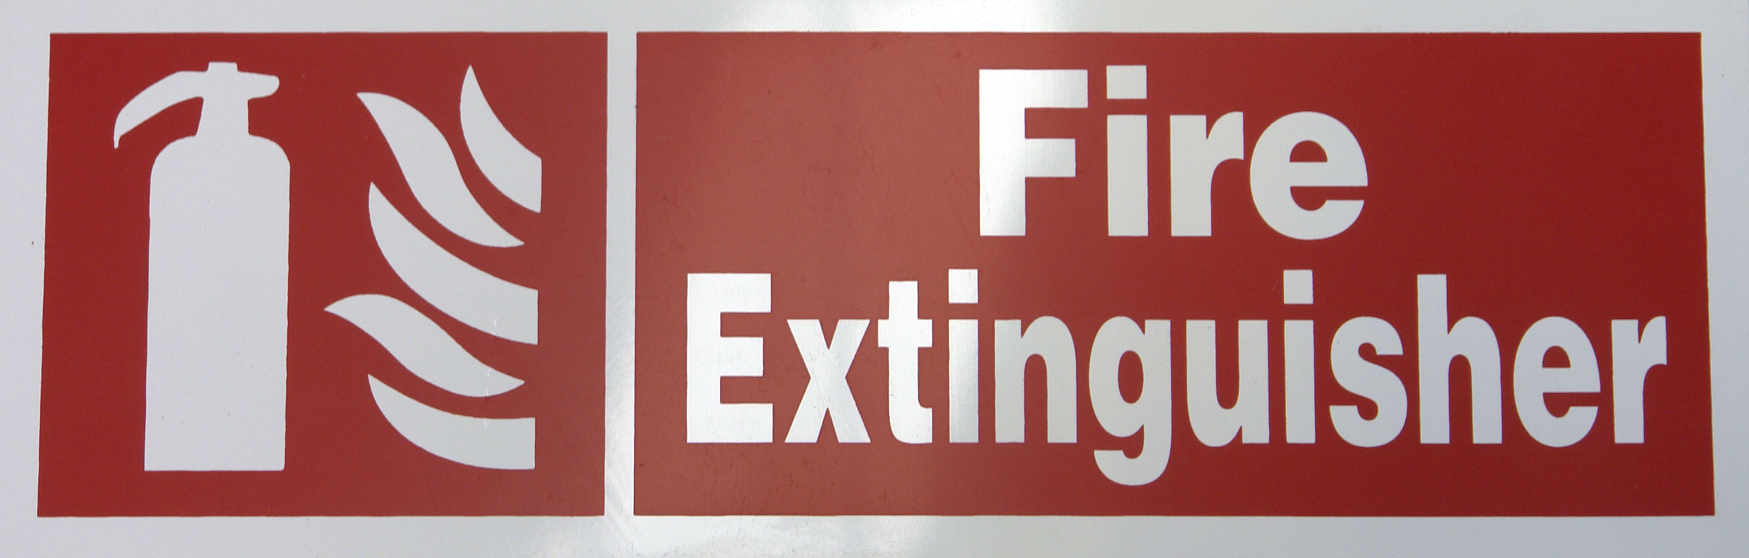
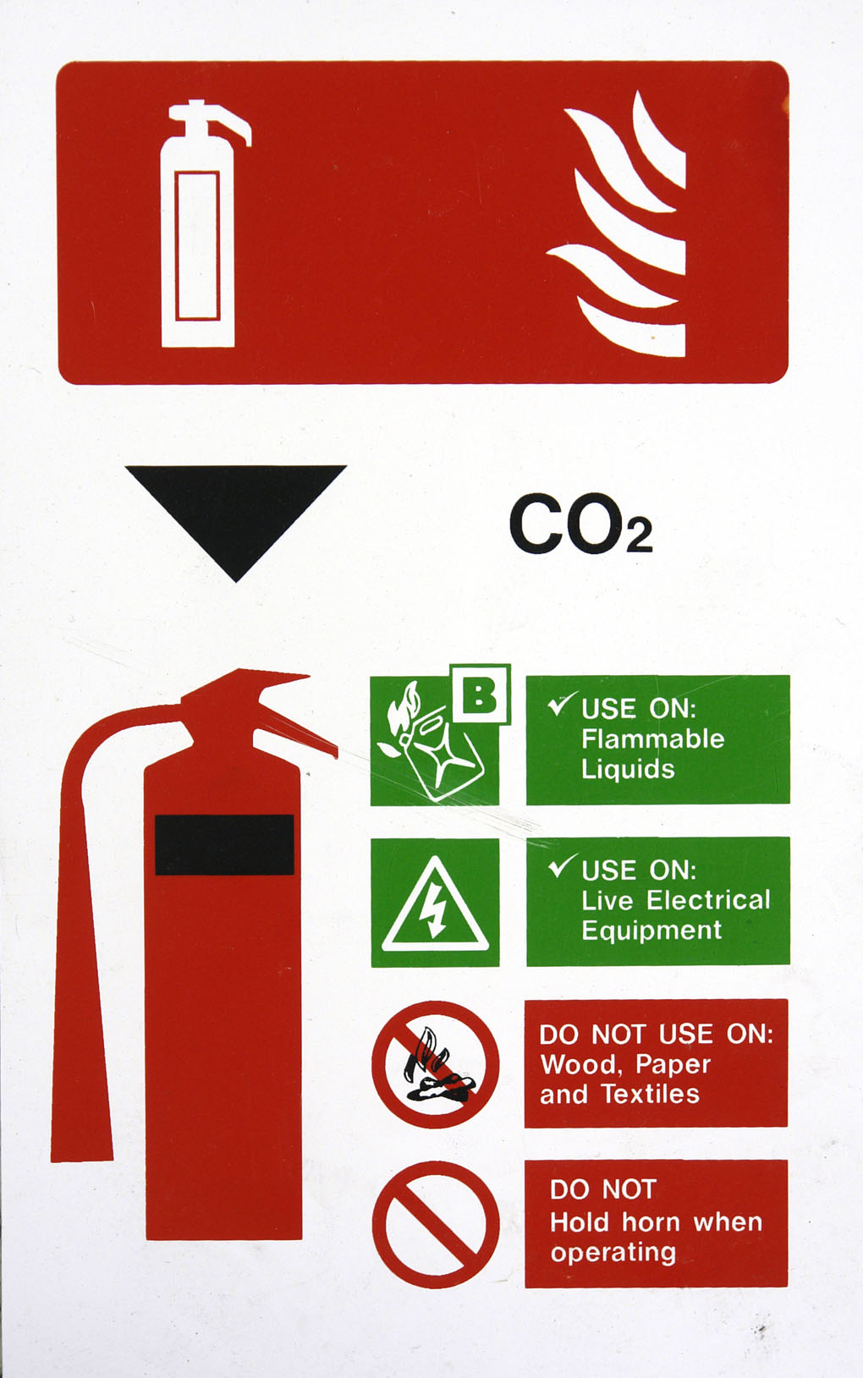
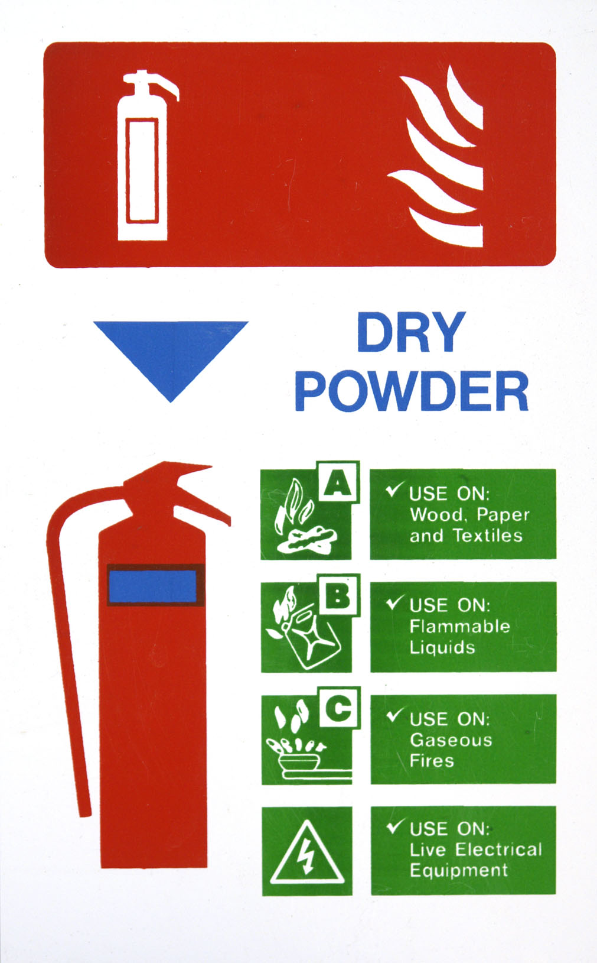

3.10 Safety in the Workshop

Safety equipment includes items such as:
  - Hand Rails
  - Machinery Guards
  - Painted Lines
  - Soundproof Rooms
  - Gas Extraction Hoses
  - Doors and Gates
  - Adequate Ventilation
- Large, fixed machinery such as repair benches present a hazard to the operator and others working in the area. To prevent accidents, a machinery guard or a yellow painted line on the floor usually borders this equipment.
- Machinery guards and yellow lines will prevent people from accidentally walking into the operating equipment or indicate that a safe distance should be kept from the equipment.
- Soundproof rooms are usually used when a lot of noise is made by operating equipment. An example is the use of a chassis dynamometer. A vehicle operating on a dynamometer produces a lot of noise from its tires exhaust and engine. To protect other workshop users from the noise, the dynamometer is usually placed in a soundproof room, keeping workshop noise to a minimum.
- Exhaust gases in workshops are a serious health hazard. Whenever a vehicle's engine is running, toxic gases are produced from its exhaust. To prevent an excess of gas build-up, a well-ventilated work area is needed as well as some method of extracting the toxic gases.
- The best way to get rid of these gases is with a suction hose that fits over the vehicle's exhaust pipe. The hose is attached to an extraction pump that vents the gas to the outside.
- Doors and gates are used for the same reason as machinery guards and painted lines. A doorway is a physical barrier that can be locked and sealed to separate a hazardous environment from the rest of the workshop, or a general work area from an office or specialist work area.
- In the day-to-day operation of a workshop, there is often a reason to temporarily separate one work bay from others. If a welding machine or an oxyacetylene cutting torch is in use, it may be necessary to place a temporary screen or barrier around the work area to protect other workshop users from "welding flash" or injury.
Step-by-step instruction
- Workshop Layout
Familiarize yourself with your workshop. There are special work areas that are defined by painted lines. These show the hazardous zone around certain machines and areas.
If you are not working specifically on the machines, you should stay outside the marked area.
- Observe warning signs
Study the various warning signs around your workshop. Understand the meaning of the Signal Word, the colors, the text and the symbols or pictures on each sign.
Ask your instructor if you do not fully understand any part of the sign.
- Identify exits
Find out where every door, window and gate is, and whether they are usually open or locked. Plan your escape route, should you need to exit in a hurry.
- Check air quality
Check for air quality. There should be good ventilation and very little chemical fumes or smell. Locate the extractor fans or ventilation outlets and make sure they aren’t obstructed in any way.
Locate and observe the use of the exhaust extraction hose, pump and outlet that’s used on the vehicle’s exhaust pipes.
- Identify fire fighting equipment
Check the location and types of fire extinguishers in your workshop.
Be sure you know when to use each type, and how.
- Identify flammable hazards
Find out where flammable materials are kept, and make sure they’re stored properly.
- Identify hazards – Compressed air
Check the hoses and fittings on the air compressor for any damage or excessive wear. You have to be particularly careful when troubleshooting air guns. Never pull the trigger while inspecting it—severe eye damage can result.
- Identify hazards – Corrosives
Find out which liquids will burn or corrode parts, metals or skin.
Identify caustic chemicals and acids associated with activities in your workshop.
- Personal protection
Be aware that YOU could be a hazard in the workshop, if you don’t wear mandatory protective gear when working on hazardous machines.
- Equipment hazards
Ask your instructor for information on any special hazards in your particular workshop, and any special avoidance procedures, which may apply to you and your working environment.
3.11 Using a Fire Extinguisher
Objective
- Locate workplace fire extinguishers and identify applications and operating procedures.
Safety check
- Do not attempt to fight a fire unless you have a fire extinguisher large enough to extinguish the fire. Many small extinguishers empty in 8 to 10 seconds.
- Never try to extinguish a fire that is spreading rapidly.
- Do not try to put out a fire unless you know what type of fire is burning. Using the wrong fire extinguisher will make the fire worse.
- Test the fire extinguisher before you attempt to extinguish a fire.
- Do not inhale any fumes from a fire. Fire gives off toxic gases.
- Do not use water on grease fires, electrical fires or fires where electrical wiring is present.
- If you cannot fight the fire, leave the area and call the fire department.
- See your local fire department for a demonstration of the appropriate procedure in your jurisdiction.
- Make sure that you understand and observe all legislative and personal safety procedures when carrying out the following tasks. If you are unsure of what these are, ask your instructor.
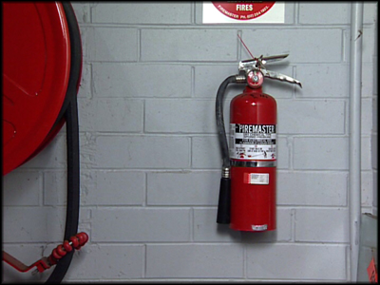

Points to note
- Each workshop will have a firefighting procedure. There should be a workshop fire warden and fire officers. Understand clearly the firefighting policy for your workshop.
- Fire extinguishers will be located in easily accessible places. Do not block access to fire extinguishers with workshop equipment and clutter.
- Fire extinguishers either smother or quench a fire. A fire extinguisher that smothers a fire does not remove heat. Keep a watch over the fire. Even though the fire may seem to be out, it may restart.
- Workshops will have various firefighting tools: fire hoses, fire buckets, fire blankets and fire extinguishers. Each has a specific application and method of use. Familiarize yourself with each of these tools.
- Fire blankets are manufactured from fire retardant material and have multiple uses. They can be used to smother a fire in a cleaning station or wrap around clothing that has caught on fire. They may be used to shield people from fire when evacuating a building or be used as a stretcher to carry injured or unconscious people.
- Never use water on a fuel-based fire. The fuel will float on the water and spread further.
- The only exception to this is in the case of a fire fuelled by methanol. Methanol is heavier than water and burns with an invisible flame. Use a water extinguisher on a methanol fire.
- Fire buckets contain sand that can be thrown over a fire to smother it. Do not be too quick to empty all the sand in one throw. You may not completely cover the fire the first time.
3.12 Fighting a Fire
- Three elements must be present at the same time for a fire to occur: fuel, oxygen and heat. These three elements are demonstrated by the fire triangle. The secret of firefighting involves the removal of one of these elements, usually the oxygen or the heat.
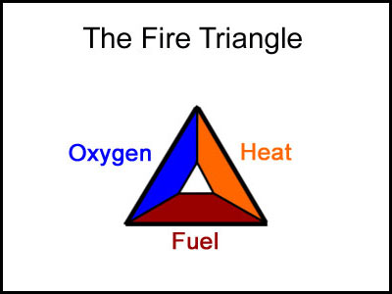
- Know how to operate the extinguisher. Read the instructions when you purchase the extinguisher. You will not have time to read them once a fire has started.
- Never turn your back on a fire or allow a fire to get between you and a means of escape. If you are fighting a fire outside, always have the wind at your back.
- If possible, get an assistant to guide you and inform you of the fire's progress.
- If a fire occurs in your work area, remember the PASSword:
  - Pull, Aim, Squeeze, Sweep
- PULL out the pin that locks the handle at the top of the extinguisher to prevent accidental use.
- Carry the fire extinguisher in one hand, and use your other hand to AIM the nozzle at the base, or seat, of the fire. Some fire extinguishers need to be turned upside down to operate. Check which way to hold the extinguisher you've chosen.
- Stand about 2.8 m (8 ft) away from the fire and SQUEEZE the handle to discharge the fire extinguisher.
- Remember that if you release the handle on the extinguisher, it will stop discharging.
- SWEEP the nozzle from side to side at the base of the fire. Watch the fire. Although it may appear to have gone out, it may re-ignite.
- If the fire is indoors, you should be standing between the fire and the nearest safe exit. If the fire is outdoors, you should be standing facing the fire with the wind on your back, so that the smoke and heat are being blown away from you. Again, make sure that you have a means of escape, should the fire get out of control.
- When you are quite sure that the fire is out, report it to your instructor. Also report what actions you took to put out the fire.
- Once the circumstances of the fire have been investigated, and your instructor or the fire brigade has given you the all clear, clean up the debris and submit the used fire extinguishers for inspection and re-filling.
3.13 Fire Classifications
- There are 5 classes of fire.
  - "A" class fires involve wood, paper, cloth, rubber and trash.
  - "B" class fires involve flammable liquids, such as oil, paint, gasoline, grease, and tar.
  - "C" class fires involve flammable gases, such as LPG, Natural Gas, Acetylene, etc.
  - "D" class fire is fuelled by combustible metals - magnesium, potassium turnings and metal shavings. They are not as common as A, B, or C class fires.
  - "E" class fires need electricity to feed the fire. This class includes wiring, damaged appliances, circuit breakers and fuse boxes. Once the electrical supply has been disconnected, the fire changes to the class of fuel it is burning.
3.14 Fire Extinguisher Types
- There are four types of fire extinguisher. Each type can be used for one or more classes of fire.
  - Water extinguishers contain water pressurized by an inert gas or compressed air. The water quenches the heat from the fire to below its vaporization point. They should only be used on class "A" fires.
  - Carbon dioxide fire extinguishers are most effective when used against "B", "C" and "E" class fires. The gas is heavier than air and provides an inert blanket that smothers the fire. A carbon dioxide fire extinguisher will spray small ice particles with the gas. This is normal.

  - Dry Powder fire extinguishers contain a fine powder, usually sodium bicarbonate, held under pressure by an inert gas. The extinguisher smothers the fire with a fine powder. These extinguishers are good to fight any fuel or liquid fire.
  - Foam fire extinguishers contain a chemical that forms a soft foam that floats over the target area and smothers the fire. These are effective fighting liquid, gaseous, paper or wood fires.
3.15 Fire Extinguisher Suitability
- You will often see more than one symbol on a fire extinguisher. This identifies the extinguisher as suitable for more than one class of fire.
- Class "A", "B" and "C" fire extinguishers have a numerical rating. These are used to determine the extinguisher's potential to fight a fire. This rating is expressed as a number from 1 to 40 for Class A fires and from 1 to 640 for Class B and C fires. It will appear on the extinguisher, e.g. 1A or 20B or 4A: 20B:C. A larger number means a larger fire extinguisher.
4.0 Use of Fixed Equipment
The major items of fixed equipment in the garage are the two and four post hoists. The following notes indicate the safety procedures to be observed in operating these items of equipment.
4.1 Using a Two-Post Hoist
Objective
- Lift a vehicle using a two-post hoist.
Safety check
- Make sure that you understand and observe all legislative and personal safety procedures when carrying out the following tasks. If you are unsure of what these are, ask your instructor.
Points to note
- Before lifting any vehicle, make sure the frame is structurally sound. If you see rust or signs of major repair, lifting the vehicle with a hoist may cause damage to the vehicle or may be dangerous to you.
- The lifting capacity of the hoist you are using must be rated for a vehicle weight greater than that of the vehicle you are intending to lift. Check the hoist rating and compare it with the weight given in the vehicle service manual.
- Make sure you know exactly how to operate the hoist. Take particular care that you know exactly where the "stop" control is so that you can use it quickly in an emergency. Refer to the operations manual for the correct procedure.
- Be sure the hoist is fully lowered before positioning the vehicle over it. Check the amount of clearance under the vehicle. Driving a low-slung vehicle over the lifting mechanism may result in damage to the underside of the vehicle.
- The lifting points on a vehicle are typically located under the jacking points. Check the vehicle service manual if you are not sure where the lift points are. The lifting arms must be positioned under the center of the lift points, so that the weight of the vehicle is distributed evenly.
- Make sure that there will be adequate headroom above the vehicle after it has been raised. Taller vehicles, especially those fitted with roof racks, may need more headroom than you think.
- The hoist should be raised so you can comfortably work under it. Lock the lift in place before moving underneath or working on the vehicle.
Step-by-step instruction
- Read instructions
Read the safety instructions that are provided with the hoist. They should be displayed near the lift operating controls. Check the hydraulic system for leaks. Make sure there are no oil spills around or under the hoist.
- Prepare the hoist
The hoist should be completely down before you attempt to drive the vehicle onto it. You should also check the arms and pads for any signs of damage. Check under the vehicle to make sure there are no parts which will interfere with the hoist operation and that the vehicle is structurally sound and not badly corroded. Check the vehicle’s service manual or your workshop service manual and locate the correct contact points for the lifting pads.
- Position the vehicle
Carefully drive the vehicle onto the hoist and position it centrally. Leave the vehicle in neutral with the emergency brake off. You may need to move the car forward or backward to allow the arms to swing under the car. Position the lifting pads under the vehicle lifting points. Make sure the lifting pads are adjusted to the same height for both sides of the vehicle.
- Raise the hoist to the vehicle
Move to the operating controls and raise the hoist just far enough to come into contact with the vehicle. Make sure that the lifting pads are positioned centrally under the contact points.
- Raise the vehicle slightly
Make sure nobody is near the vehicle, and then raise it just far enough for the wheels to be off the floor. Check the position of the lifting pads to make sure they have not moved, and shake the vehicle gently to confirm that it is stable on the hoist.
- Raise the vehicle completely
Once you are sure the vehicle is safely positioned on the hoist, lift it to the working height.
- Engage safety device
With the vehicle at the correct height you should now lock the hoist in place and engage whatever safety device is used with it.
- Lower the vehicle
Before the hoist is lowered, remove all tools and equipment from the hoist area, and wipe up any spilled fluids. Remove the safety device or unlock the lift before lowering it. Make sure nobody is near the vehicle on the hoist before lowering it. Once the vehicle is on the ground you can remove the lifting arms and drive it away from the hoist.
4.2 Operation of a Four Post Hoist
Using a four-post hoist
Objective
- Lift a vehicle using a four-post hoist.
Safety check
- Make sure that you understand and observe all legislative and personal safety procedures when carrying out the following tasks. If you are unsure of what these are, ask your instructor.
Points to note
- Four-post hoists allow the vehicle to be positioned and lifted easily. They are often used to lift a vehicle for wheel alignment services and brake repairs.
- Some four-post hoists are fitted with attachments that allow the vehicle to be raised in a "wheels free" position. Refer to the operations manual for the correct operational procedure.
- The lifting capacity of the hoist you are using must be rated for a vehicle weight greater than that of the vehicle you are intending to lift. Check the hoist rating and compare it with the weight given in the vehicle service manual.
- Make sure you know exactly how to operate the hoist, taking particular care to know exactly where the stop control is so that you can use it quickly in an emergency. Refer to the operations manual for the correct procedure for stopping the hoist.
- Make sure that there will be adequate headroom above the vehicle after it has been raised. Taller vehicles, especially those fitted with roof racks, may need more headroom than you think.
- The hoist should be raised so you can comfortably work under it. Lock the lift in place before moving underneath or working on the vehicle.
Step-by-step instruction
- Read instructions
Read the safety instructions that are provided with the hoist. They should be displayed near the lift operating controls. Check the hydraulic system for any leaks, and the steel cables for any sign of damage. Make sure there are no oil spills around or under the hoist.
- Prepare the hoist
The hoist should be completely down before you attempt to drive the car on to it. The platform may have built in wheel restraints, or attachments for wheel alignment equipment. A set of bars is mounted at the front of each ramp to prevent the vehicle from being driven off the front of the hoist. At the back there will be ramps that allow the vehicle to be driven up and on to the hoist. These will lift up when the hoist is raised and prevent the vehicle from rolling off.
- Position the vehicle
Drive the vehicle slowly and carefully onto the hoist and position it centrally. If the vehicle has front wheel restraints, drive the vehicle forward until the wheels lock into the brackets. Get out of the vehicle and check that it’s correctly positioned on the platform. If it is, apply the emergency brake and select first gear or park.
- Raise the vehicle
Make sure the hoist area is clear. Move to the controls and lift the vehicle until it’s reached the appropriate work height.
- Lock safety device
Most 4 -post hoists will have an automatic locking mechanism. If the hoist has a manual safety mechanism you should lock it in place to engage whatever safety device is used.
- Lower the vehicle
Before the hoist is lowered, remove all tools and equipment from the hoist area, and wipe up any spilled fluids. Remove the safety device or unlock the lift before lowering it. Make sure that nobody is near the vehicle or the hoist. Once the hoist is fully lowered you can drive the vehicle off the hoist.
Other non fixed equipment deserves special mention
4.3 Using an engine hoist
Objective
- Use an engine hoist and choose the correct attachments to lift an engine.
Safety check
- The weight rating of the crane or hoist must be greater than the weight of the object to be lifted.
- Never leave an unsupported engine hanging on a shop crane. Secure the engine on an engine stand, or on the ground, before starting to work on it.
- If using engine stands, make sure they are designed to support the weight of the object you are lifting.
- Make sure that you understand and observe all legislative and personal safety procedures when carrying out the following tasks. If you are unsure of what these are, ask your instructor.
Points to note
- Mobile floor cranes are capable of lifting very heavy objects, which make them suitable for lifting engines.
- The lifting arm is moved by a hydraulic cylinder and is adjustable for length. If the arm is lengthened, the lifting capacity of the arm is reduced. The weight limit is usually marked on the arm so that the arm or the hydraulic mechanism is not damaged by attempting to lift too heavy a load.
- Make sure the lifting attachment at the end of the lifting arm is strong enough to lift the engine and is not damaged or cracked.
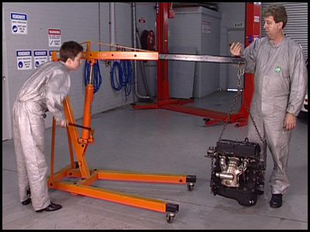
- When attaching the lifting chain, or sling, to an engine make sure it is firmly attached and that the hoist is configured to lift that weight. Make sure that the fasteners attaching the lifting chain, or sling, have a tensile strength that is in excess of the weight of the engine.
- Leave enough length in the sling so that when the engine is hanging, the angle at the top of the sling is close to 45 degrees and not exceeding 90 degrees.
- If removing an engine from an engine bay, once it is lifted free and away from the vehicle, lower the engine so that it is close to the ground. If the engine is lifted high in the air, the hoist will be unstable.
- When moving a suspended engine, move the hoist slowly. Do not change direction quickly because the engine will swing and may cause the whole apparatus to tumble.
Part 2: Step-by-step instruction
- Position the hoist
Make sure the weight rating of the lifting crane is greater than the weight of the object you’re lifting. In this case, you’ll be lifting and moving an engine. Lower the lifting arm and position the lifting end and chain over the center of the engine.
- Inspect the lifting attachments
Inspect the chain, steel cable or sling and bolts to make sure they are in sound condition. They must be strong enough to support the weight of the engine. The sling should be long enough so when you lift the engine the angle at the top of the sling is about forty-five degrees.
- Locate the lifting points
Look carefully around the engine to determine if it has lifting “eyes” or other anchor points
- Attach the hoist sling
If the engine has lifting eyes, attach the sling with “D” shackles or chain hooks. If you need to screw in bolts and spacer washers to lift the engine, make sure you use the correct bolt and spacer size for the chain or cable. Screw the bolts until the sling is held tight against the engine.
- Attach the hoist hook
Attach the hook of the hoist under the center of the sling and raise the hoist just enough to lift the engine an inch or two. Double-check the sling and attachment points for safety. The center of gravity of the engine should be directly under the hook of the hoist, and there should be no twists or kinks in the chain or sling.
- Raise the engine
Raise the hoist high enough so that the engine is clear of the ground and any obstacles. Slowly and gently move the hoist and engine to its new position.
- Lower the engine
Lower the engine until it touches the ground. Making sure it is positioned correctly. You may need to place spacers under the engine to stabilize it. Once you are sure the engine is stable lower the hoist, remove the sling and any securing fasteners, then, return the equipment to its storage area.
4.4 Using a Floor Jack
Objective
- Lift and secure a vehicle with a floor jack and jack stands.
Safety check
- Make sure the jack and stands you are using are suitable for the job.
- Never lift a vehicle that is heavier than the jack's rated capacity.
- Always use matched pairs of jack stands.
- Never support a vehicle on anything other than jack stands.
- Do not use wood or steel blocks to support the vehicle. They may slide or split under the weight of the vehicle.
- Do not use bricks to support the vehicle. They will shatter under the weight of the vehicle.
- Make sure that you understand and observe all legislative and personal safety procedures when carrying out the following tasks. If you are unsure of what these are, ask your instructor.
Points to note
- There are three types of workshop jacks: hydraulic, pneumatic and mechanical.
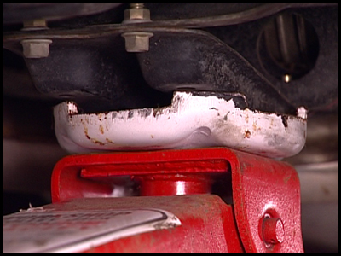
- Hydraulic and pneumatic jacks are the most common. They can be mounted on slides or on a wheeled trolley.
- The size of jack you use will be determined by the weight of the vehicle you want to lift. Most workshops will have a jack that has a lifting capacity of about 2 ½ tons/tonnes. If the vehicle is heavier than that, or if the vehicle is loaded, you will need to use a jack with a larger lifting capacity.
- Always check the vehicle service manual or owner's manual to determine the best position to support a vehicle. Some vehicles require special attachments to be fitted before they can be lifted.
- Do not jack or support a vehicle under any independent suspension components. They are not strong enough to support the weight of the vehicle.
- Make sure the vehicle is positioned on a firm level surface.
- Make sure the jack stands are in good condition before you use them to support the vehicle. If they are cracked or bent, they will not support the vehicle safely.
Step-by-step instruction
- Position the vehicle
Position the vehicle on a flat, solid surface. Put the vehicle into first gear or park and set the emergency brake. Then place blocks in front of and behind the wheels that aren’t going to be raised off the ground.
- Inspect the floor jack
Before you try to use the jack, check for leaks in the hydraulic system. Check the pad, or saddle, and the wheels of the jack. They should rotate freely and show no signs of damage. Check the manufacturers’ label on the jack. The specifications will tell you the maximum load weight it will bear, so it must suit the vehicle you want to raise.
- Check the vehicle handbook
Refer to the owner’s manual to find out where you can safely place the jack. This is usually a major point on the chassis, a cross member or axle unit.
- Select the jack safety stands
Before operating the jack, select two safety stands of the same type, suitable for the weight of the vehicle. Check the stands for any cracks, and if necessary lubricate the threaded adjusting post with a few drops of engine oil. Place one stand on each side of the vehicle at the same point. Adjust them so that they are both the same height, and high enough to slip under the vehicle once you’ve raised it.
- Position the jack
Roll the jack under the vehicle, and make sure the pad, or saddle, is positioned correctly under the frame or cross member. Turn the valve on the top of the jack handle clockwise, and begin pumping the handle up and down until the jack pad touches and begins to lift the vehicle.
- Check position of jack
Once the wheels lift off the floor, stop and check the placement of the jack pad under the vehicle to make sure there’s no danger of slipping. Double check the position of the wheel blocks to make sure they haven’t moved. If the vehicle is stable, continue lifting it until it’s at the height where you can safely work under it.
- Position the safety stands
Slide the two jack safety stands underneath the vehicle. Make sure they’re positioned at a point that can support the weight. Both stands should be adjusted to the same height and placed as far apart as practical.
- Lower the vehicle onto the stands
Turn the valve on the jack handle counter-clockwise and gently lower the vehicle onto the stands. When the vehicle has settled onto the stands, lower the jack completely and remove it from under the vehicle. Repeat this process to lift the other end of the vehicle. Be aware that the vehicle is now supported on jack stands and will not be as stable as it would if the wheels were on the ground. When you’ve finished working under the vehicle, make sure you’ve removed all tools and equipment before you attempt to lower it.
- Raise the vehicle off the stands
Use the jack to raise the vehicle off the safety stands. Slide out the safety stands from under the vehicle.
- Lower the vehicle
Turn the valve on the jack handle counter-clockwise very gently to lower the vehicle to the ground. Do not allow the vehicle to drop quickly or you may cause serious damage. Return the floor jack, the safety stands and the wheel wedges to their storage area before you continue working on the vehicle.
5.0 Personal Safety and Protection
5.1 Personal Protection Equipment (PPE)

During the Delivery of each unit and module of the course the Personal Protection Equipment may change, however the following notes and guidelines cover most of the standard issue protective personal equipment necessary for safe working.

Figure 2.
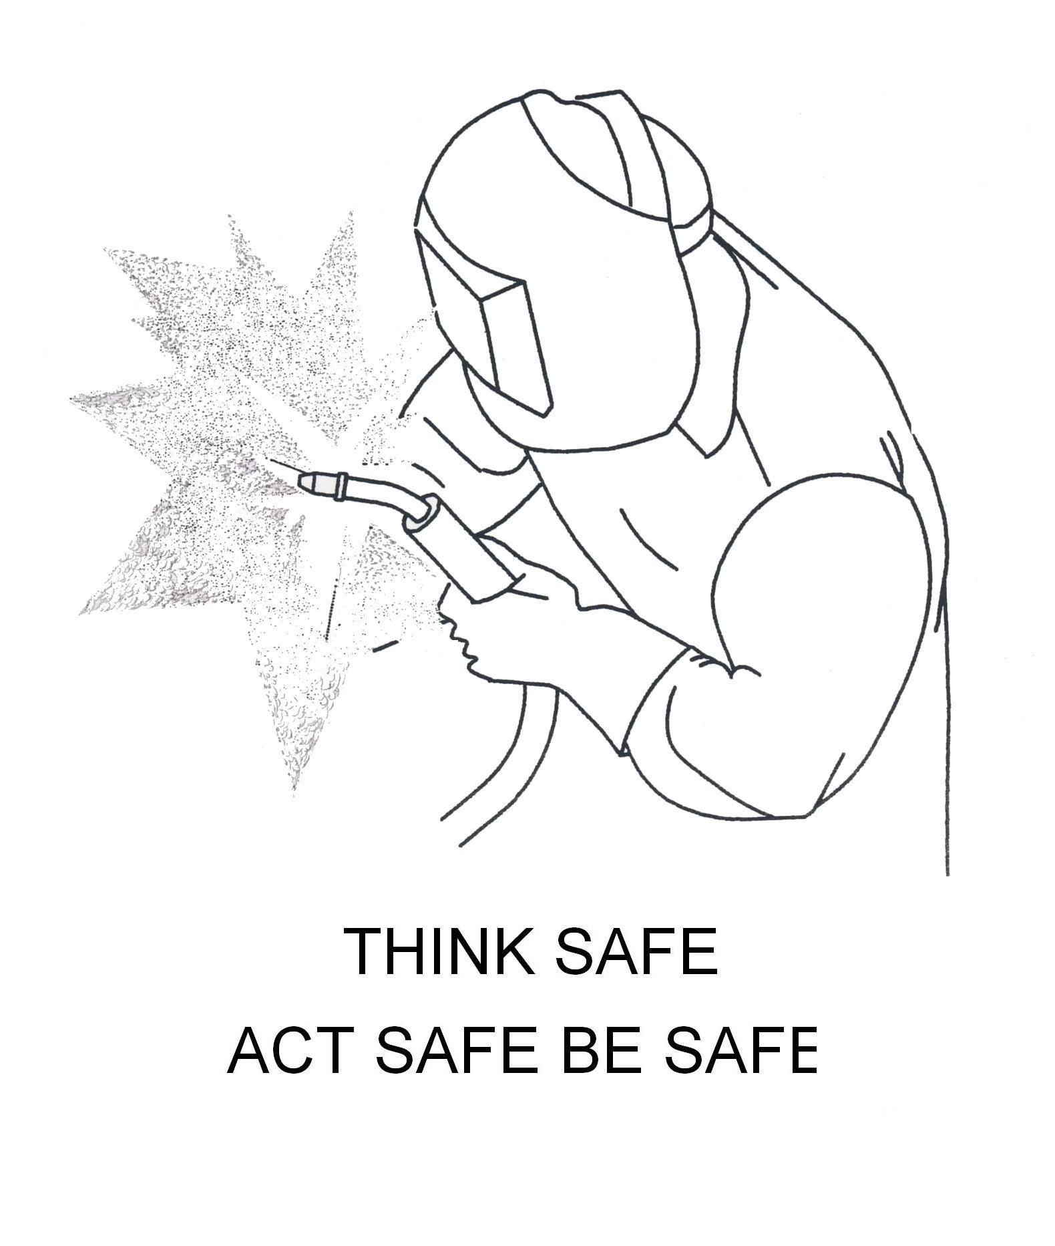
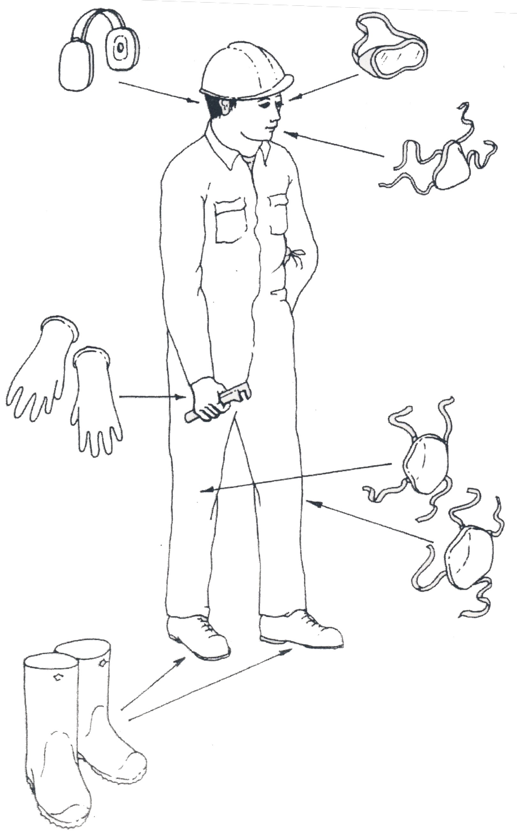
Figure 3.

Always use the correct and safe equipment for the job at all times when in the workshop!

5.2 Personal Protection - Protective Clothing
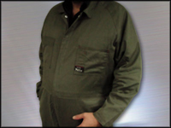

5.3 Outerwear
Always wear appropriate work clothing. Whether this is a one piece coverall/overall, or a separate shirt and pants, the clothes you work in should be comfortable enough to allow you to move without being loose enough to catch on machinery. The material must be flame retardant and strong enough that it is not easily torn. A flap must cover buttons or press-studs. If you wear a long sleeve shirt, the cuffs must be close fitting, without being tight. Pants should be cuff-less so that hot debris doesn’t become trapped.
Care of clothing
Always wash your work clothes separately from your day-to-day clothes. Start a new working day with clean clothes and change out of contaminated clothing as soon as possible. It is a good idea to keep a spare set of work clothes in the workshop in case some toxic flammable or corrosive fluid is spilt on the ones you are wearing.

WARNING
You are not to commence work without fireproof workshop overalls being fitted first; you are required to wear them at all times when on the workshop floor.

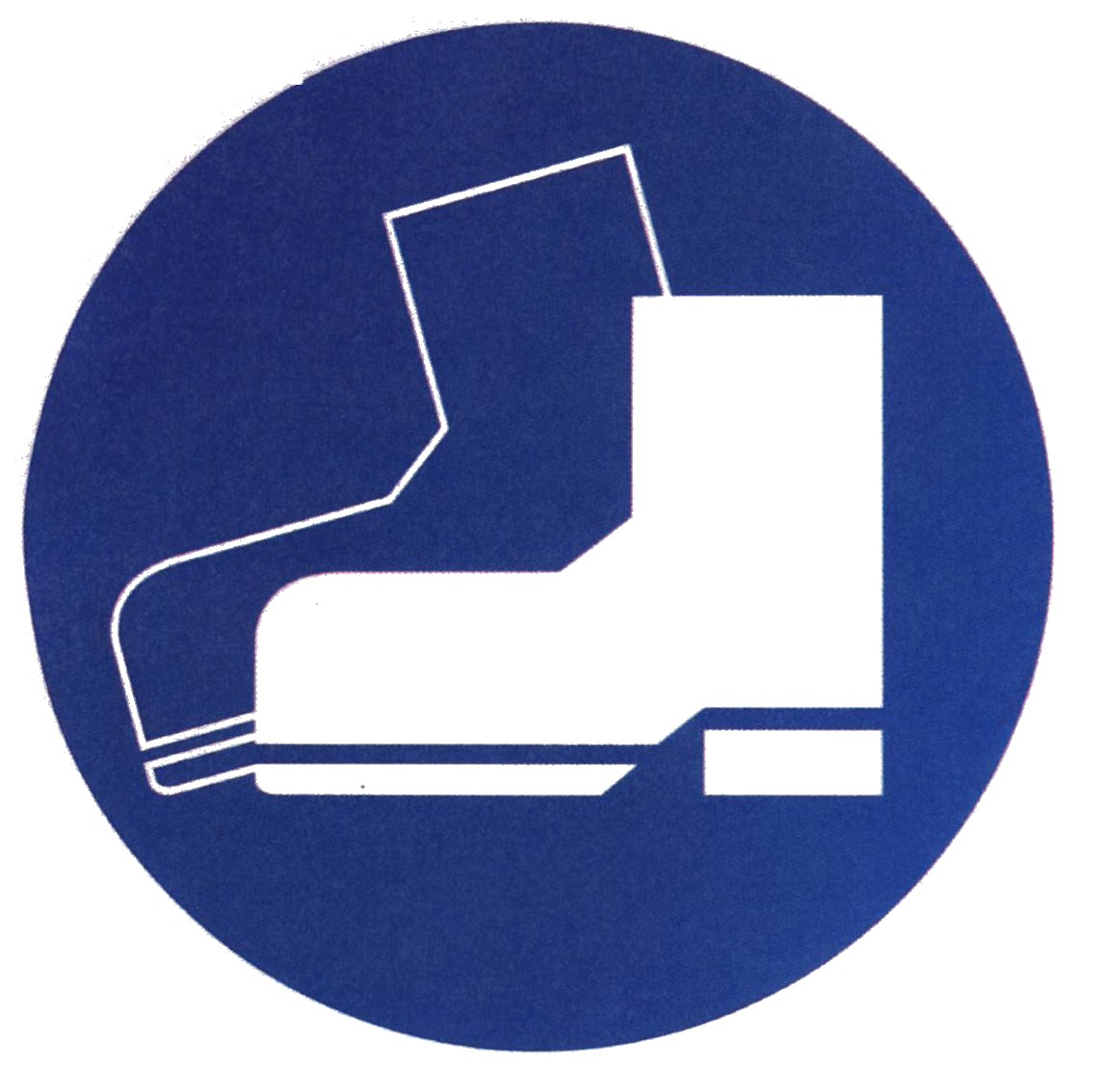
5.4 Safety Boots
Industrial safety footwear must be worn at all times in the workshop.

Footwear


Always wear safety shoes that comply with the relevant standards for your area. The soles must be acid and slip resistant, the uppers made from a puncture proof material such as leather and the toes protected by a steel cap. Industrial safety shoes must be worn at all times in the workshop.
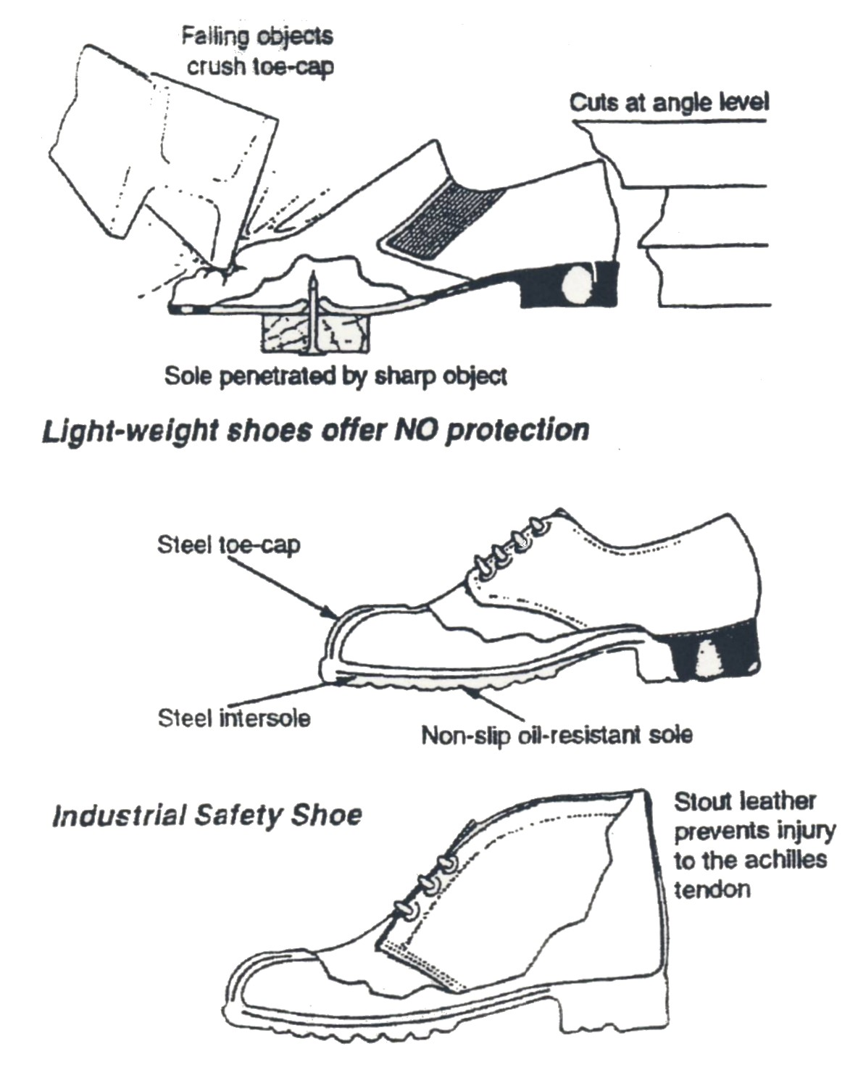

Figure 4.
5.5 Headgear

It is also good practice to wear a cap to hold longer hair in place and to keep it clean when working under a vehicle.


5.6 Hand Protection

Wherever possible wear gloves to protect your hands. There are many types of gloves available and their applications vary greatly.
Chemical gloves


Heavy-duty impervious gloves should always be worn when using solvents and cleaners. They should also be worn when working on a battery. They should extend up to the middle of your forearm to reduce the risk of liquid spilling into them when your hands are immersed. Some chemical gloves are also slightly heat resistant. They are suitable for use when removing radiator caps and mixing coolant.

Leather gloves
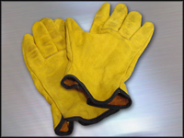
These will protect your hands from burns when welding and heating or handling hot components. You should also use them when removing steel from a storage rack and when handling sharp objects.
Rubber gloves

Light duty rubber and plastic gloves should be used to protect your hands from exposure to greases and oils.

General-purpose cloth gloves

Wear these in cold temperatures, particularly during winter so that cold tools do not stick to your skin.

Barrier cream
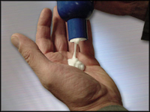
This prevents chemical being absorbed into your skin and should be applied to your hands before you commence work. Even the slightest exposure to some chemicals can lead to dermatitis, a painful skin irritation.

Cleaning your hands


When cleaning your hands use only specialized hand cleaners, which protect your skin, not solvents such as gasoline or kerosene as they remove the natural oils.
5.7 Eye Protection

Auto Darkening Welding Mask
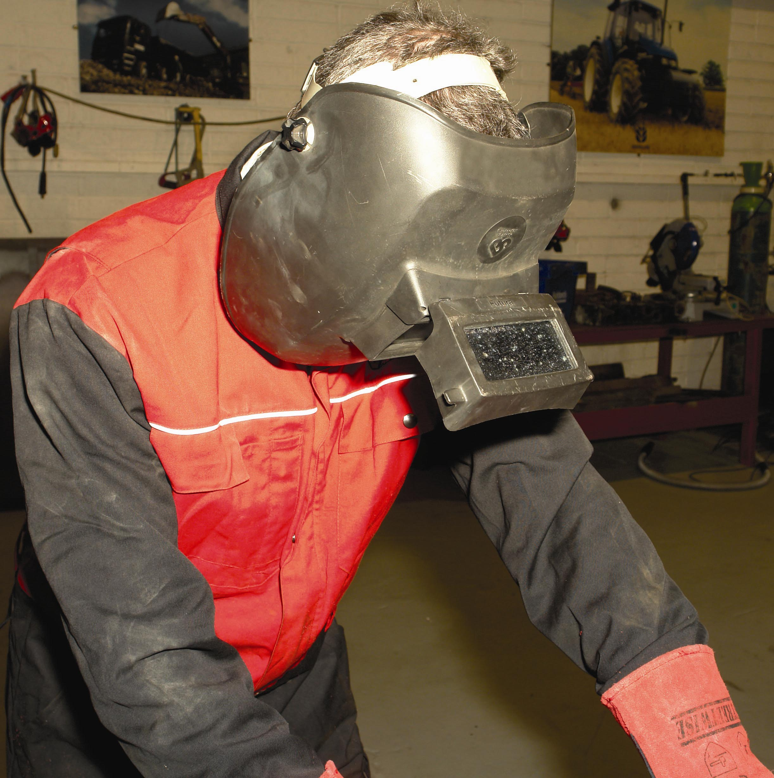
- Always read the instructions before use.
- This helmet is not designed for laser or laser cutting or gas welding.
- Designed to protect your eyes and face from sparks, splatter and harmful IR and UV radiation.
- Will not protect you from explosive devices or corrosive liquids.
- Never operate this helmet without lens cover properly installed.
- Keep front lens cover and light sensors clean for proper operation.
- Replace auto darkening lens if it is cracked, scratched or pitted to avoid serious personal injury.
- Use only replacement parts specified in this manual.

Welding with the Auto Darkening Welding Mask
- Will automatically change from a light state (shade No.4) to a dark state (No. 9, 10, 11, 12, 13) when the arc welding starts.
- The lens automatically returns to a light state when the arc stops.
- Infinite shade adjustments can be made between 9 and 13 whilst welding.
- Match your welding application to the shade indicated on the shade chart.
- This helmet is good for MIG, TIG, SMAW, Plasma Arc and Air Carbon Arc cutting.
- Increased welding productivity and quality because hands are free at all times.
- Protection from harmful UV and IR radiation at all times, in darkened or clear state.
- The lens contains two sensors to detect the light from the welding arc and darken the lens
Gas welding goggles

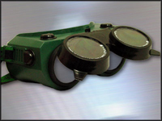

Gas welding goggles can be worn instead of a welding mask when using, or assisting a person using, an oxyacetylene welder. The eyepieces are heavily tinted, but not as much as those in an electric welding mask, allowing you to see the welding task. There is no ultraviolet radiation from an oxy/acetylene flame, so the full-face shield is not required.
Welding mask
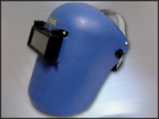

Wear a welding mask when using, or assisting a person using, an electric welder. The light from a welding arc is very bright and contains high levels of ultraviolet radiation. For this reason the viewing aperture has heavily tinted glass, to reduce the intensity of the light from the welding tip, so you can see what you are doing and the remainder of the mask is made from a durable material that blocks any other light from reaching your face.
Safety glasses


The most common is a pair of safety glasses. It is good practice to wear these whenever you are in a workshop. They are designed to protect your eyes from direct impact or debris damage. The only time they should be removed is when you are using other eye protection equipment. Prescription safety glasses are also available.

Full face shield

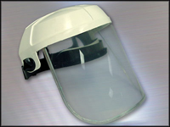

When using solvents and cleaners, epoxies and resins, or when working on a battery, it is necessary to use a full-face shield. The clear mask allows you to see all that you are doing, but will protect your whole face from chemical burns should there be any splashes or battery explosions. You should also use a full-face shield combined with safety goggles when using a bench or angle grinder.

Safety goggles
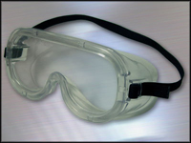
Safety goggles provide much the same eye protection as safety glasses but with the added protection from any harmful gas that may find its way behind the lenses. Safety goggles must be worn when servicing air conditioning systems or any other system that contains pressurized gas

5.8 Ear Protection
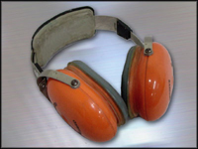


Ear Protection should be worn once sound levels exceed 85 dB, when working around operating machinery for any period of time or when the equipment you or others nearby are using produces loud noise.
If you have to shout at a person two feet away from you in order to be heard, then the sound level is about 85 decibels.
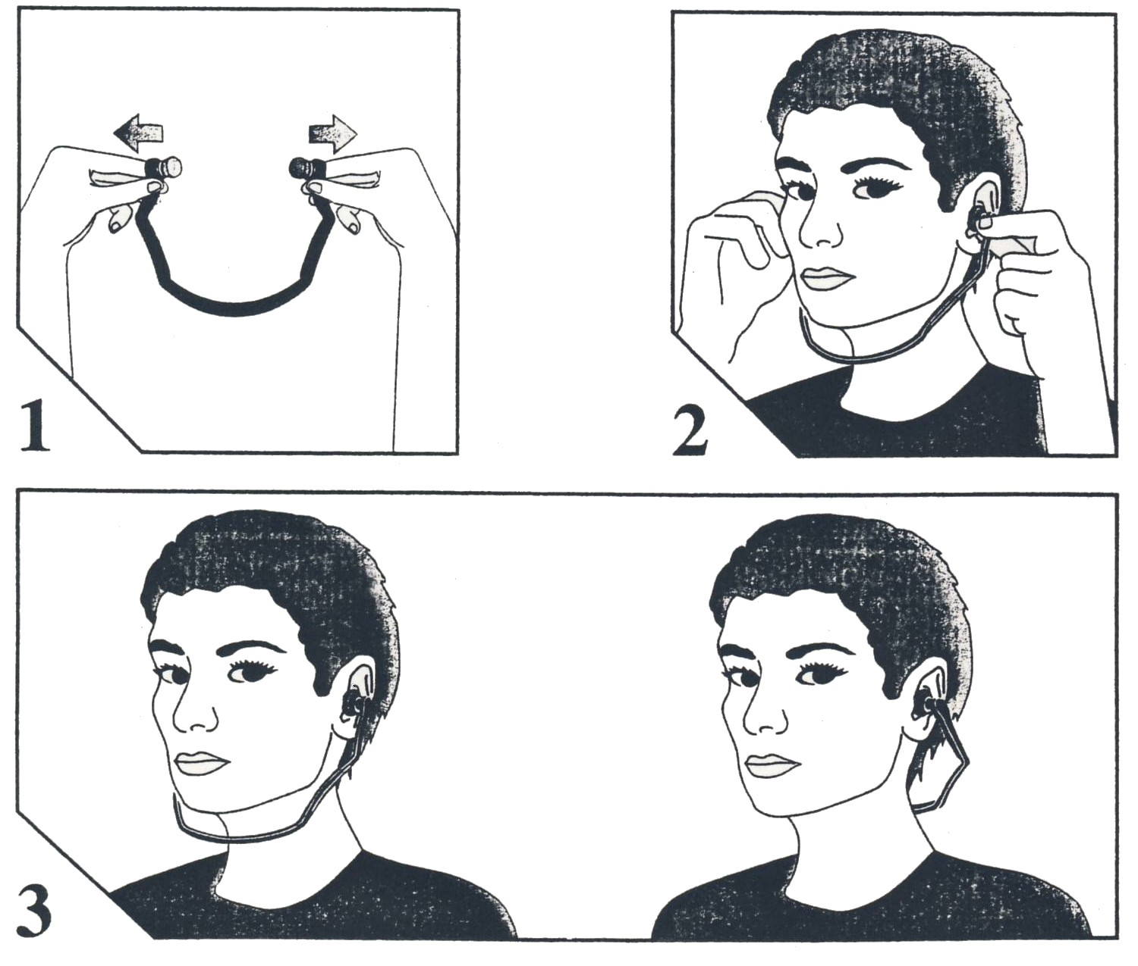
Ear protection comes in two forms, one type covers the entire outer ear and the other is fitted into the ear canal. Both types perform the same task and it is a matter of personal preference as to which is the most suitable for you.
Figure 5.
Breathing Devices

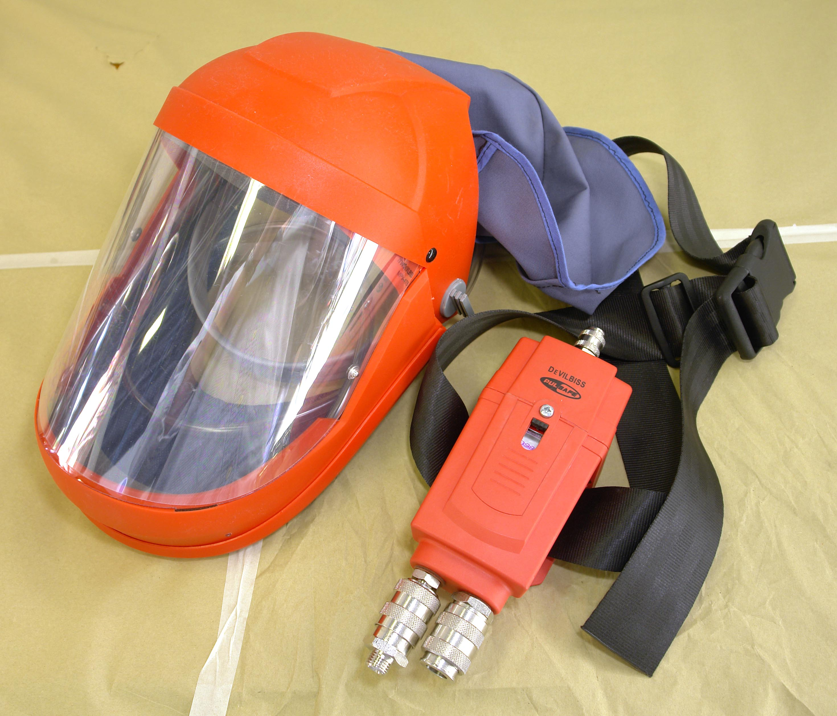

Always wear an Air Fed Respirator when applying spray paint.

When working in an environment where dust is present or where the task you are performing will produce dust you should always wear some form of breathing device.
There are two types, disposable dust mask & respirator.
Disposable dust mask

A disposable dust mask is made from paper with a wire reinforced edge that is held to your face with an elastic strip. It covers your mouth and nose, and is disposed of at the completion of the task.

Respirator
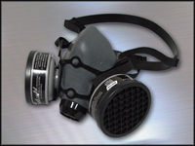

The respirator has removable cartridges that can be changed according to the type of contaminant they are to filter. The cartridges should be replaced periodically to ensure their effectiveness. Refer to manufactures guidelines.

7.0 Self-Assessment
Questions: Module 1. Unit 2

Give the meaning of each of the following safety signs

1.

2.

3.

4.
5.
6.

7.
List 7 pieces of PPE – Personal Protection Equipment.

8.
What must be worn before work begins in the VBR Workshop.

9.
State the Fire Drill if you discover a Fire.

10.
Where do you assemble in the event of a Fire?

11.
How would you find the First Aid Person?

12.
What do you do in the event of an Accident?

Answers to Questions 1-12. Module 1. Unit 2
1.
This indicates a potentially hazardous situation if not avoided may result in minor or moderate injury.

2.
Eye protection must be worn.
3.
Foot protection must be worn.
4.
Hand protection must be worn.
5.
Ear protection must be worn.

6.
Respirators must be worn.
7.
Boots overalls gloves, glasses, ear muffs, respirator and hand protection must be worn.
8.
Personal Protection Equipment.
9.
Sound alarm, call the instructor, evacuate and count co. workers.
10.
Designated assembly point.

11.
Ask an instructor or dial the main switchboard.
12.
Call first aid person and inform the instructor.

27-33 Upper Baggot Street
Dublin 4

