TRADE OF
VEHICLE BODY REPAIR

PHASE 2

Module 2

UNIT: 3

Shrinking
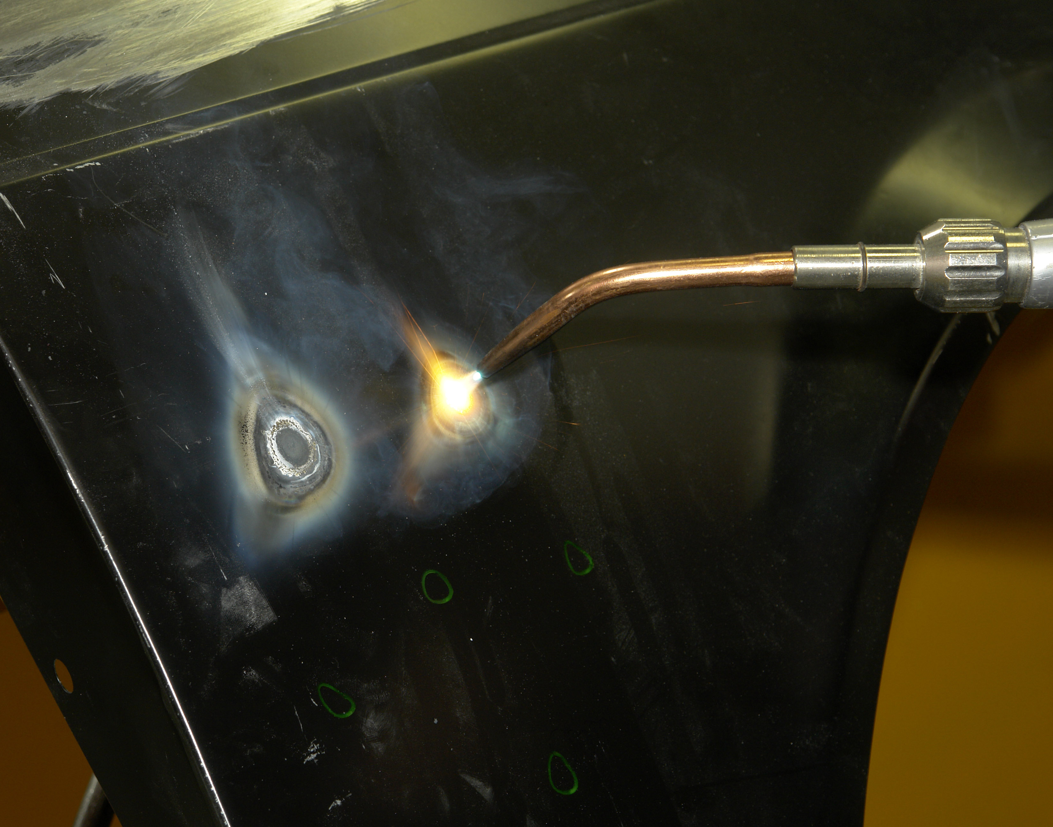

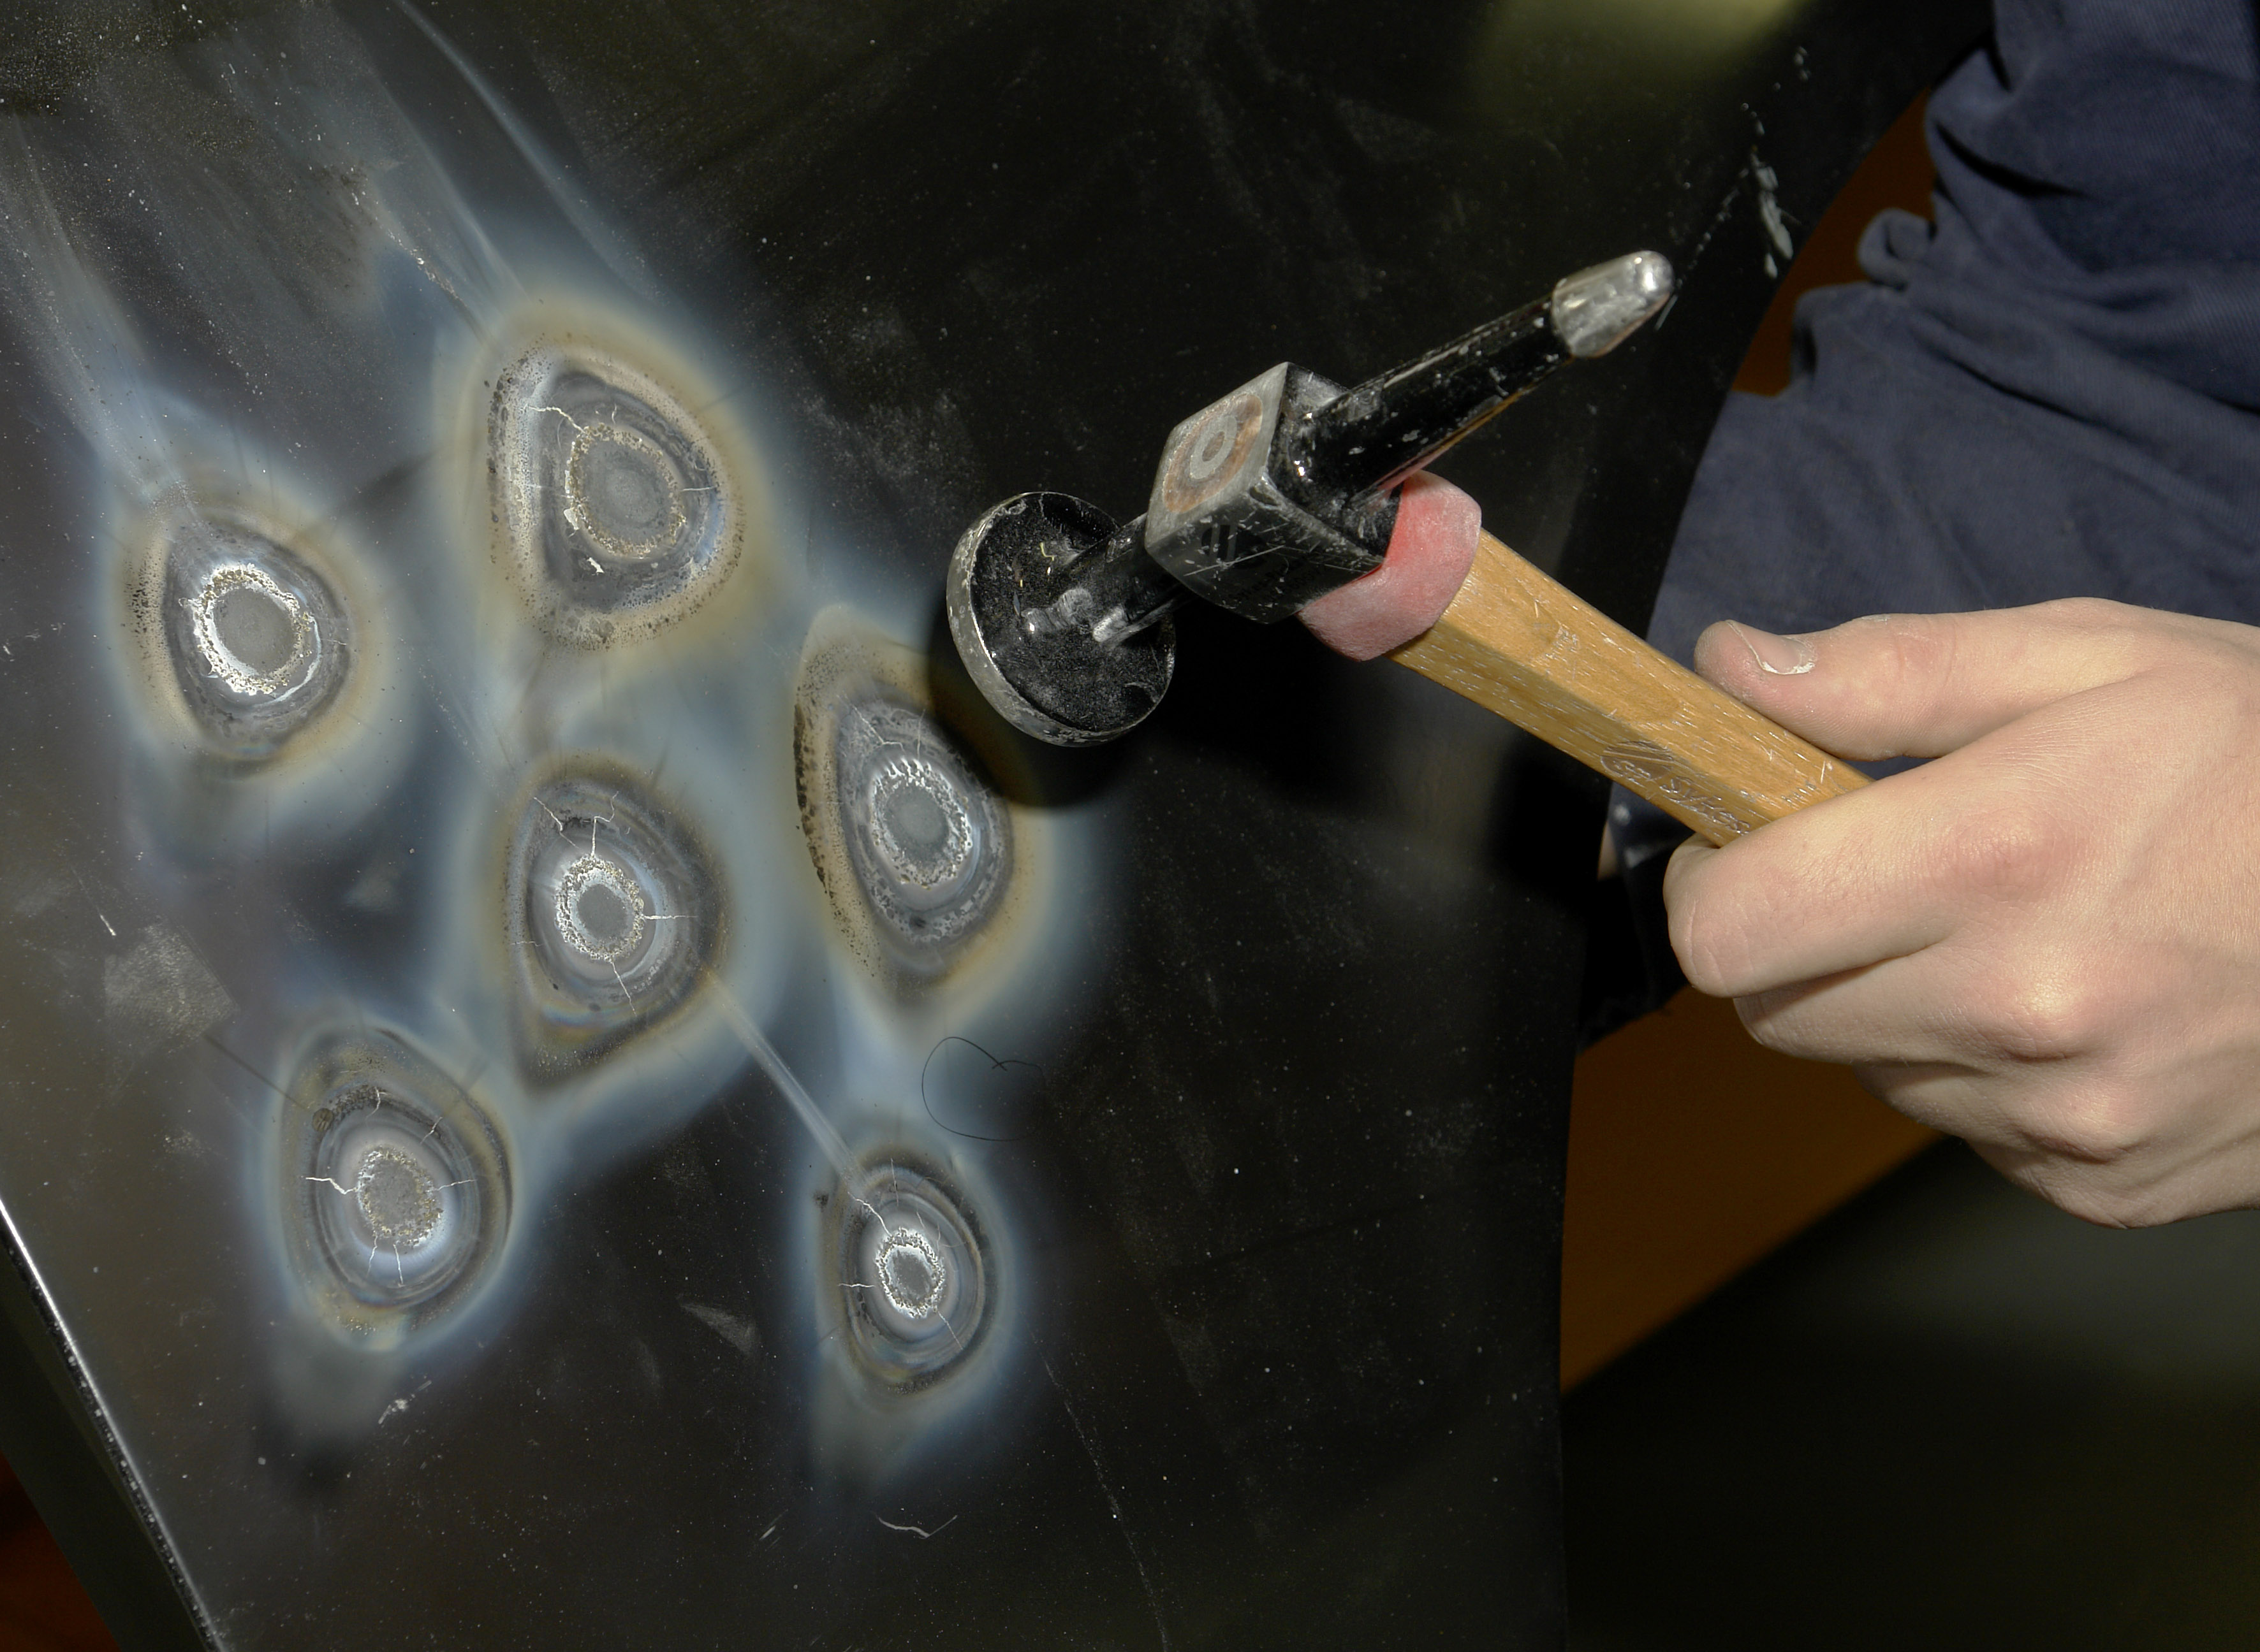

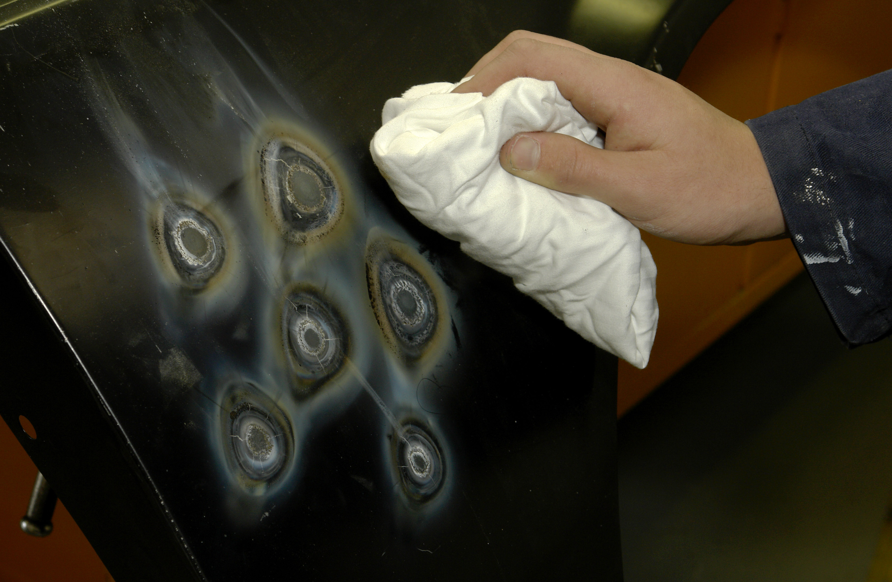

Produced by

In cooperation with subject matter expert:
Maurice Stack
Some material courtesy of CDX Global and
FENC – Further Education National Consortium.
© SOLAS 2014

© Foras Áiseanna Saothair 2006

Table of Content
Introduction 1
Shrinking 1
Unit Objective 2

Shrinking 2
1.0 Methods to Determine Limit of Damage 3
2.0 Shrinking Equipment 4
2.1 Tools used for Hot Shrinking 4
2.2 Control of Distortion 4
3.0 The Technique of Hot Shrinking 8
4.0 Shrinking Panels using Single and Multiple Shrinks 10
4.1 Hot Shrinking Technique 10
4.2 Shrinking Aluminium 11
4.3 Cold Shrinking Technique 11
5.0 To Set up Gas Heating Equipment 13
6.0 To Repair a Panel after it has been Shrunk 13
7.0 Thermal Processes 13
Summary 14
Self Assessment 15
Suggested Exercise – Shrinking
Training Resources

Table of Figures
Figure 1: Suitable Shrinking Equipment 5
Figure 2: Planning Shrink Pattern 7
Figure 3: Planning Shrink Pattern 7

Introduction
Shrinking
One of the most important skills in the repair of damaged panels is that of hot shrinking. It is important because in most cases of collision which cause the damage to body panels, stretching of the metal beyond its elastic limit takes place. The actual process is carried out by gathering the stretched metal into a common centre or area and then by heating this section. The panel steel is then at its best condition to be hammered down, thus reducing the surface area and so making shrinking possible. The oxy-acetylene flame is used as a means of heating the panel and care must be taken to reduce the spread of the heat to the surrounding area of the panel. This can be done by cooling the panel with water after every shrink. The advisable welding nozzle size when using a 1.00mm panel is a number 2 nozzle.
The tools required for the hot shrinking are:
Wire brush and scraper:
Used to prepare metal prior to shrinking, the scraper is used to remove anti drum pads.
Mallet or shrinking hammer:
The mallet is made from wood and has a larger face than the planishing hammer. It is used in conjunction with a dolly. The shrinking hammer is similar in size to the planishing hammer but with a serrated face and is used to complete the shrink after malleting.
See page 18 Module 2 Unit 1.

Unit Objective:
Shrinking
By the end of this unit each apprentice will be able to:
- Determine the extent of damage
- Identify stretched areas on damaged panels
- Select suitable shrinking equipment
- Set up gas heating equipment
- Plan a pattern of shrinks
- Shrink panels using single and multiple shrinks
- Repair a panel after it has been shrunk
- Apply post repair anti-corrosion treatments
- Determine the hardness of the panel post shrinking

Key Learning Points:
- Methods to determine limit of damage
- Planning shrink pattern
- Hot shrinking technique
- Cold shrinking technique
- Tools used for cold shrinking
- Tools used for hot shrinking
- Thermal processes
- Resistance projection shrinking
- Control of distortion
- Shrinking equipment

1.0 Methods to Determine Limit of Damage
When replacing panels some slightly stretched areas of metal may be encountered. The repairer, determines the exact location, size and shape of the area by ‘hand-feeling’ (running the palm of the hand over the surface), by ‘eye’ or in the case of a large flat area, such as a door panel, by the use of a straight edge. To increase sensitivity when ‘hand-feeling’ a light weight cotton glove could be used to ‘feel’ the panel. On a paint finished car body a spray of light oil and a strong light source can be used to show slight irregularities in the surface. Once the stretched area is located the treatment will depend on the amount of stretch involved.
2.0 Shrinking Equipment
2.1 Tools used for Hot Shrinking
Before commencing to heat up the stretched section, it is essential that all tools and material needed to carry out the shrink are conveniently placed so that they can be brought into use quickly. The tools required are as follows:
Wire Brush: The wire brush and scraper are used in preparing the panel prior to shrinking. With the scraper any anti-drum or underseal compound must be removed before applying the heat.
Mallet or Shrinking Hammer: The mallet face has a soft surface much larger than that of a planishing hammer. If used together with a suitable dolly block it will bring the metal down to a level surface whilst hot and also avoid stretching the panel as the mallet is made of wood and not metal like the panel hammer. Another tool that can be used is the shrinking hammer; this is similar to a planishing hammer but the faces have cross-milled serrations, which reduce the tendency for the hammer to stretch the metal because of the very small contact area between the points on the serrations and the panel.
Planishing Hammer: This should be used to complete the shrink after malleting, as the hammer is better for levelling out the surface of the panel than the mallet.
Dolly Block: This should not be fuller in shape than the actual panel being repaired. Also it should be of a rather light weight so that it forms a relatively weak backing for the malleting, thus reducing the stretching during the levelling operation. A grid dolly has a serrated face to reduce the possibility of stretching in the panel.

2.2 Control of Distortion
Damp Cloth: This is helpful in checking the spread of heat, thus reducing the risk of panel distortion.

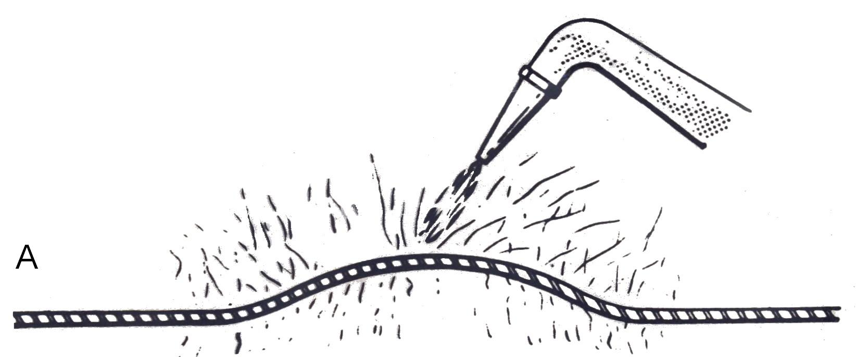
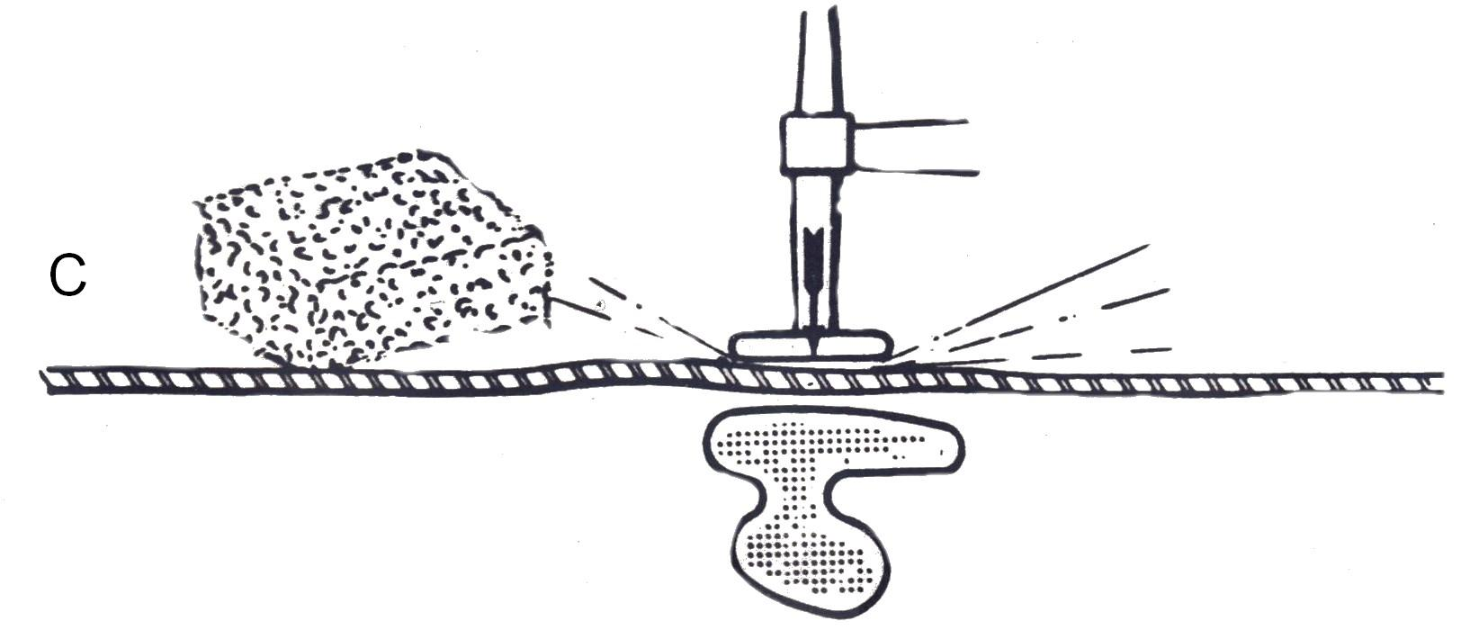
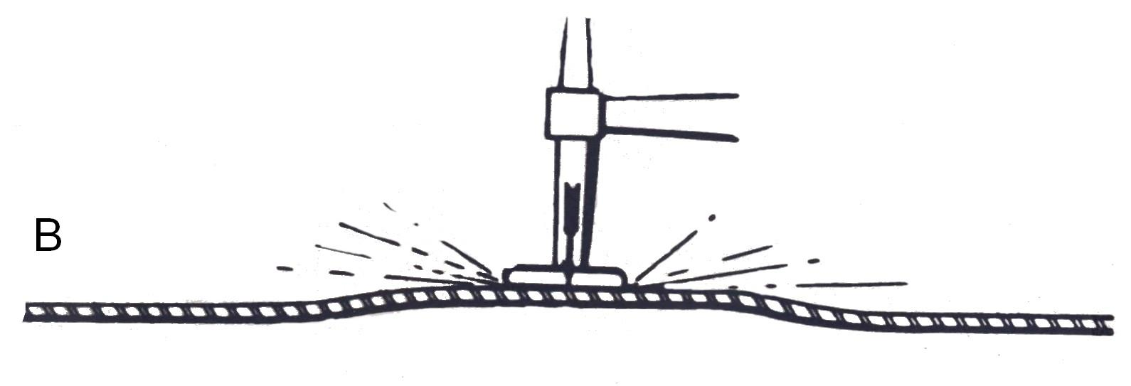

Figure 1: Suitable Shrinking Equipment
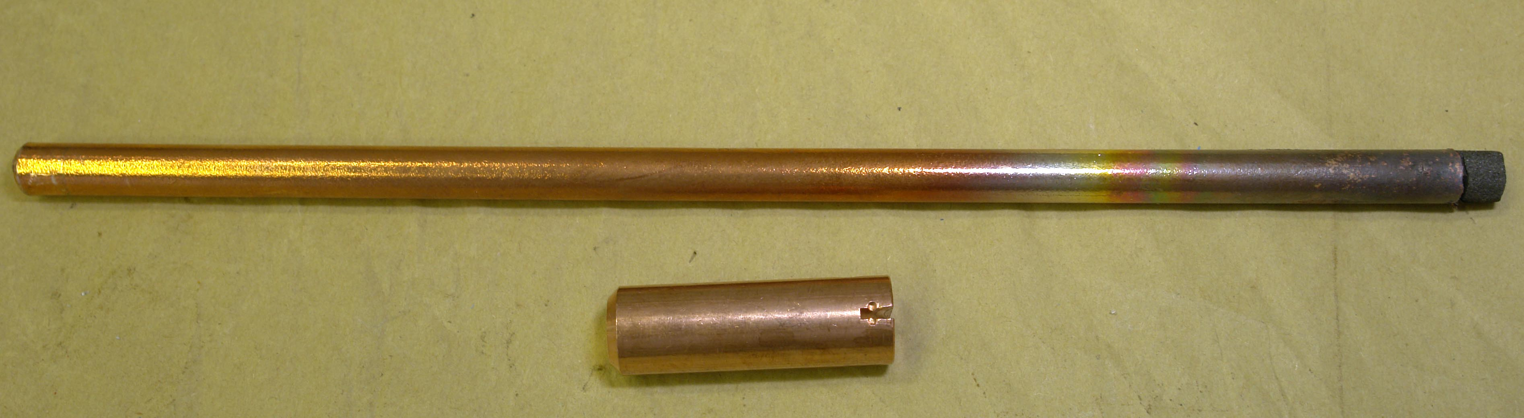
D

A - Oxy Acetylene Torch
B - Dolly Hammer
C - Dolly/Sponge/Hammer
D - Copper/Carbon

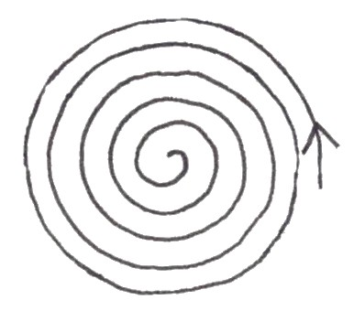
Start of Shrink

Shrinking pattern starts on the outside of area to be shrunk and worked to the centre in a circular motion.
Shrinking can also be carried out using shrinking equipment, which can be either a specialised piece of equipment or an attachment to a MIG welder. Basically the equipment consists of a power source to which two cables are attached; one is to the shrinking torch fitted with a tungsten or carbon electrode (which is interchangeable) and the other is to the earth return clamp for completing the circuit.
To use the equipment, first position the earth clamp, making sure of a good connection. Switch on the power source, which in some cases has a built-in timer and then apply the tip of the electrode to the highest point on the surface of the stretched panel to be shrunk. The resulting arc will produce an extreme concentration of heat to the small area on the panel surface.
Heat until bright red or the preset time, then immediately cool with water. This high concentration of heat in one area together with rapid cooling is extremely effective in reducing high spots by heat shrinking in vehicle repair.

Planning Shrink Pattern
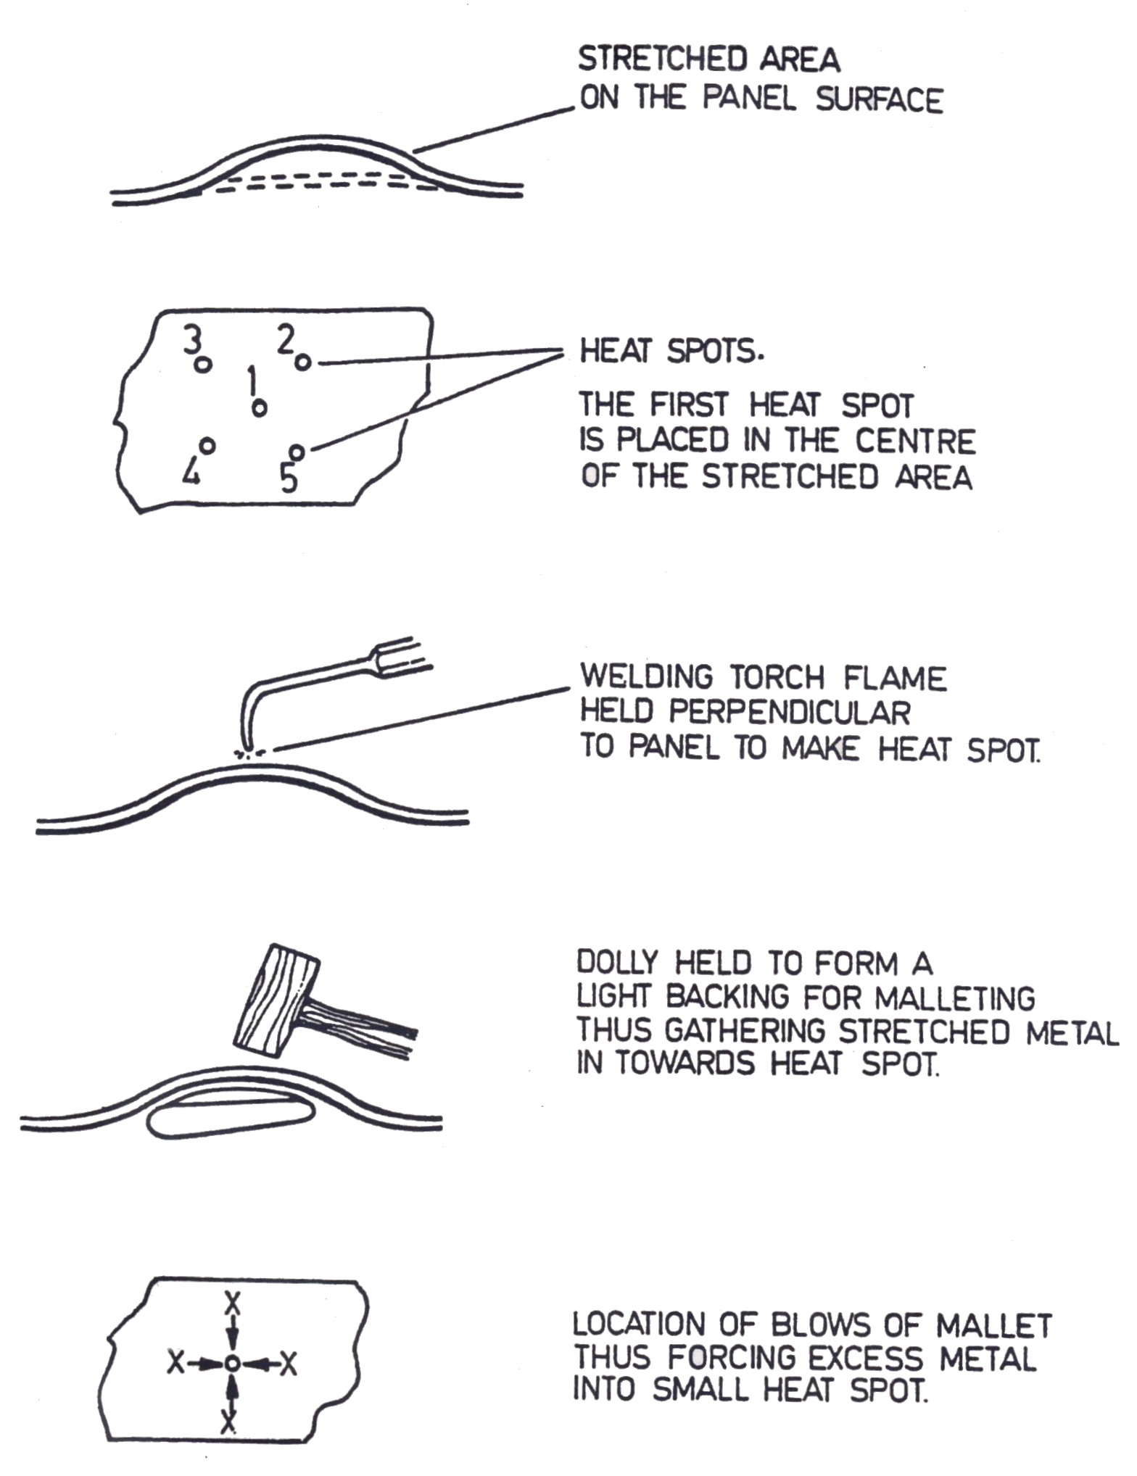
Figure 2: Planning Shrink Pattern
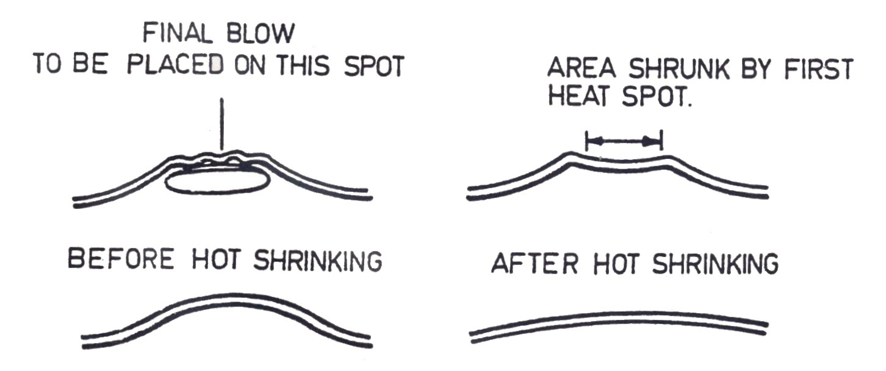

Figure 3: Planning Shrink Pattern
3.0 The Technique of Hot Shrinking
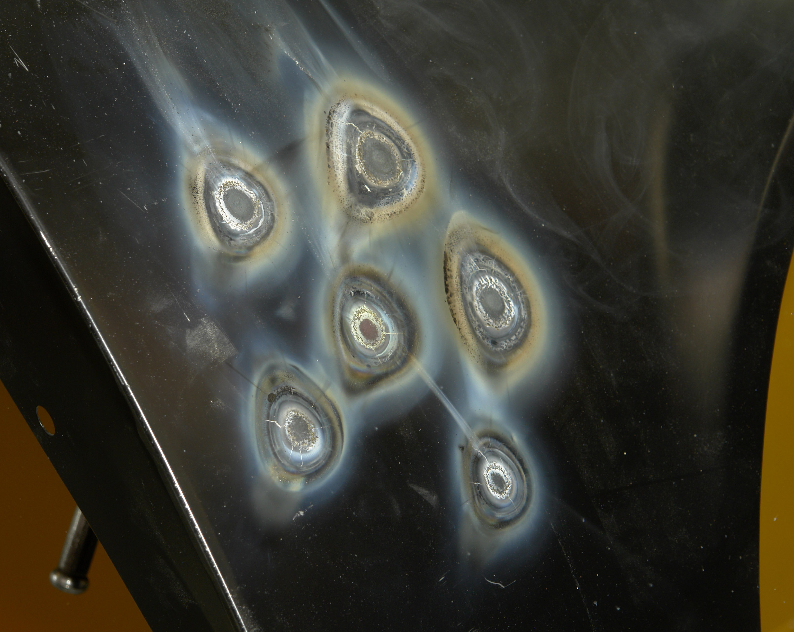

Heat Spots
The first heat spot is placed in the centre of the stretched area

Welding torch flame held perpendicular to panel to make a heat spot.

Dolly held to form a light backing for malleting thus gathering stretched metal in towards heat spot.

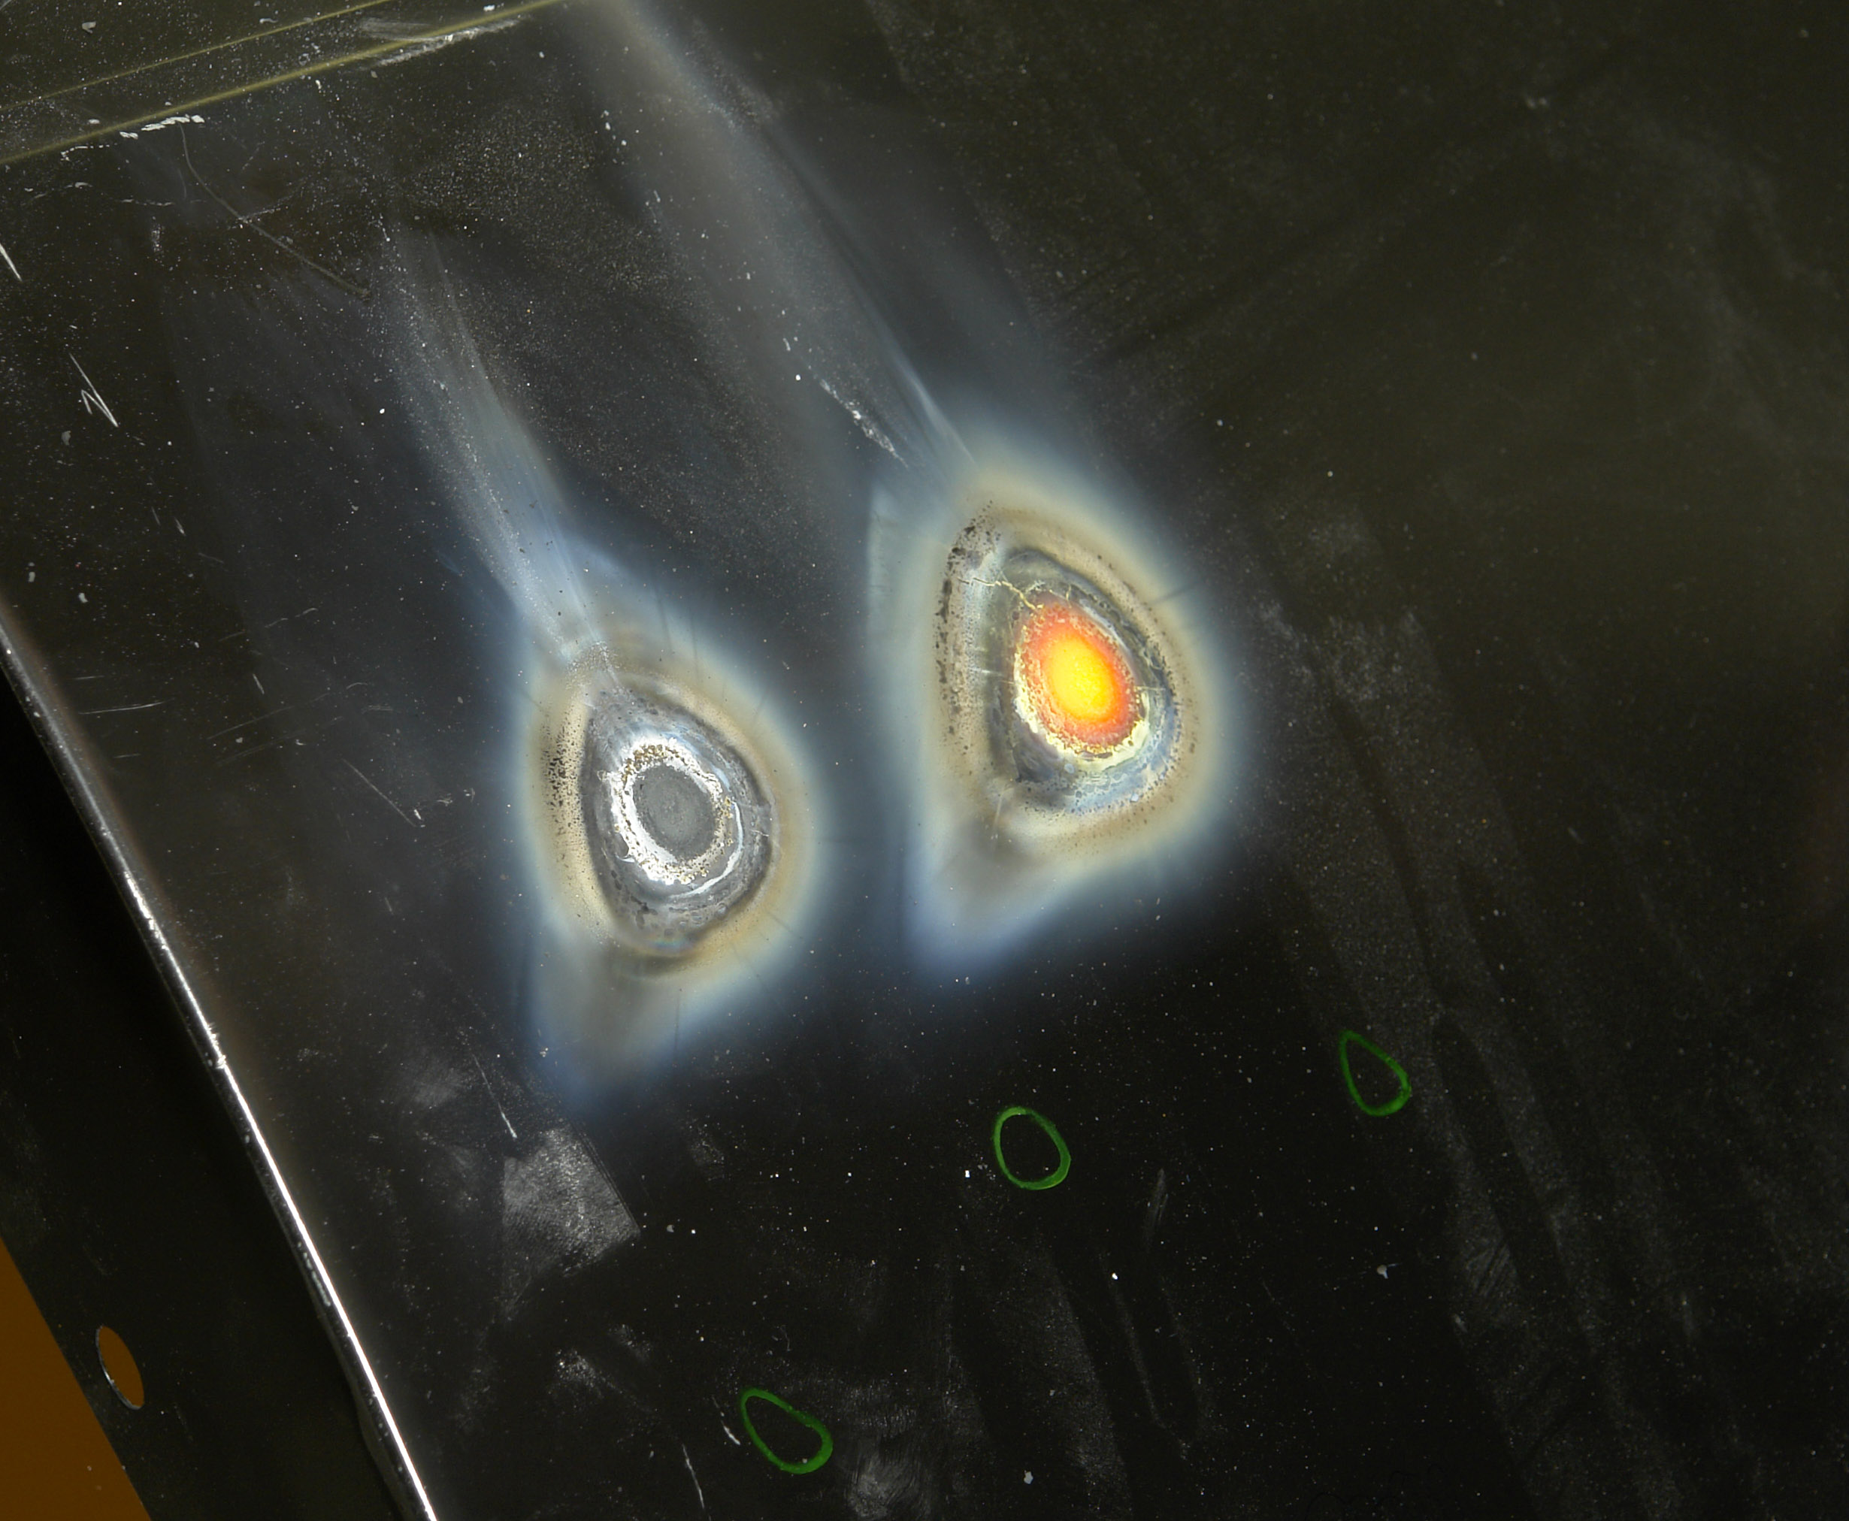

Never over heat a heat spot
Only heat to cherry red
The centre of this spot in the picture is overheated

Never quench a red hot heat spot; wait until the metal has turned black.
Never heat an area greater than that which can be hammered with mallet and dolly.

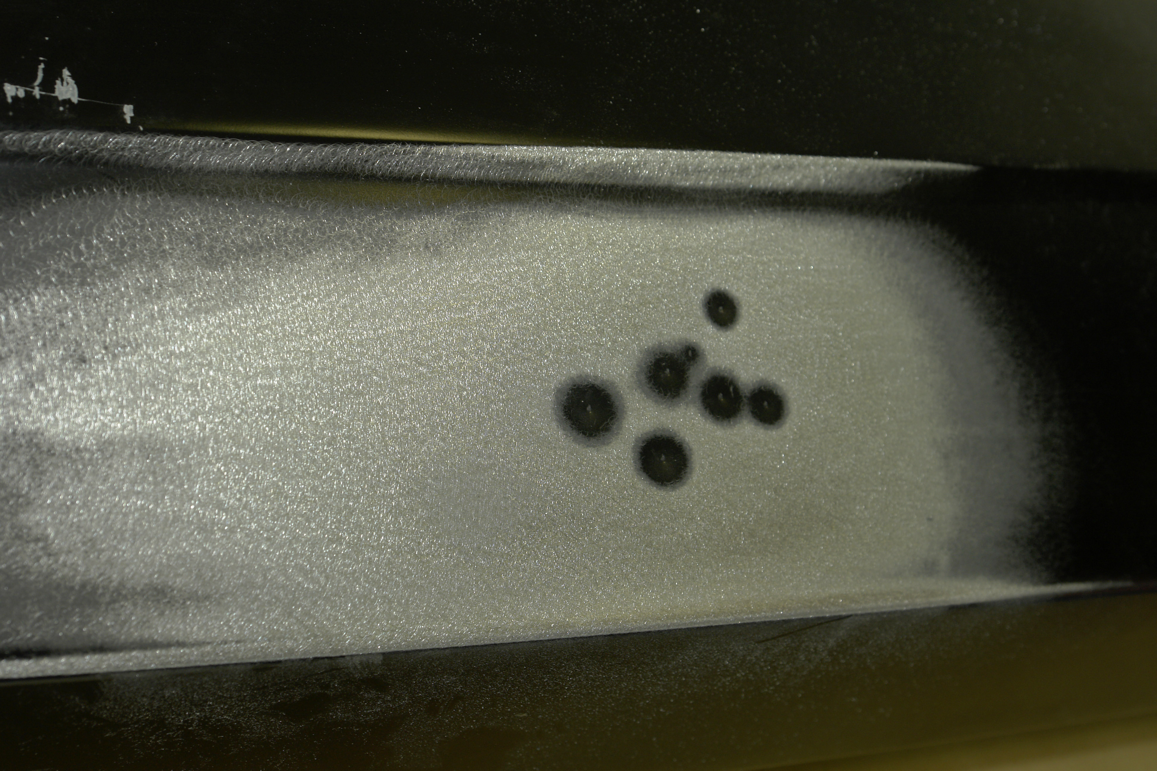

Original contour restored after hot shrinking.
4.0 Shrinking of Panels using Single and Multiple Shrinks
4.1 Hot Shrinking Technique
Arrange your tools so that they are within easy reach, as it is necessary to change quickly from one tool to another when performing a shrinking operation. Locate the highest point in the stretched section of the panel with which you are working. Light the torch and heat the spot to approximately 10mm diameter in the centre of the high spot or stretched area to a cherry red, using a circular motion when heating the spot. Be careful not to burn through the metal by overheating. As soon as the spot is cherry red place the shrinking dolly (grid dolly), which is usually fairly flat, under the spot and strike several sharp blows with a mallet around the heat spot; this will force the surplus stretched metal into the heat spot. Then the blows are directed on the centre of the heat spot, which pushes the metal down while it is still red hot. At all times the dolly block must be held loosely against the underside of the panel, exactly centred under the heat spot. After four or five mallet blows, the last being on the centre of the heat spot, the heat spot will turn black, and should be quenched immediately with a water filled sponge. Repeat this operation taking the next highest spot in the stretched section of the panel, until the bulge or fullness is finally shrunk down below the level of the surrounding surface. It can then be brought up to its correct level by planishing with a hammer and dolly and then finishing with a panel file.
The following points should be noted:
- Never quench a red hot heat spot; wait until the metal has turned black.
- Never heat an area greater than that which can be hammered with mallet and dolly.
- Never use anything but an oxy-acetylene welding torch for heating a stretched section.
- Never attempt to shrink a panel until it has been roughed out.
- Always hammer the stretched section outwards before applying heat.
- If the stretched part of the surface is small, make a smaller heat spot.
- It is possible to shrink metal without quenching each spot. However, the shrinking operation is much faster when each spot is quenched with water, as fewer heat spots are required if the expansion is drawn out by quenching than additional spots.
- In some panels it is possible to use a spoon for the backing tool for the hammering operation, especially on the door panels or over inner constructions.
- When performing a shrinking operation, take care to avoid over-shrinking the panel. This will cause the metal to warp and buckle both in and out of the stretched area, owing to overheating of the stretched section. If this does arise, heat a small spot in the area where the panel is buckling, apply a dolly block or spoon with enough pressure to hold the buckling section up, then allow the metal to cool. Do not use the mallet or water in this case. In extreme cases like this it may be necessary to repeat this operation in several different places in the buckled section.

4.2 Shrinking Aluminium
Sheet aluminium can, with the application of heat, be subjected to shrinking. The process is similar to that used for sheet steel except that the work should be carried out faster than when shrinking steel. This speed is essential because aluminium is a good heat conductor and the spread of heat must be prevented from distorting adjoining panels. Unlike steel, aluminium does not change colour when heated and because of the melting temperature differences, great care must be taken not to melt holes in the panel while it is being heated.
4.3 Cold Shrinking Technique
Cold shrinking is another method of repairing stretched sections on vehicle body panels. In this case a hammer and special dolly block are used in conjunction with one another. This dolly block is a shrinking dolly and is shaped like the toe dolly but has a grove running along the full length of the top face. The dolly block is placed under the high spot formed by the stretched metal of the damaged panel and the panel is hammered down into the groove with hammer or mallet to form a valley, care being taken not to make the valley any longer or deeper than is necessary to draw the stretched metal back to its original contour. The valley formed is then filled using body solder, which is filed to give a good finish. From the reverse side of the panel it will be seen that a rib has been formed, which will in effect give strength to the damaged area should this be required.
This method is also most useful in reducing welds: the weld on the face of the panel is depressed into the channel of the dolly to form a valley below the line of the face of the panel and the valley is then filled by the body soldering method.

5.0 To Set up Gas Heating Equipment
See Oxy/Acetylene Brazing Module 1 unit 2
6.0 To Repair a Panel after it has been Shrunk
See Metal Finishing Module 2 unit 2
7.0 Thermal Processes
See Oxy/Acetylene Brazing Module 1 unit 2
Summary
Always wear Personal Protection Equipment.
When a panel is damaged it is important to determine the extent of the damage and identify areas that need to be shrunk, rough out the panel then select suitable shrinking equipment. Plan a pattern of shrinks and if required shrink the damaged area with single or multiple shrinks, always keep distortion down to a minimum. Try to leave the contour of the panel as close to original as possible, when the shrinking process is finished, this reduces metal finishing and ensures a speedy repair.

Self Assessment
Questions – Module 2. Unit 3
1. Where is the first heat shrink placed in the damaged area?
2. Can a damaged panel be repaired by shrinking before it’s roughed out?
3. To what colour is a heat spot to be heated?
4. What is the purpose of quenching a panel with water?
5. Is it possible to shrink metal without quenching?

6. When resistance projection shrinking, where do you start the sequence in relation to the damaged area?
7. Why is it important not to overheat the panel?
8. Where is the final blow placed in the heat shrink?
9. What colour does aluminium change to when heat shrunk?
10. Will aluminium withstand the same temperature as metal?

Answers to Questions 1-10. Module 2. Unit 3
1.
In the centre.
2.
No
3.
Cherry red
4.
To make the process quicker with fewer shrinks.
5.
Yes, you don’t have to quench all of them.
6.
On the outside in a spiral motion towards the centre.

7.
To avoid distortion
8.
In the centre of the heat spot
9.
Does not change colour
10.
No

Suggested Exercise
Repair stretched area on given body panel to acceptable standard ready for paintwork

Exercise – Shrinking
Repair stretched area on given body panel to acceptable standard ready for paintwork.
Instructions:
- Assess by sight and touch minor damage to vehicle body panel
- Select, use correctly and safely the correct tools
- Minor damage to vehicle body panel
Tools and Materials:
- Safety Equipment
- A range of panel beating dollies, hammers and bumping files
- Oxy/Acetylene torch
- Grinders and discs
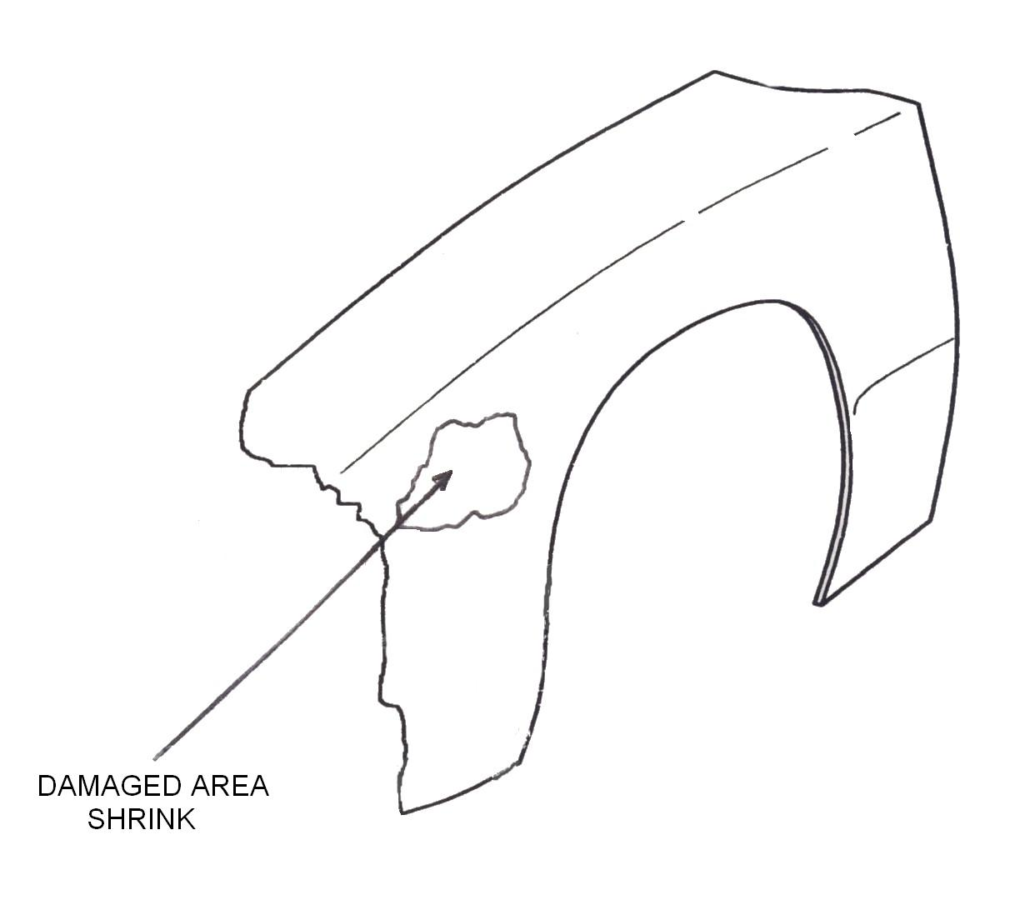
- Damaged vehicle body panel
- Personal Protection Equipment (see Induction)

Dimensions | Gen. tol. | Scale | Material
mm |  | nts
METAL FINISH
SOLAS | Phase 2. Mod 2. Practice

Standards: Re-shaping carried out with minimum distortion. Hammering techniques carried out correctly. Original contour achieved. Repairs free from file disc or burn marks.

Training Resources
- Classroom/workshop
- Safety equipment
- Hammers and wooden mallet
- Various dollies
- Body file
- Grinder and disc
- Damaged (stretched) body panel
- Oxy-acetylene welding plant
- Anti-corrosion materials

27-33 Upper Baggot Street
Dublin 4

