TRADE OF
VEHICLE BODY REPAIR

PHASE 2

Module 2

UNIT: 6

Weld Cuts and Tears
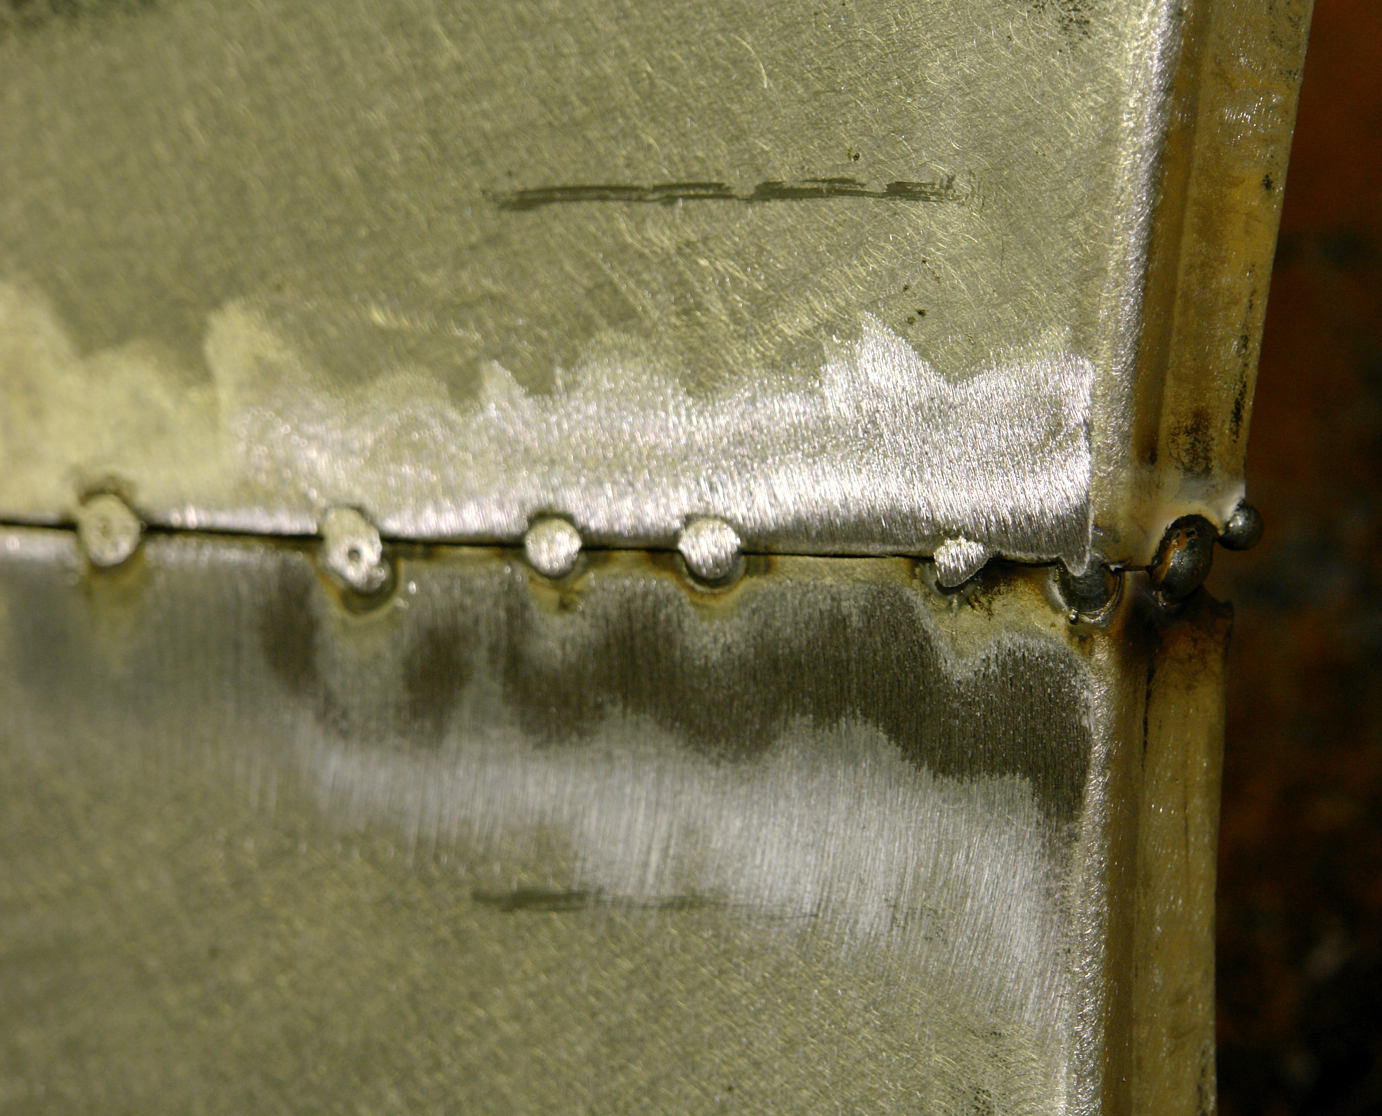
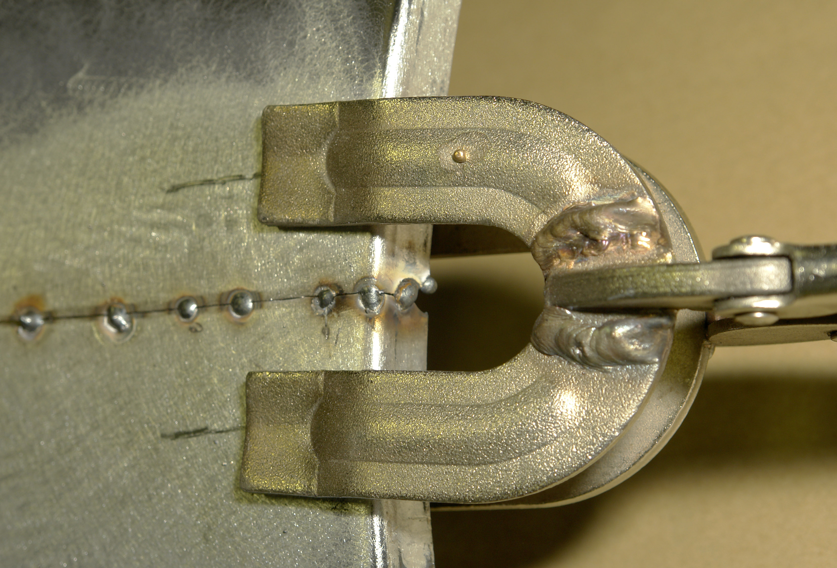

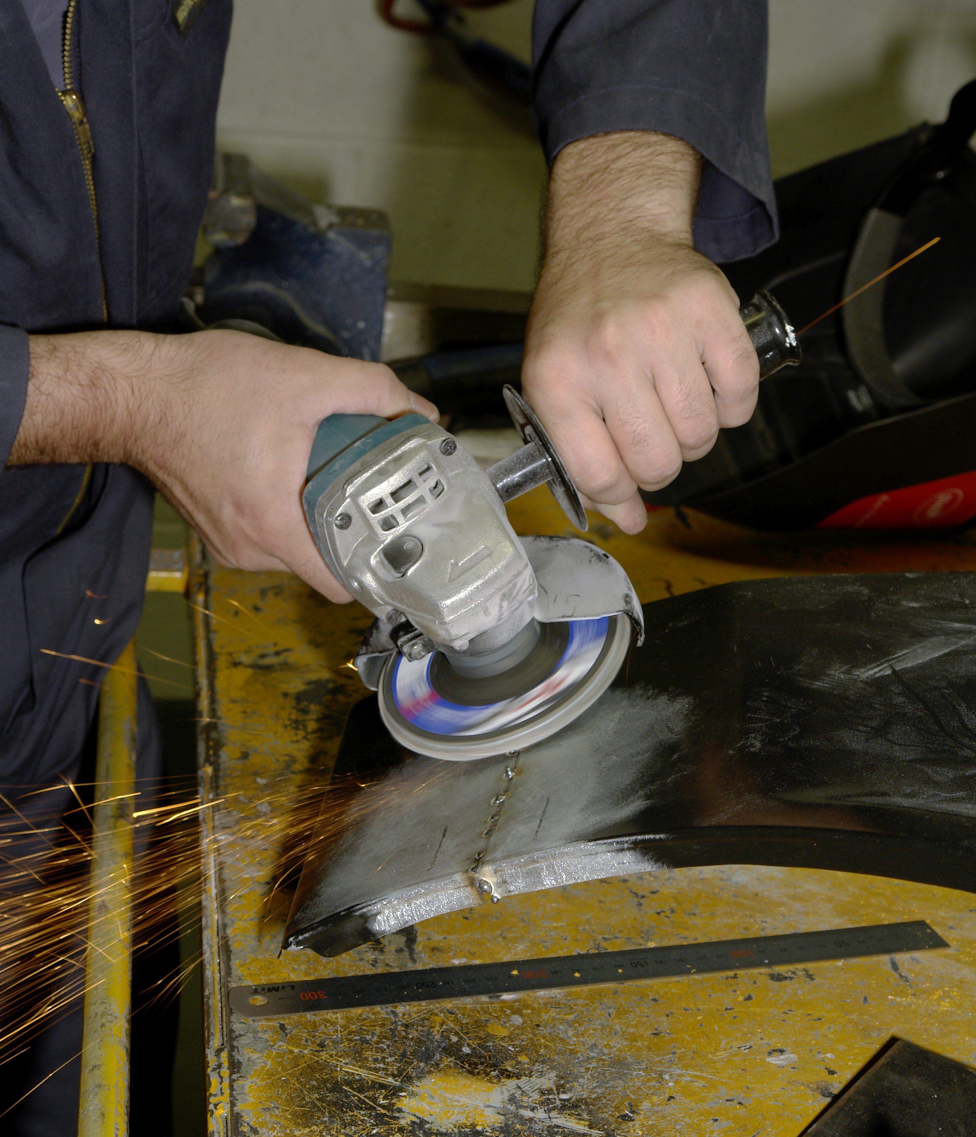

Produced by

In cooperation with subject matter expert:
Maurice Stack
Some material courtesy of CDX Global and
FENC – Further Education National Consortium.
© SOLAS 2014

Table of Contents
Introduction 1
Weld Cuts and Tears 1
Unit Objective 2

Weld Cuts and Tears 2

1.0 Realign the Edges of the Tear 3
1.1 Edge Alignment 3
1.2 Clamping 3
1.3 Prepare Substrate 3
1.4 Sharpe Edge, Hot Material Dust Particle and Fume Hazards 3
2.0 Set up the Welder for the Tacking Process 4
2.1 Welding Techniques 4
2.2 Tacking Edges and Grinding Down Tacks 4
2.3 Distortion Control 4
3.0 Welding the Tear using the M.I.G Welding Process 5
3.1 Grinding the Weld Bead 6
3.2 Body Filler/Lead Load 6
4.0 Rust Rectification 7

Summary 8
Self-Assessment 9
Suggested Exercise – Weld Cuts and Tears
Training Resources

Table of Figures
Figure 1: Grinding the Weld Bead 6
Figure 2: Rust Rectification 7
Figure 3: Traverse Distortion 7
Figure 4: Angular Distortion 7

Introduction
Weld Cuts and Tears
Welding cuts and tears are common tasks in the repair replacement of vehicle body panels. Great skill and patience is required to carry out this task, because the panels on the exterior are very thin, which are galvanised to protect them from rust. The galvanised coating evaporates when the panel is being welded and the vapours interfere with the welding process thus making it very difficult to weld.

Unit Objective:
Weld Cuts and Tears
By the end of this unit each apprentice will be able to:
- Realign the edges of the tear
- Set up the welder for the tacking process
- Tack the edges and grind down tacks
- Weld the tear using the MIG welding process
- Grind the weld bead
- Metal finish the area
- Prepare surface prior to painting process

Key Learning Points:
- Sharp edge, hot material, dust particles and fume hazards
- Edge alignment
- Repair assessment
- Distortion control
- Finish
- Clamping
- Welding techniques
- Metal finish techniques
- Body filler

1.0 Realign the Edges of the Tear
1.1 Edge Alignment
Realign the edge of panel starting with the strongest swage line.
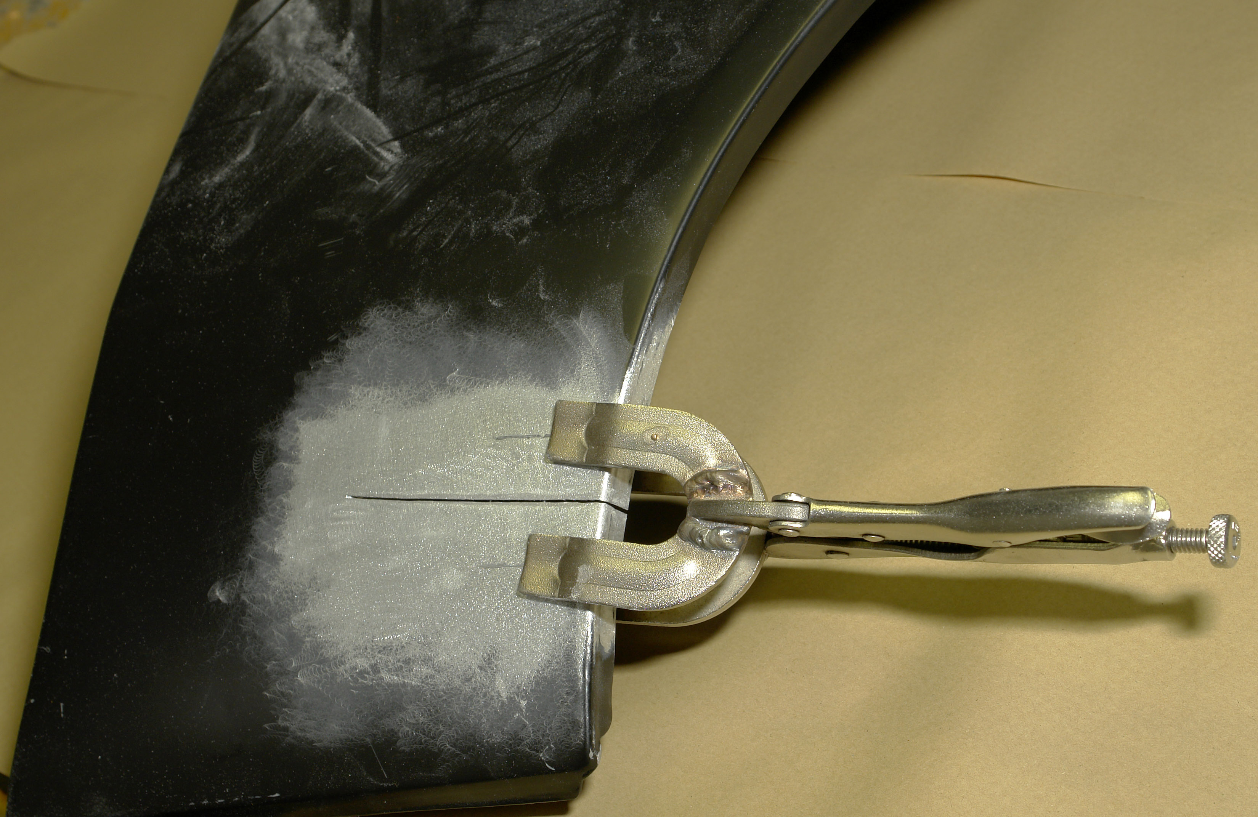
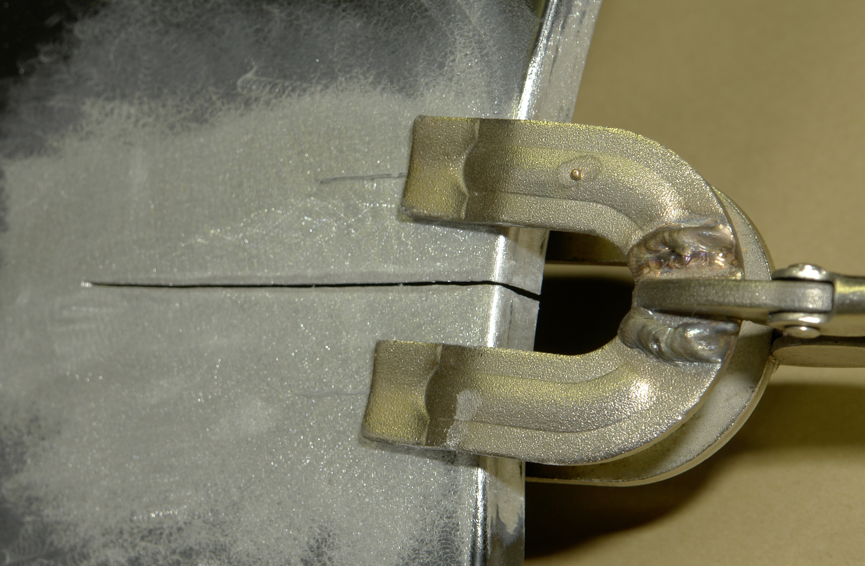

1.2 Clamping
Clamp panel with appropriate clamp to suit contour of the panel.
1.3 Prepare Substrate
Sand down the area around the cut to remove galvanised coating in preparation for welding.
Note: Both sides must be sanded.
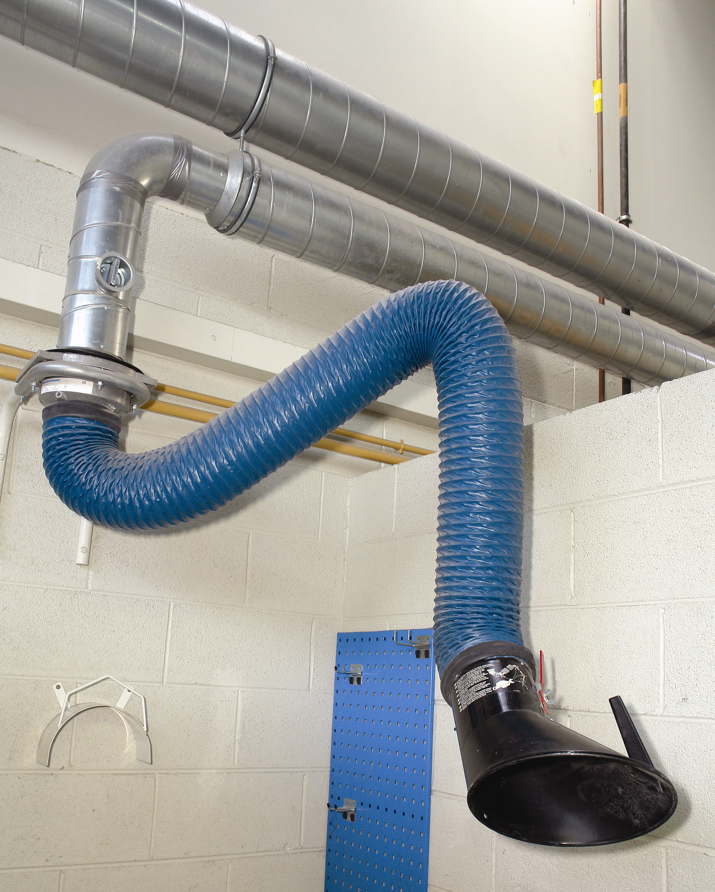
1.4 Sharpe Edge, Hot Material Dust Particles and Fume Hazards
Always use PPE and fume extraction when carrying out any type of sanding and welding.

2.0 Set up the Welder for the Tacking Process
2.1 Welding Techniques
See MIG Welding Module 1. Unit 4
2.2 Tacking Edges and Grinding Down Tacks
Tack the edges about every 15mm starting with the swage corners.

2.3 Distortion Control
Tacking the cut at equal intervals controls distortion and prevents movement during welding.

3.0 Welding the Tear using the M.I.G Welding Process
Before welding grind down the tack welds, this will give a more uniform weld bead.
Continuous weld is best because it seals the panel and moisture cannot cause the filler to separate from the substrate.

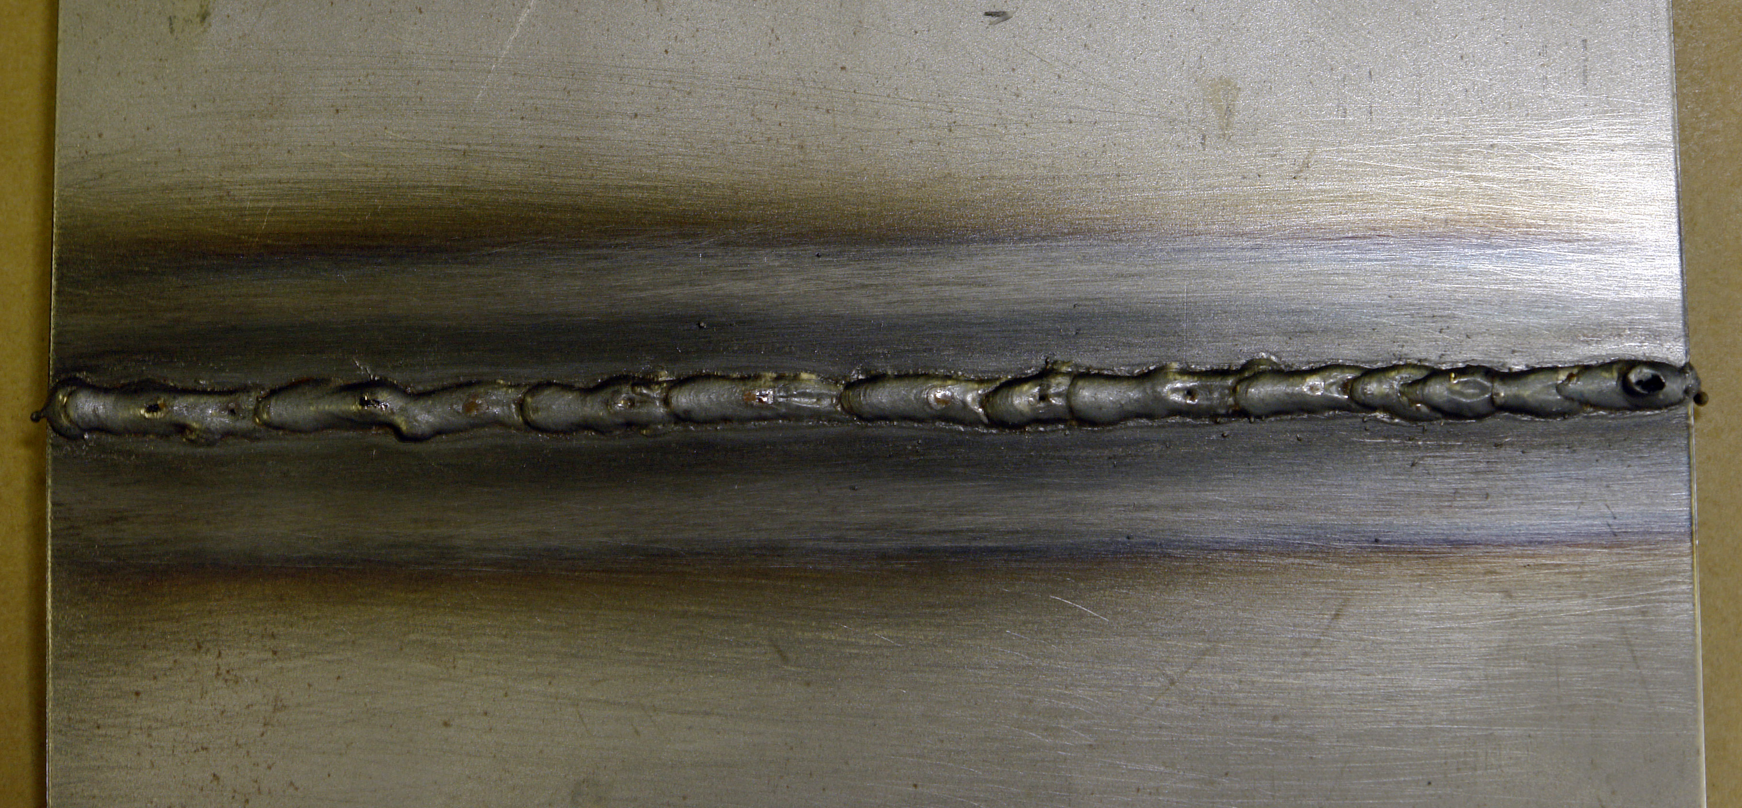
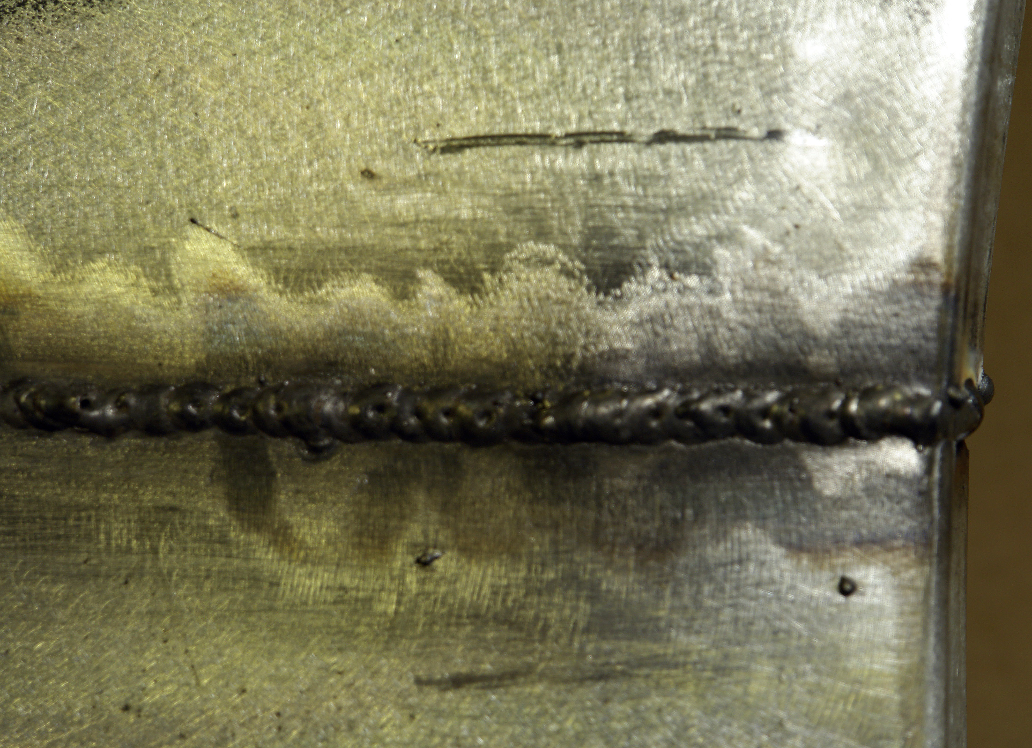
Good Penetration

Weld Bead

3.1 Grinding the Weld Bead
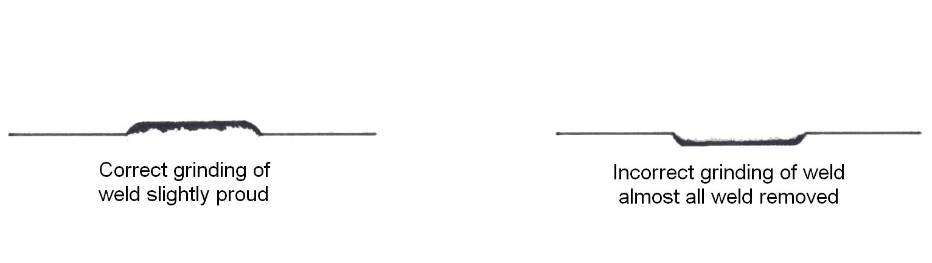
Figure 1: Grinding the Weld Bead
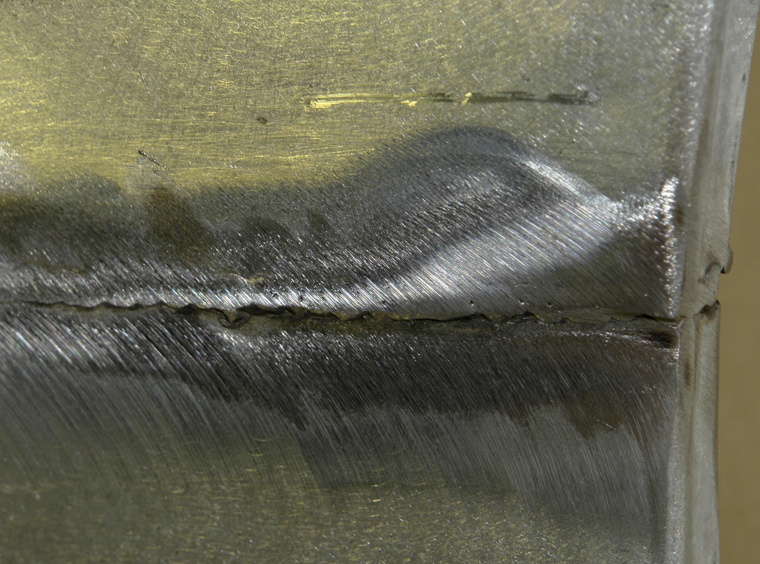

3.2 Body Filler/Lead Load
See Body Filler Mod 2. Unit 5

4.0 Rust Rectification
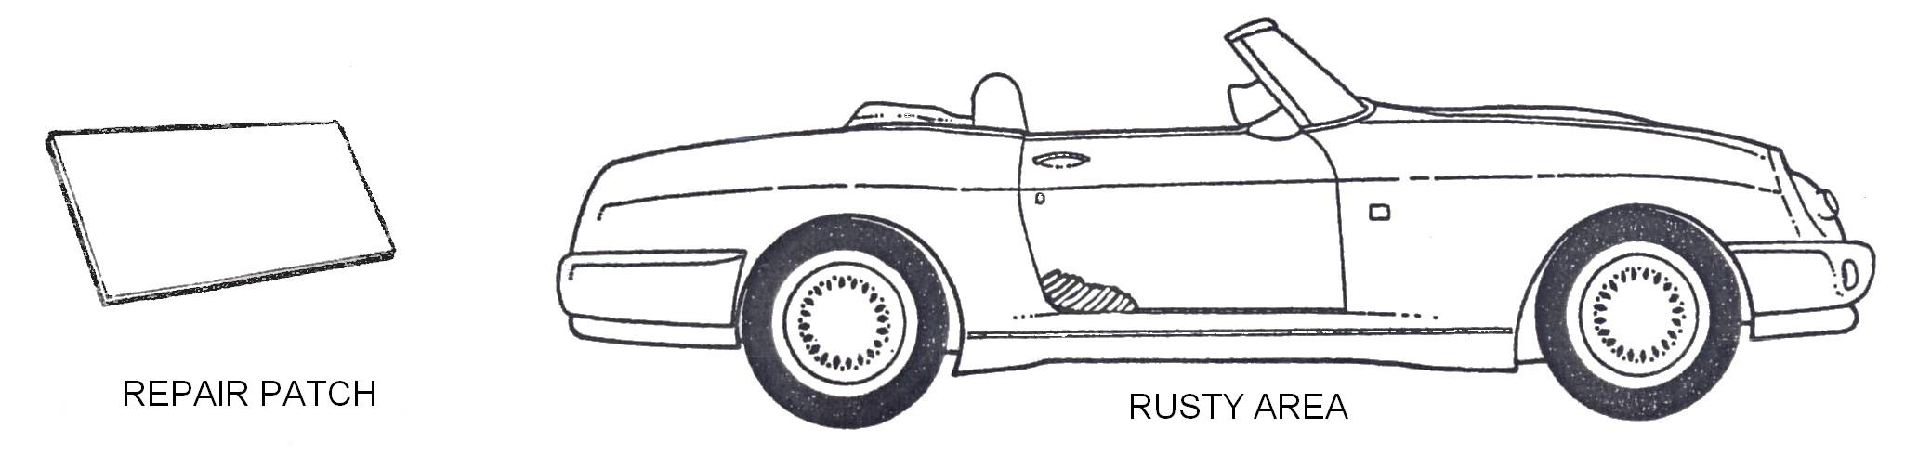
Where you find a rusty section on a vehicle always cut it out completely and weld in a piece of new metal (repair patch). The best method is edge set the panel and drop in the patch leaving about 5mm all around for welding.

Figure 2: Rust Rectification
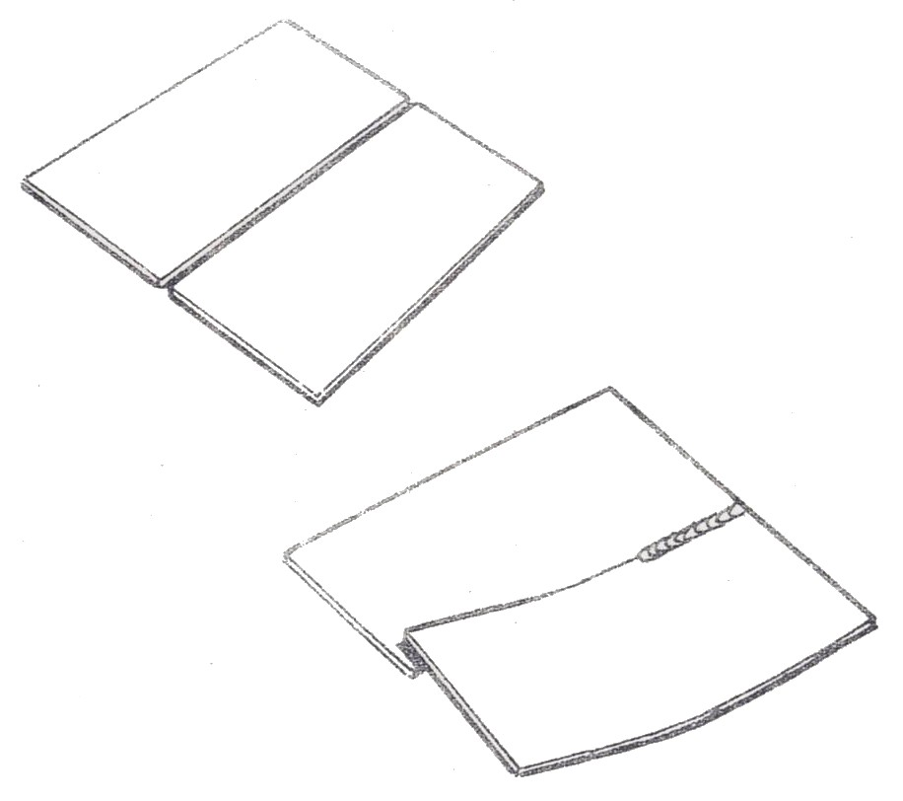
Figure 3: Traverse Distortion
When a butt weld is made between two thin plates that are free to move, the plate edges will be drawn together. The edges in advance of the weld may overlap.

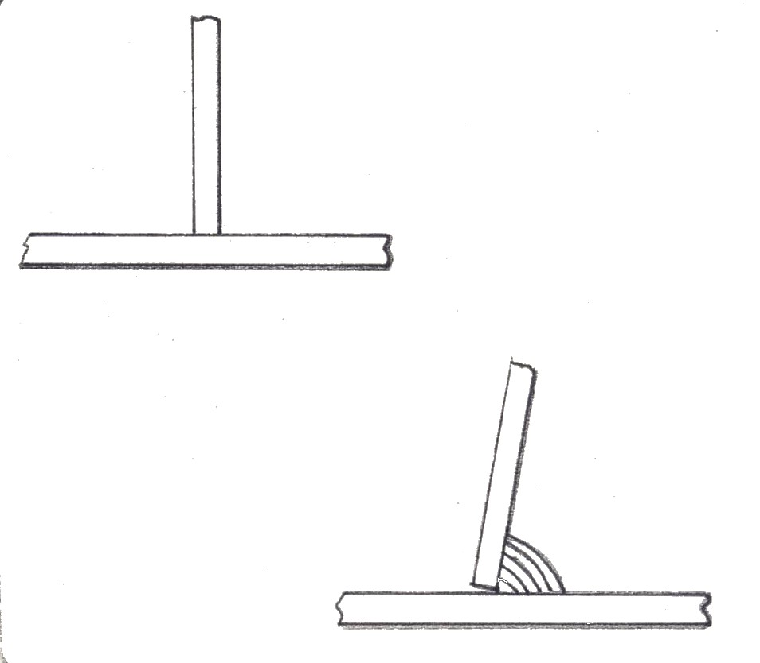
Figure 4: Angular Distortion
If a fillet weld is deposited between two plates in a T-joint, the angle between the plates will be reduced as the weld cools.

Summary
The biggest problems associated with welding cuts and tears are:
- Distortion
- Burn through
- When using a sander, do not grind into the panel surface.
- When sanding, do not work-heat the panel to the point where it turns blue or begins to warp.
- Where specified by the manufacturer, ensure that the inner surfaces of outer panels such as front and rear wings, front and rear panels, sill panels, etc. are top-coated before welding.
- It’s essential to avoid mistakes to work to the manufacturers recommendations.
- Always practice on a test piece to achieve perfection before welding car components.
- It is the requirement of health and safety regulations that all residual swarf and metal filings must be removed from the work area following the dressing operations.


Always wear a particle mask and use dust extractors on power tools!
Self-Assessment
Questions - Module 2. Unit 6

1. What safety requirements must be met when welding cuts and tears?
2. What surface preparation is required for substrate prior to welding?
3. What tools are required for alignment of panels?
4. At which pitch are tak welds to be approximately?
5. Why are tak welds ground down?

6. Why is a continuous weld preferred over tak welds?
7. When grinding what is the correct way to leave weld on the substrate?
8. Is penetration required when welding cuts and tears?
9. How is a finished weld surface prepared ready for painting?
10. What safety precaution must be met when using the grinder?

Answers to Questions 1-10. Module 2. Unit 6
1.
Wear filtered dust mask along with air dust extraction unit.
2.
Remove galvanised coating.
3.
Panel vice grips
4.
About 15mm
5.
To achieve a more uniform weld
6.
Because a continuous weld eliminates the risk of moisture entering the joint.

7.
Leave the weld proud about ½mm

8.
Yes, very important.
9.
It’s prepared by sanding down with a 40 grit flap disc, etch prime and apply plastic filler.

10.
Always use safety glasses.

Suggested Exercise
Exercise – Weld Cuts and Tears
Instructions:
- Select and name tools and materials
- Prepare damaged area of body panel
- Set up welding equipment to weld cuts and tears
- Mix and apply body filler, file and sand to correct contour of panel
Tools and Materials:
- Safety Equipment
- Grinder
- Vacuum sander
- Tool kit
- Various grades of sandpaper
- Body fillers
- Spatula
- Damaged body panel
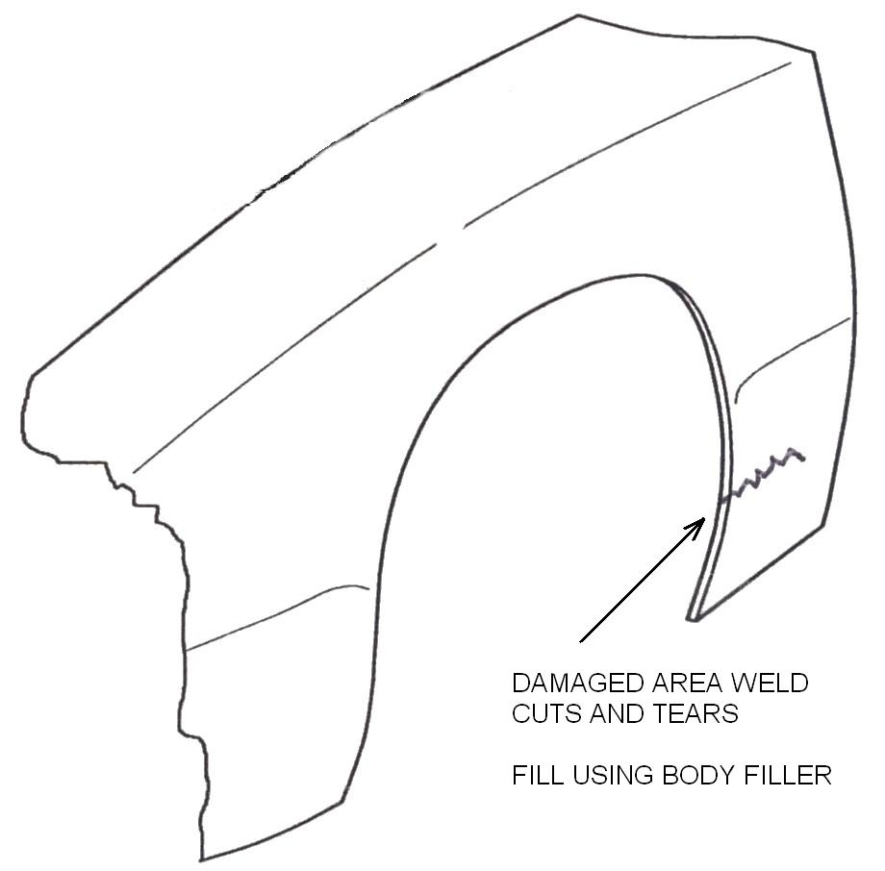
- Welding equipment

Dimensions | Gen. tol. | Scale | Material
mm |  | nts
WELD CUTS AND TEARS
SOLAS | Phase 2. Mod 2. Practice

Standards: Correct tool and material selected. Safety standards applied. Damaged area cleaned correctly. Components of body filler mixed correctly. Correct application. Correct contour achieved. No file or scratch marks or pin holes.

Training Resources
- Classroom/workshop
- Personal protection equipment
- MIG welding units
- Grinder
- Tool kit
- Welding clamp

27-33 Upper Baggot Street
Dublin 4

