TRADE OF
VEHICLE BODY REPAIR

PHASE 2

Module 3

UNIT: 4

Transport Studies

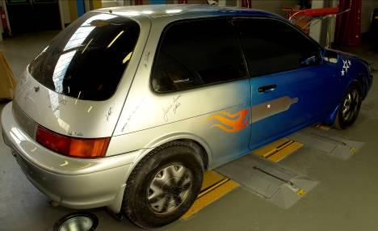

Produced by

In cooperation with subject matter expert:
Maurice Stack
Some material courtesy of CDX Global and
FENC – Further Education National Consortium.
© SOLAS 2014

Table of Contents
Introduction 1

Unit Objective 2

Transport Studies 2

1.0 Development of the Motor Car Body 3
1.1 Highlights of Motor Vehicle History 9
1.2 Terms used to Describe Early Vehicle Body Styles 10
1.3 Vehicle Classification: 12
1.4 The Evolution of Design 15
1.5 Creation of a New Design from Concept to Realization 15
1.6 Vehicle Styling 17
1.7 Safety 18
1.8 Crumple Zone 22
1.9 The Safety Cage 23
1.10 The Development and Construction of the Car Body 28
1.11 Body Engineering for Production 36
1.12 Methods of Construction 36
1.13 Basic Body Construction 44
2.0 Identification of Major Body Pressings 48
2.1 Front End Panel Operations 67
2.2 Rear End Panel Operations 72
2.3 Vehicle identification Numbers 75
Summary 76
Self Assessment 77
Training Resources

Table of Figures

Figure 1: The Austin Car 1909 to 1963 4
Figure 2: The Austin Car 1970-1987 5
Figure 3: The Austin Car 1988-1992 6
Figure 4: Vehicle Styling Forms 14
Figure 5: Automatic Seat Belt Tensioner 20
Figure 6: Crumple Zones 22
Figure 7: Crumple Zone on a Chassis 22
Figure 8: Driver’s Airbag System 24
Figure 9: Driver and Passenger Airbag System 25
Figure 10: Safety Cage 26
Figure 11: Safety Features 27
Figure 12: Scale Model Maker at Work 28
Figure 13: Full-size Clay Model 29
Figure 14: Checking Dimensional Accuracy of Full-size Model 29
Figure 15: Theoretical Drag Curves 31
Figure 16: Wind Tunnel Testing of a Prototype 33
Figure 17: Wind Tunnel Testing of a Prototype 33
Figure 18: Basic Frontal Crash and Side Impact (Angled side swipe) 34
Figure 19: Standard Frontal Impact Test 34
Figure 20: Volvo Crash Test 35
Figure 21: Road Testing a Prototype 35
Figure 22: Water Testing a Prototype 35
Figure 23: Composite Construction (conventional separate chassis) 37
Figure 24: Composite Construction Showing a Lutus Elan Chassis before fitting the Body 38
Figure 25: Complete Body Assembly of Austin Maestro 38
Figure 26: Front End Construction (a) integral or Mono and (b) Composite 39
Figure 27: Motor Body Panel Assembly using GRP: Loyus Elan 40
Figure 28: Espace High-Rise Car with Galvanized Skeletal Steel Body Shell 41
Figure 29: Espace High-Rise Car showing Composite Panel Cladding 42
Figure 30: Body Shell Variations 43
Figure 31: Body Constructional Details of Austin Rover Maestro 45
Figure 32: Major Body Panels 49
Figure 33: Body Shell Assembly 50
Figure 34: Complete Front-end Assemblies 52
Figure 35: Body Side Assembly 55
Figure 36: Main Floor and Boot Assemblies 56
Figure 37: Body Side Assemblies, Roof, BC-Post, Front and Rear Doors 57
Figure 38: Exterior Trim 62
Figure 39: Major Body panels 64
Figure 40: Major Body Panels 65
Figure 41: Front End Panel Repairs 66
Figure 42: Front Chassis Leg Section 67
Figure 43: Front Inner Wing Assembly and Reinforcement 68
Figure 44: ‘A’ Post Repair 69
Figure 45: Outer ‘B’ Post/Sill Panel Section 70
Figure 46: Rear wing Repairs 71
Figure 47: Lower Rear Panel Assembly 72
Figure 48: Boot Floor Section 73
Figure 49: Interior Trim 74
Figure 50: Vehicle Identification Numbers 75

Introduction
Transport as we know it today is very different from the late 1800 because these vehicles were like horse drawn carriages made of wood, they then evolved into all steel bodies that incorporates safety both primary and secondary.
Reliability is also much better because of advances in mechanical engineering and computer technology.
The following unit traces vehicles from 1896 to present day.

Unit Objective:
Transport Studies
By the end of this unit each apprentice will be able to:
- Outline the development of vehicles in the transport industry
- Understand career patterns in the transport industry and the education and training opportunities to be taken to achieve promotion
- Distinguish between types of transport vehicles

Key Learning Points:
- Manufacturing techniques for production cars
- Manufacturing techniques for hand-built cars
- Construction of PSU
- Construction and methods of operational of other forms of transport

1.0 Development of the Motor Car Body
Brief History
The first motor car bodies and chassis frames, made between 1896 and 1910, were similar in design to horse-drawn carriages and like the carriages were made almost entirely of wood. The frames were generally made from heavy ash, and the joints were reinforced by wrought iron brackets which were individually fitted. The panels were either cedar or Honduras mahogany about 9.5mm thick, glued, pinned or screwed to the framework. The tops, on cars which had them, were of rubberized canvas or other fabrics. Some bodies were built with closed cabs and the tops were held in place by strips of wood bent to form a solid frame. About 1921 the Weymann construction was introduced, in which the floor structure carried all the weight of the seating and the body shell, which was of very light construction, was attached to the floor unit. Each joint in the shell and between the shell and the floor was made by a pair of steel plates, one on each side of the joint and bolted through both pieces of timber, leaving a slight gap between the two pieces. The panelling was of fabric, first canvas, then a layer of wadding calico and finally a covering of leather cloth. This form of construction allowed flexibility in the framing and made a very light and quiet body frame, but the outer covering had a very short life.
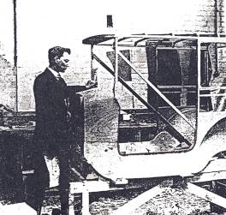
As the demand for vehicles increased it became necessary to find a quicker method of production. Up to that time steel had been shaped by hand, but it was known that metal in large sheets could be shaped using simple die tools in presses and machine presses were introduced to the steel industry to form steel sheets into body panels. Initially the sheets were not formed into complex shapes or contours, and the first bodies were very square and angular with few curves. The frame and inner construction was still for the most part made of wood. In about 1923 the first attempts were made to build all-steel bodies, but these were not satisfactory as the design principles used were similar to those which had been adopted for the timber-framed body.

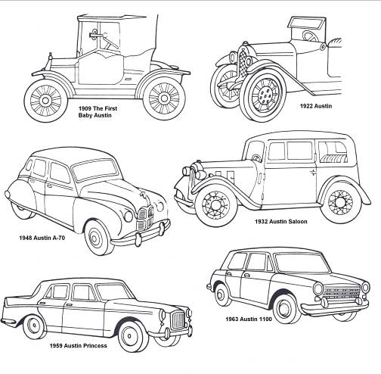
The real beginning of the all-steel body shell came in 1927, when presses became capable of producing a greater number of panels and in more complex shapes, this was the dawn of the mass production era. During the 1930s most of the large companies who manufactured motor vehicles adopted the use of metal for the complete construction of the body shell and motor cars began to be produced in even greater quantities. Owing to the ever-increasing demand for private transport, competition increased between rival firms, and in consequence their body engineers began to incorporate features which added to the comfort of the driver and passengers. This brought about the development of the closed cars or saloons as we know them today. The gradual development of the shape of the motor car body can be clearly seen in figure 1, which shows a selection of Austin vehicles from 1909 to 1992.

Figure 1: The Austin Car 1909 to 1963

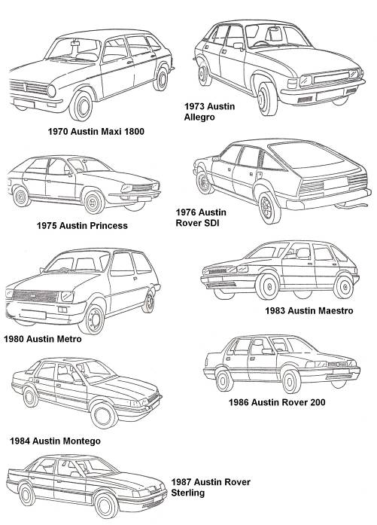
Figure 2: The Austin Car 1970-1987

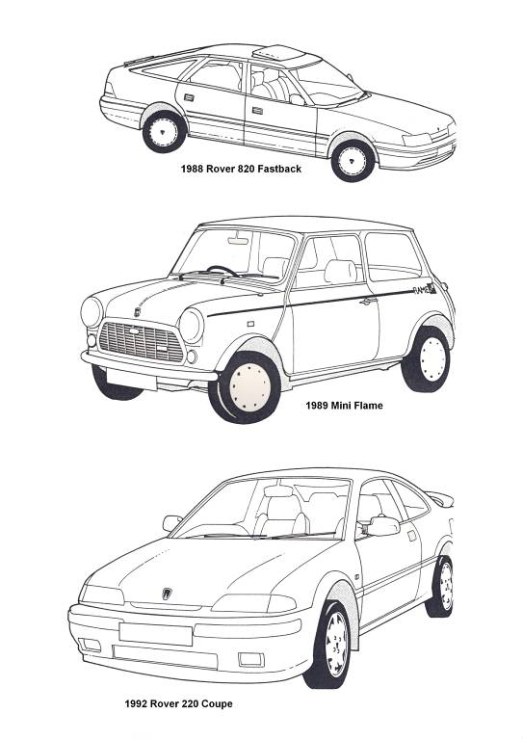
Figure 3: The Austin Car 1988-1992

The inner construction of the head roof of these saloons was concealed by a headlining. Up to and including the immediate post-war years, this headlining was made from a woolen fabric stitched together and tacked into position on wooden frames. However, the more recently developed plastic and vinyl materials were found to be more suitable than fabric, being cheaper and easier to clean and fit. They are fitted by stretching over self-tensioning frames which are clipped into position for easy removal, or alternatively the headlining is fastened into position with adhesives.
Comfort improved tremendously with the use of latex foam rubber together with coil springs in the seating, instead of the original plain springing. The general interior finish has also been improved by the introduction of door trim pads, fully trimmed dash panels and a floor covering of either removable rubber or carpeting.
Then came the general use of celluloid for windows instead of side curtains and next a raising and lowering mechanism for the windows, nowadays the windscreen and door glasses are made of laminated and/or toughened safety glass. The window mechanism in use today did not begin to develop until well into the 1920s.
Mudguards, which began as wooden or leather protections against splattered mud, grew into wide splayed deflectors in the early part of the twentieth century and then gradually receded into the body work, becoming gracefully moulded into the streamlining of the modern motor car and taking the name of wings. Carriage steps retained on earlier models gave place to running boards which in turn disappeared altogether.
Steering between 1890 and 1906 was operated by a tiller. This was followed by the steering wheel which is in current use. The position of the gear lever made an early change from the floor to the steering column, only to return to some convenient place on the floor.
Some of the first vehicles, or horseless carriages as they were known, carried no lights at all; then carriage candle lamps, acetylene lamps and finally the electric lighting system, first fitted as a luxury extra and ultimately becoming standard and finally obligatory equipment which must conform with legislation of the day.
When windscreens were first introduced such accessories as windscreen wipers and washers were unknown. Then came the single hand operated wiper, followed by the suction wiper and finally electrically driven wipers.
The design of the wheels was at first dictated by fashion. It was considered necessary for the rear wheels to be larger than the front, a legacy from the elegant horse drawn carriages. Wooden spokes and iron tyres were the first wheels to appear and with both rear and front wheels of the same dimensions. Then came the wooden-spoked artillery wheel with pneumatic tyre. The artillery wheel gave way to the wire-spoked wheel, and this in turn to the modern disc wheel with tubeless tyres.
Great strides have been made in the evolution of the motor car since 1770, when Cugnot’s steam wagon travelled at 3 mile/h (4.8km/h), to the modern vehicle which can carry driver and passengers in silence, comfort and safety at speeds which at one time were thought to be beyond human endurance: indeed, special vehicles on prepared tracks are now approaching the speed of sound.
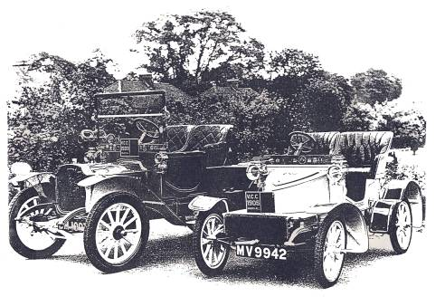
It must be borne in mind that the speed of the vehicle is governed by (a) the type of power unit, (b) its stability and maneuvering capabilities and (c) its shape, which is perhaps at present one of the most important features in high-speed travel. Whatever the mechanical future of the car, we may rest assured that the shape of the motor car body will continue to change as technical progress is made.

1.1 Highlights of Motor Vehicle History
The idea of a self-propelled vehicle occurs in Homer’s Ilad. Vulcan, the blacksmith of the gods, in one day made 20 tricycles with ‘self-moved obedient to the beck of the gods’. The landmarks in more modern motor vehicle history are as follows:
1688 | Ferdinand Verbiest, missionary in China, made a model steam carriage using the steam turbine principle.
1740 | Jacques de Vaucansen showed a clockwork carriage in Paris.
1765 | Watt developed the steam engine
1765 | Nicholas Joseph Cugnot, a French artillery officer, built a steam wagon which carried four people at a speed of 2.25 mile/h. It overturned in the street of Paris and Cugnot was thrown into prison for endangering the populace.
1803 | Richard Trevithickbuilt a steam carriage and drove it in Cornwall.
1831 | Sir Charles Dance ran a steam coach (built by Sir Goldsworthy Gurney) on a regular service from Gloucester to Cheltenham. Sometimes they did four round trips a day, doing 9 miles in 45 minutes. The steam coaches were driven off the road by the vested interests of the stage coach companies, who increased toll charges and piled heaps of stones in the roads along which the steam coaches passed. This, combined with mechanical breakdowns and the advent of railways, contributed to the withdrawal of the steam coaches.
1859 | Oil was discovered in USA.
1865 | The Locomotive Act of 1865 (The Red Flag Act) was pushed through by the railway and coach owners. One of the stipulations was that at least three people must be employed to conduct the locomotive through the streets, one of whom had to walk 60 yards in front carrying a red flag. Speeds were restricted to 2-4 miles/h. this legistration held back the development of the motor vehicle in Great Britain for 31 years, allowing the continentral countries to take the lead in this field.
1885 | Karl Benz produced his first car. This is recognized as being the first car with an internal combustion engine as we know it.
1886 | Gottlieb Daimler also produced a car.
1890 | Panhard and Levasser began making cars in France.
1892 | Charles and Frank Duryea built the first American petrol-driven car, although steam cars had been in use long before.
1895 | First motor race in Paris. First Automobile Club formed in Paris.
1896 | The repeal of the Red Flag Act. This is commemorated by the London to Brighton veteran car run. The speed limit was raised to 12 mile/h and remained at that until 1903, when the 20 mile/h limit in built-up areas was introduced. There was much persecution of motorists by police at this time, which led to the formation of the RAC and AA.
1897 | The RAC was formed, largely through the efforts of F.R.Simms, who also founded the SMMT in 1902.
1899 | Jenatzy set world speed record of 66 mile/h.
1900 | Steering wheel replaces tiller. Frederick Lanchester produced his first car, a 10 hp model. He had built an experimental phaeton in 1895.
1901 | Front-mounted engine. Mercedes car produced.
1902 | Running board. Serpollet did a speed of 74 km/h in a steam car.
1903 | Pressed steel frames. First windshield. The Motor Car Act resulted in considerable persecution of the motorist for speeding number plates and lights, so much so motoring organizations paid cyclists to find police speed traps.
1904 | Folding windshield. Closed saloon-type body. A petrol car reached 100 mile/h and in the same year a Stanley steam car achieved a speed of 127 mile/h. Stanley steam cars used paraffin in a multitube boiler and had a chassis made from hickory. Rolls Royce exhibited their first car in Paris. The motoring press were impressed with its reliability. Veteran cars are cars up to and including this year.

1.2 Terms used to Describe Early Vehicle Body Styles
In the history of the motor car there has been some ambiguity in the names used to describe various types of body styles, built by coach builders from different countries. The following terms relate to the vehicles produced during the period 1895 to 1915 and show the derivation of the terminology used to describe the modern vehicle:
Berlina: Rarely used before the First World War. A closed luxury car with small windows which allowed the occupants to see without being seen.

Cab: A term taken directly from the days of horse-drawn carriages. Used to describe an enclosed vehicle which carried two passengers, while the driver was situated in front of this compartment and unprotected.
Cabriolet: Used towards the end of the period, describes a car with a collapsible hood and seating two or four people.
Coupé: A vehicle divided by a fixed or movable glass partition, behind the front seat. The driver’s position was only partially protected by the roof whilst the rear compartment was totally enclosed and very luxurious.
Coupé Cabriolet or Double Cabriolet: A long vehicle having the front part designed as a coupe and the rear part designed as a cabriolet. There were often two supplementary seats.
Coupé de Ville: A coupé having the driving position completely open.
Coupé Limousine: A vehicle having a totally enclosed rear compartment and the front driving position closed on the sides only.
Double Berlina: A longer version of the Berlina but having the driving position separated from the rear part of the vehicle.
Double Landaulet: A longer version of the landaulet. It had two permanent seats plus two occasional seats in the rear and a driving position in front.
Double Phaeton: A phaeton which had two double seats including the driver’s seat.
Double Tunneau: A longer version of the tonneau in which the front seats were completely separated from the rear seats.
Landau: A cariolet limousine having only the roof behind the rear windows collapsible.
Landaulet or Landaulette: A small landau having only two seats in the closed collapsible roof portion.
Limousine: A longer version of the coupe with double side windows in the rear compartment.
Limousine Chauffeur: A limousine with an extended rear roof to cover the driving position.
Phaeton: A term from the days of the horse-drawn carriage. In early motoring it was used to describe a lightweight car with large spoked wheels, one double seat and usually a hood.
Runabout: An open sporting type of vehicle with simple bodywork and two seats only.
Tonneau: An open vehicle having a front bench seat and a semicircular rear seat which was built into the rear doors.
Glass Saloon: A large closed vehicle similar to a double Berlina but with enlarged windows.
Saloon: A vehicle having the driving seat inside the enclosed car but not separated from the rear seat by a partition.
Torpedo: A long sports vehicle having its hood attached to the windscreen.
Victoria: Another term derived from the era of horses. The Victoria was a long, luxurious vehicle with a separate driving position and a large rear seat. It was equipped with hoods and side screens.
Wagon Saloon: A particularly luxurious saloon used for official purposes.
1.3 Vehicle Classification:
There are many ways in which motor vehicles may be classified into convenient groups for recognition. Much depends on such factors as the manufacturer, the make of the car, the series and the body type or style. Distinctive groups of passenger vehicle bodies include the following:
- Small-bodied mass produced vehicles
- Medium-bodied mass produced vehicles
- Large-bodied mass produced vehicles
- Modified mass produced bodywork to give a standard production model a more distinctive appearance
- Specially built vehicles using the major components of mass produced models.
- High-quality coach-built limousines (hand made)
- Sports and GT bodywork (mass-produced)
- Specially coach-built sports cars (hand made)
Styling forms include the following:
Saloon: The most popular style for passenger vehicles is the two -door or four-door saloon. It has a fully enclosed, fixed-roof body for four or more people. This body style also has a separate luggage or boot compartment.
Hatchback: This body style is identified by its characteristic sloping rear tailgate, which is classed as one of the three or five doors. With the rear doors down there is no division between the passenger and luggage compartments and this increases the luggage carrying capacity of the vehicle.
Estate: This type of vehicle is styled so that roof extends to the rear to give more luggage space, especially when the rear seats are lowered.
Sports coupé and coupé: A sports coupe is a two seated sports car with a fixed roof and a high-performance engine. A coupé is a two-door, fixed-roof, high performance vehicle with similar styling but with two extra seats at the rear and is sometimes referred to as a 2-plus-2.
Convertible or Cabriolet: This can have either two or four doors. It has a soft-top folding roof (hood) and wind-up windows, together with fully enclosed or open bodywork.
Sports: This is a two-seater vehicle with a high-performance engine and a folding or removable roof (hood).
Limousine: This vehicle is characterized by its extended length, a high roofline to allow better headroom for seating five passengers comfortably behind the driver, a high-quality finish and luxurious interiors.

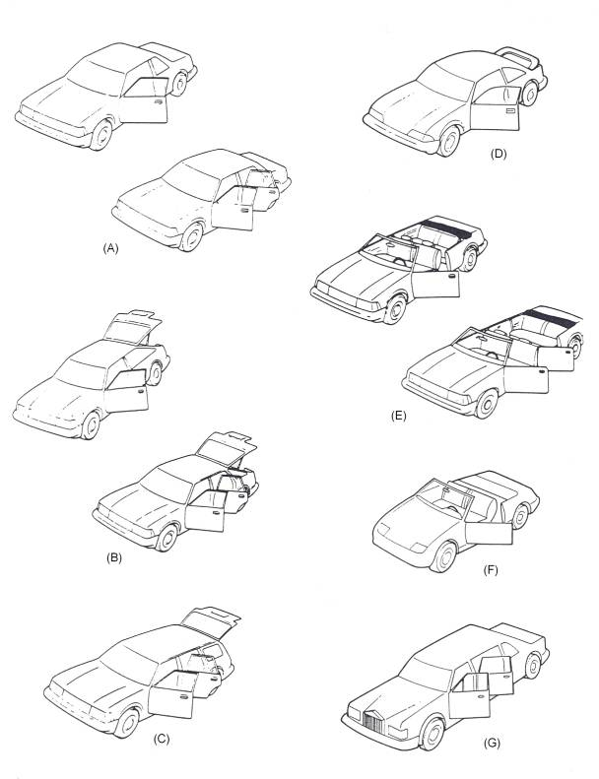
Figure 4: Vehicle Styling Forms

(A) Saloon (B) Hatchback (C) Estate (D) Coupé (E) Convertible (F) Sports (G) Limousine
1.4 The Evolution of Design
When the first motor cars appeared, little attention was paid to their appearance, it was enough that they ran. Consequently the cars initially sold to the public mostly resembled horse-drawn carriages with engines added. Henry Ford launched his Model T in 1908, and it sold on its low price and utility rather than its looks. However, the body design of this car had to be changed over its 19 year production span to reflect changes in customer taste.
The 1930s saw greater emphasis on streamlining design. Manufacturers began to use wind tunnels to eliminate unnecessary drag-inducing projections from their cars. One of the dominant styling features of the 1950s and 1960s was the tail fin, inspired by the twin tail fins of the wartime Lockhead Lightning fighter aircraft. Eventually a reaction set in against such excesses and the trend returned to more streamlined styling.
In creating cars for today’s highly competitive car market, designers have to do far more than just achieve a pleasing shape. National legal requirements determine the positions of lamps direction indicators and other safety-related items, while the buying market has become much more sophisticated than before. Fuel economy, comfort, function and versatility are now extremely important.
1.5 Creation of a New Design from Concept to Realization
The planning, design, engineering and development of a new motor car is an extremely complex process. With approximately 15,000 separate parts, the car is the most complicated piece of equipment built using mass production methods. Every major design project has its own design team led by a design manager and they stay with the project throughout. The size of the team varies according to the progress and status of the project. The skill and judgment of the trained and experienced automotive designer is vital to the creation of any design concept.
To assist in the speed and accuracy of the ensuring stages of the design process (the implementation), some of the most advanced computer-assisted design equipment is used by the large vehicle manufacturers. For example, computer-controlled measuring bridges that can automatically scan model surfaces, or machines that can mill surfaces, are linked to a computer centre through a highly sophisticated satellite communication network. The key terms in computer equipment are as follows:
Computer-aided Design (CAD): Computer assisted design work, basically using graphics.
Computer-aided Engineering (CAE): All computer aided activities with respect to technical data processing, from idea to preparation for production, integrated in an optimum way.
Computer-aided Manufacturing (CAM): Preparation of production and analysis of production processes.
Computer-integrated manufacturing (CIM): All computer-aided activities from idea to serial production.
The use of CAE is growing in the automotive industry and will probably result in further widespread changes. Historically, the aerospace industry was the leader in CAE development. The three major motor companies of GM, Ford and Chrysler started their CAE activities as soon as computers became readily available in the early 1960s. the larger automotive companies in Europe started CAE activities in the early 1970s – about the same time as the Japanese companies.
Each new project starts with a series of detailed paper studies, aimed at identifying the most competitive and innovative product in whichever part of the market is under review. Original research into systems and concepts is then balanced against careful analysis of operating characteristics, features performance and economy targets, the projected cost of ownership and essential dimensional requirements. Research into competitors’ vehicles, market research to judge tastes in future years, and possible changes in legislation are all factors that have to be taken into account by the product planners when determining the specification of a new vehicle.

The various stages of the design process are as follows:
- Vehicle styling, ergonomics and safety
- Production of scale and full-size models
- Engine performance and testing
- Wind tunnel testing
- Prototype production
- Prototype testing
- Body engineering for production
1.6 Vehicle Styling
Styling
Styling has existed from the early times. However, the terms ‘stylist’ and ‘styling’ originally came into common usage in the automotive industry during the first part of the twentieth century.
The automotive stylist needs to be a combination of artist, inventor, craftsman and engineer, with the ability to conceive new and imaginative ideas and to bring these ideas to economic reality by using up-to-date techniques and facilities. He must have a complete understanding of the vehicle and its functions, knowledge of materials available, the costs involved, the capabilities of the production machinery, the sources of supply and the directions of worldwide changes. His responsibilities include the conception, detail, design and development of all new products, both visual and mechanical. This includes the exterior form, all applied facias, the complete interior, controls, instrumentation, seating and the colours and textures of everything visible outside and inside the vehicle.
Styling departments vary enormously in size and facilities, ranging from the individual consultant stylist to the comprehensive resources of major American motor corporations like General Motors, who have more than 2000 staff in their styling department at Detroit. The individual consultant designer usually provides designs for organizations which are too small to employ fulltime stylists. Some act as an additional brain for organizations who want to inject new ideas into their own production. Among the famous designers are the Italians Pininfarina (Lancia, Ferrari, Alfa), Bertone (Lamborghini), Ghia (ford) and Issigonis (mini).
The work of the modern car stylist is governed by the compromise between his creativity and the world of production engineering. Every specification, vehicle type, payload, overall dimensions, engine power and vehicle image inspire the stylist and the design proposals he will make. Initially he makes freehand sketches of all the fundamental components placed in their correct positions. If the drawing does not reduce the potential of the original ideas, he then produces more comprehensive sketches of this design, using colours to indicate more clearly to the senior executives the initial thinking of the design. Usually the highly successful classic designs are the work of one outstanding individual stylist rather than of a team.
The main aim of the designer is to improve passenger comfort and protection, vision, heating and ventilation. The styling team may consider the transverse engine as a means of reducing the space occupied by the mechanical elements of the car. Front-wheel drive eliminates the driveshaft and the tunnel and the occupants can sit more comfortably. Certain minimum standards are laid down with regard to seat widths, knee-room and headroom. The interior dimensions of the car are part of the initial specifications and not subject to much modification. Every inch of space is considered in the attempt to provide the maximum interior capacity for the design. The final dimensions of the interior and luggage space are shown in a drawing, together with provision for the engine and remaining mechanical assemblies.
Ergonomics
Ergonomics is a fundamental component of the process of vehicle design. It is the consideration of human factors in the efficient layout of controls in the driver’s environment. In the design of instrument panels, factors such as the driver’s reach zones and his field of vision together with international standards, all have to be considered. Legal standards include material performance in relation to energy absorption and deformation under impact. The vision and reach zones are geometrically defined, and allow for the elimination of instrument reflections in the windshield. Basic elements affecting the driver’s relationship to the instrument panel controls, instruments, steering wheel, pedals, seats and other vital elements in the car are positioned for initial evaluation using the ‘Manikin’, which is a two and three dimensional measuring tool developed as a result of numerous anthropometric surveys and representing the human figure. Changes are recorded until the designer is satisfied that an optimum layout has been achieved.
1.7 Safety
With regards to bodywork, the vehicle designer must take into account the safety of the driver, passengers and other road users. Although the vehicle cannot be expected to withstand collision with obstacles or other vehicles, much can be done to reduce the effects of collision by the use of careful design of overall shape, the selection of suitable materials and the design of the components, the chances of injury can be reduced both outside and inside the vehicle by avoiding sharp-edged, projecting elements.
Every car should be designed with the following crash safety principles in mind:
- The impact from a collision is absorbed gradually by controlled deformation of the outer parts of the car body.
- The passenger area is kept intact as long as possible.
- The interior is designed to reduce the risk of injury.
Safety-related vehicle laws cover design, performance levels and the associated testing procedures: requirements for test inspections, documentation and records for the process of approval: checks that standards are being maintained during production; the issue of safety-related documentation and many other requirements throughout the vehicle’s service life.
Primary or active safety
This refers to the features designed into the vehicle which reduce the possibility of an accident. These include primary design elements such as dual-circuit braking systems, anti-lock braking systems high aerodynamic stability and efficient bad weather equipment, together with features that make the driver’s environment safer, such as efficient through ventilation, orthopaedic seating, improved all-round vision, easy to read instruments and ergonomic controls.
An anti-lock braking system (ABS) enhances a driver’s ability to steer the vehicle during hard braking. Sensors monitor how fast the wheels are rotating and feed data continuously to a microprocessor in the vehicle to signal that a wheel is approaching lockup. The computer responds by sending a signal to apply and release brake pressure as required. This pumping action continues as long as the driver maintains adequate force on the brake pedal and impending wheel condition is sensed.
The stability and handling of the vehicle are affected by the width of the track and the more stable is the vehicle.
Secondary or passive safety
If a crash does happen, secondary safety design should protect the passengers by:
- Making sure that, in the event of an accident, the occupants stay inside the car.
- Minimizing the magnitude and duration of the deceleration to which they are subjected.
- Restraining the occupants so that they are not injured by secondary impacts within the car, and if they do strike any parts of the inside of the vehicle, making sure that there is sufficient padding to prevent serious injury.
- Designing the outside of the vehicle so that the least possible injury is caused to pedestrians and others who may come into contact with the outside of the vehicle.
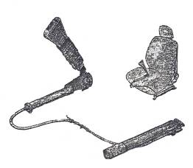
The primary concern is to develop efficient restraint systems which are comfortable to wear and easy to use. Manufacturers are now fitting automatic seatbelt tensioners. These automatic ‘body lock’ front seatbelt tensioners reduce the severity of head injuries by 20 per cent with similar gains in chest protection. In impacts over 12 mile/h (20 km/h) the extra tension in the seatbelts buckle triggers a sensor which tightens the lap and diagonal belts in 22 milliseconds, that is before the occupant even starts to move. In addition, because it operates at low speeds, it covers a broad spectrum of accident situations. Anti-submarining ramps built into the front seats further aid safety by reducing the possibility of occupants sliding under the belt.
Figure 5: Automatic Seat Belt Tensioner
There are also engineering features such as impact energy-absorbing steering columns, head restraints, bumpers, anti-burst door locks and self aligning steering wheels. Anti-burst door locks are to prevent unrestrained occupants from falling out of the vehicle, especially during roll over. The chances of survival are much reduced if the occupant is thrown out. Broad padded steering wheels are used to prevent head or chest damage. Collapsible steering columns also prevent damage to the chest and abdomen and are designed to prevent the steering column being pushed back into the passenger compartment whilst the front end is crumpling. The self-aligning steering wheel is designed to distribute force more evenly if the driver comes into contact with the steering wheel during a crash. This steering wheel has an energy absorbing hub which incorporates six deformable metal legs. In a crash, the wheel deforms at the hub and the metal legs align the wheel parallel to the chest of the driver to help spread the impact and reduce chest, abdomen and facial injuries.
Body shells are now designed to withstand major collision and rollover impacts while adsorbing shock by controlled deformation of structure in the front and rear of the vehicle. Vehicle design and accident prevention is based on the kinetic energy relationship of damage to a vehicle during collision. Energy is absorbed by work done on the vehicle materials such as foam-filled plastics and heavy rubber sections. Data indicates the long energy-absorbing distances should be provided in vehicle design and the panel assemblies used for this purpose should have a lower stiffness than the central section or passenger compartment of the vehicle.

1.8 Crumple Zone
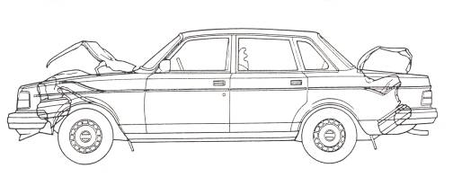
The crumple zones are designed to help decelerate the car by absorbing the force of collision at a controlled rate, thereby cushioning the passengers and reducing the risk of injury.

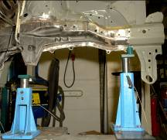
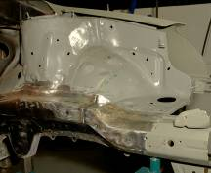
Figure 6: Crumple Zones
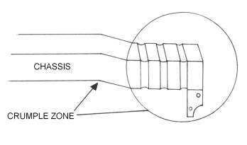

Figure 7: Crumple Zone on a Chassis
1.9 The Safety Cage
The safety cage (or safety cell) is the central section of the car body which acts as the passenger compartment. To ensure passenger safety, all body apertures around the passenger area should be reinforced by box-type profiles: seats should be secured rigidly to the floor and heavy interior padding should be used around the dashboard areas. A strengthened roof construction, together with an anti-roll bar, are additional protection in case of overturning.
The counteract side impact manufacturers are now fitting, in both front and rear doors. Lateral side supports in the form of twin high-strength steel tubular beams, which are set 90mm apart to reduce the risk of the vehicle riding over the beams during side collision. These beams absorb the kinetic energy produced when the vehicle is struck from the side. To further improve the body structure the BC pillars are being reinforced at the points of attachment to the sill and roof, again giving more strength to the safety cage and making it stronger and safer when the vehicle is involved in a collision.
Visibility in design is the ability to see and be seen. In poor visibility and after dark, light sources must be relied upon. The lights on vehicles now are much more efficient than on earlier models. The old tungsten filament lamp has given way to quartz-halogen lamps which provide much better illumination. The quartz-halogen lamp is able to produce a more powerful beam because the filament can be made hotter without shortening its lifespan. Hazard, reversing and fog lights are now fitted to most vehicles to improve safe driving. In daylight, colour is probably the most important factor in enabling cars to be seen. If a vehicle is coloured towards the red end of the spectrum, it can be less obvious to other road users than a yellow one, especially in sodium vapour street lights: a red car absorbs yellow light from the street light and reflects little and so appears to be dark in colour. Whereas a yellow car reflects the yellow light and appears more obvious. Silver vehicles will blend into mist and fog and become difficult to see. Blind spots can be diminished firstly by good design of front pillars, making them slim and strong and secondly by reducing the area of rear quarter sections. This elimination of blind spots is now being achieved by using bigger windscreens which wrap round the front A-post, and rear windows which wrap round the rear quarter section, giving a wider field of vision.
Many automotive manufacturers now believe that a seatbelt/airbag combination provides the best possible interior safety system. Airbags play an important safety role in the USA since the wearing of seatbelts is not compulsory in many states.
As competition to manufacturer Europe’s safest car increases, more manufacturers including those in the UK are starting to fit airbags. These Eurobags, or facebags as they are now called, since their main function is to protect the face rather than the entire body in the event of a collision, are less complex than their USA counterparts.
The first automotive airbags were more that 20 years ago using nylon-based woven fabrics and these remain the preferred materials amongst manufacturers. Nylon fabrics for airbags are supplied in two basic designs depending on whether the airbag is to protect the driver or the front passenger. The driver’s airbag is housed in the steering wheel and requires special attention because of the confined space. The passenger’s airbag system has a compartment door, located in the front of the passenger in the dash area, which must open within 10 milliseconds and deploy the airbag within 30 milliseconds. The vehicle has a crash sensor which signals the airbags to deploy on impact.
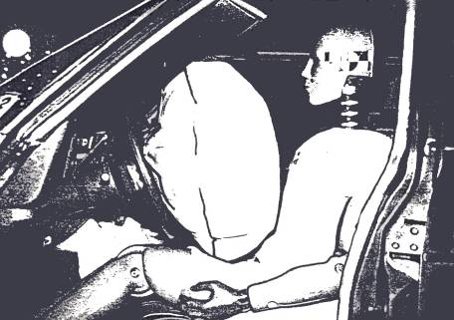
Figure 8: Driver’s Airbag System

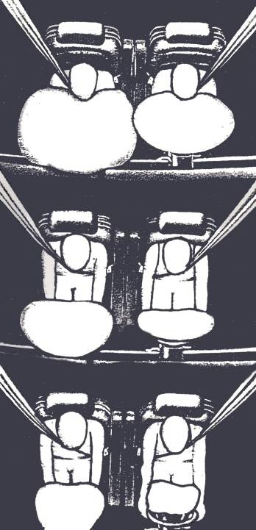

Figure 9: Driver and Passenger Airbag System

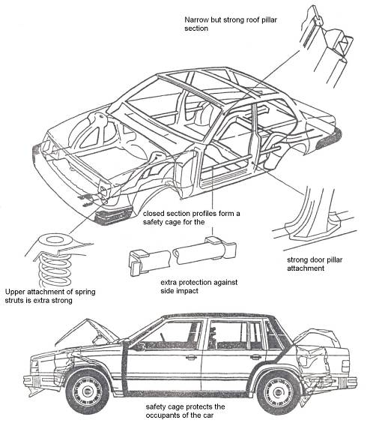
Figure 10: Safety Cage
A. Safety features included in the safety cage
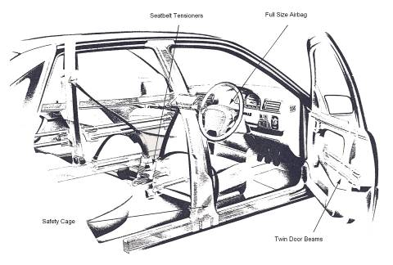
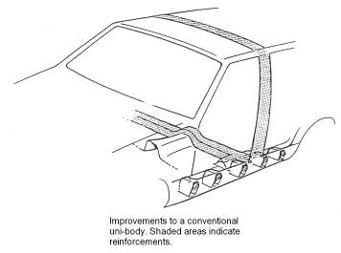
B. Reinforced BC-pillar and anti-roll bar

Figure 11: Safety Features

1.10 The Development and Construction of the Car Body
Using wood and clay allows for modifications to be made easily. At the same time, design engineering personnel construct models of alternative interiors so that locations of instruments can be determined.
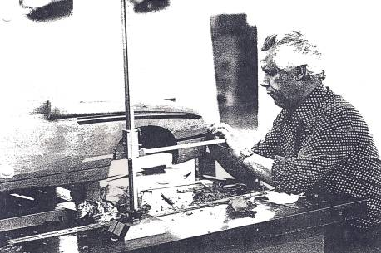
A ¼ or ⅜ scale model is produced from the stylist’s drawings to enable the stylist designer to evaluate the three-dimensional aspect of the vehicle. These scale models can look convincingly real. The clay surfaces are covered with thin coloured plastic sheet which closely resembles genuine painted metal. Bumpers, door, handles and trim strips are all cleverly made-up dummies, and the windows are made of Plexiglass. The scale models are examined critically and tested. Changes to the design can be made at this stage.

Figure 12: Scale Model Maker at Work
Full-size Models
A full-size clay model is begun when the scale model has been satisfactorily modified. It is constructed in a similar way to the scale model but uses a metal, wood and plastic frame called a buck. The clay is placed on to the framework by professional model makers, who create the final outside shape of the body to an accuracy of 0.375mm. The high standard of finish and detail results in an exact replica of the future full-size vehicle.
This replica is then evaluated by the styling management and submitted to top management for their approval. The accurate life-size model is used for further wind tunnel testing and also to provide measurements for the engineering and production departments. A scanner, linked to a computer, passes over the entire body and records each and every dimension. These are stored and can be produced on an automatic drafting machine.
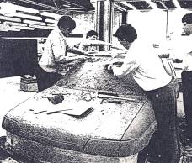
Figure 13: Full-size Clay Model
The same dimensions can also be projected on the screen of a graphic station; this is a sophisticated computer-controlled video system showing three-dimensional illustrations, allowing design engineers either to smooth the lines or to make detail alterations. The use of computer or CAD allows more flexibility and saves a lot of time compared with more conventional drafting systems.
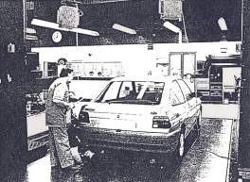
At the same time as the exterior model is being made, the interior model is also being produced accurately in every detail. It shows the seating arrangement, instrumentation, steering wheel, control unit location and pedal arrangements. Colours and fabrics are tired out on this mock-up until the interior styling is complete and ready for approval.

Figure 14: Checking Dimensional Accuracy of Full-size Model
Engineering Performance and Testing
Development engineers prepare to test an engine in a computer-linked test cell to establish the optimum settings for the best performance, economy and emission levels. With the increasing emphasis on performance with economy, computers are used to obtain the best possible compromise. They are also used to monitor and control prolonged engine testing to establish reliability characteristics. If current engines and transmissions are to be used for a new model, a programme of refining and adapting for the new installation has to be initiated. However, if a completely new engine, transmission or driveline configuration is to be adopted, development work must be well in hand by this time.
Aerodynamics and Wind Tunnel Testing
Aerodynamics is an experimental science whose aim is the study of the relative motions of a solid body and the surrounding air. Its application to the design of a car body constitutes one of the chief lines of the search for energy economy in motor vehicles.
In order to move over flat ground, a car must overcome two forces:
1. Resistance to type tread motion, which varies with the coefficient of tyre friction over the ground and with the vehicle’s mass.
2. Aerodynamic resistance, which depends on the shape of the car, on its frontal area, on the density of the air and on the square of the speed.
One of the objects of aerodynamics research is to reduce the latter: in other words to design a shape that will, for identical performance, require lower energy production. An aerodynamic or streamlined body allows faster running for the same consumption of energy, or lower consumption for the same speed. Research for the ideal shape is done on reduced scale models of the vehicle. The models are placed in a wind tunnel, an experimental installation producing wind of a certain quality and fitted with means for measuring the various forces due to the action of the wind on the model or vehicle. Moreover, at a given cruising speed, the more streamlined vehicle has more power left available for acceleration: this is a safety factor.
The design of a motor car body must, however, remain compatible with imperatives of production, of overall measurements and of inside spaciousness. It is also a matter of style, for the coachwork must be attractive to the public. This makes it impossible to apply the laws of aerodynamics literally. The evolution of the motor car nevertheless tends towards a gradual reduction in aerodynamic resistance.
Aerodynamic Drag
The force which opposes the forward movement of an automobile is aerodynamic drag, in which air rubs against the exterior vehicle surfaces and forms disturbances about the body, thereby retarding forward movement.
Aerodynamic drag increases with speed; thus if the speed of a vehicle is doubled, the corresponding engine power must be increased by eight times. Engineers express the magnitude of aerodynamic drag using the drag coefficient Cd. The coefficient expresses the aerodynamic efficiency of the vehicle: the smaller the value of the coefficient, the smaller the aerodynamic drag.
Figure 15 illustrates the improvements in aerodynamic drag coefficient achieved by alterations to the shape of vehicles. Over the years, the value Cd has been reduced roughly as follows:
1910 0.95 1960 0.40 1920 0.82 1970 0.36 1930 0.56 1980 0.30 1940 0.45 1990 0.22 1950 0.42 1993 0.20 (probable)
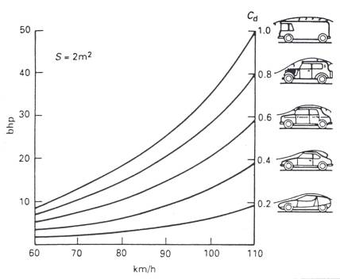
Figure 15: Theoretical Drag Curves
Theoretical drag curves for four types of vehicle, all reduced for comparison purposes to a …… section of 2m². Since air resistance increases in proportion to the square of the speed, a truck with Cd 1.0 requires 35 bhp at 100km/h, whereas a coupé with Cd 0.2 requires only 7bhp.

During the wind tunnel test all four wheels of the car rest on floating scales connected to a floor balance, which has a concrete foundation below the main floor area. The vehicle is then subjected to an air stream of up to 112 mile/h: the sensitive balances register the effect of the headwind on the vehicles as it is either pressed down or lifted up from the floor, pushed to the left or right, or rotated about its longitudinal axis. The manner in which the forces affect the vehicle body and the location at which the forces are exerted depends upon the body shape, underbody contours and projecting parts. The fewer disturbances which occur as air moves past the vehicle, the lower its drag. Threads on the vehicle exterior as well as smoke streams indicate the air flow and enable test engineers to see where disturbance exists and where air flows are interrupted or redirected and therefore where reshaping of the body is necessary in order to produce better aerodynamics.
Prototype Production
The new model now enters the prototype phase. The mock-ups give way to the first genuine road-going vehicle, produced with the aid of accurate drawings and without complex tooling and machinery. The prototype must accurately reproduce the exact shape, construction and assembly conditions of the final production body it represents if it is to be of any value in illustrating possible manufacturing problems and accurate test data. The process begins with the issue of drawing office instructions to the experimental prototype workshop. Details of skin panels and other large pressings are provided in the form of tracings as photographic reproductions of the master body drafts. As the various detailed parts are made by either simple press tools or traditional hand methods, they are spot welded into minor assemblies or subassemblies; these later become part of a major assembly to form the complete vehicle body.
Prototype Testing
Whilst still in the prototype stage, the new car has to face a number of arduous tests. For these tests a mobile laboratory is connected to the vehicle by a cable, which transmits signals from various sensors on the vehicle back to the onboard computer for collation and analysis. The prototype will also be placed on a computer-linked simulated rig to monitor, through controlled vibrations, the stresses and strains experienced by the driveline, suspension and body. Crash testing is undertaken to establish that the vehicle will suffer the minimum of damage or distortion in the event of an impact and that the occupants are safely installed within the strong passenger compartment or safety cell. The basic crash test is a frontal crash at 30 mile/h (48 km/h) into a fixed barrier set perpendicularly to the car’s longitudinal axis. The collision is termed 100 per cent overlap, as the complete front of the car strikes the barrier and there is no offset. The main requirement is that the steering wheel must not be moved back by more than 120mm (5in), but there is no requirement to measure the force to which the occupants will be subject in collision. The manufacturers use anthropometric dummies suitably instrumented with deceleration and strain gauges which collect relevant data on the effect of the collision on the dummies. A passenger car side impact test aimed at reducing chest and pelvic injuries have been legal in the USA since 1993. This stricter standard requires that a new vehicle must pass a full-scale crash test designed to simulate a collision at an intersection in which a car traveling at 15 mile/h is hit in the side by another car traveling at 30 mile/h. this teat is called an angled side-swipe: the displacement is 27 degrees forward from the perpendicular of the test vehicle’s main axis. The test is conducted by propelling a movable deformable barrier at 33.5 mile/h into the side of the test car occupied by dummies in the front and rear seats. The dummies are wired with instruments to predict the risk potential of human injury.
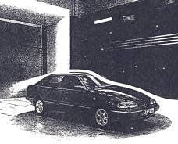

Figure 16: Wind Tunnel Testing of a Prototype
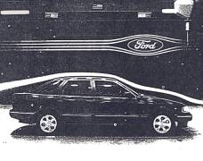

Figure 17: Wind Tunnel Testing of a Prototype
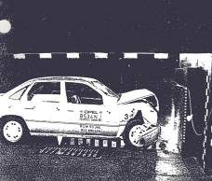
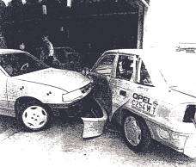
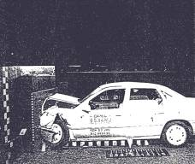
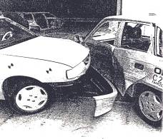
Figure 18: Basic Frontal Crash and Side Impact (Angled side swipe)

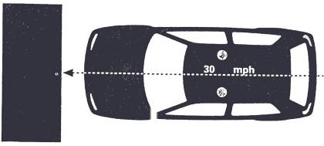
Figure 19: Standard Frontal Impact Test
Volvo has a very unusual promotional crash test which involves propelling a car from the top of a tall building (Figure 20).
Extensive durability tests are undertaken on a variety of road surfaces in all conditions. Vehicles are also run through water tests and subjected to extreme climatic temperature changes to confirm their durability. The final stages are now being reached: mechanical specifications trim levels, engine options, body styles and the feature lists are confirmed.
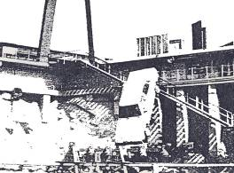

Figure 20: Volvo Crash Test
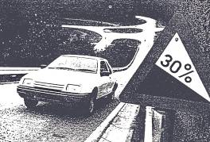

Figure 21: Road Testing a Prototype
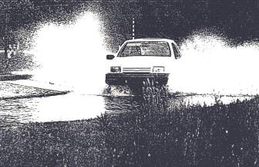

Figure 22: Water Testing a Prototype

1.11 Body Engineering for Production
The body engineering responsibilities are to simulate the styling model and overall requirements laid down by the management in terms of drawing and specifications. The engineering structures designed for production, at a given date, at the lowest possible tooling cost and to a high standard of quality and reliability.
As competition between the major car manufacturers increases, so does the need for light and more effective body structures. Until recently the choice of section, size and metal gauges was based upon previous experience. However methods have now been evolved which allow engineers to solve problems with complicated geometry on a graphical display computer which can be constructed to resemble a body shape. The stiffness and stress can then be computed from its geometry and calculation made of the load bearing of the structures using finite-element methods.
With the final specifications approved, the new car is ready for production. At this stage an initial batch of cars is built (a pilot run) to ensure that the plant facilities and the workforce are ready for the start of full production. When the production line begins to turn out the brand new model every stage of production is carefully scrutinized to ensure quality in all vehicles to be built.
1.12 Methods of Construction
The steel body can be divided into two main types: those which are mounted on a separate chassis frame and those in which the underframe or floor forms an integral part of the body. The construction of today’s mass-produced motor car has changed almost completely from the composite, that is a conventional separate chassis and body, to the integral or mono unit. This change is the result of the need to reduce body weight and cost per unit of the total vehicle.
Composite Construction (conventional separate chassis) The chassis and body are built as two separate units. The body is then assembled on to the chassis with mounting brackets, which have rubber-bushed bolts to hold the body to the rigid chassis. These flexible mountings allow the body to move slightly when the car is in motion. This means that the car can be dismantled into the two units of the body and chassis. The chassis assembly is built up of engine, wheels, springs and transmission. On to this assembly is added the body, which has been preassembled in units to form a complete body shell.

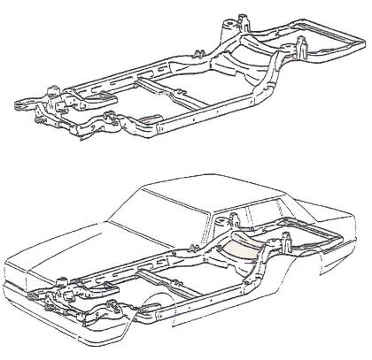

Figure 23: Composite Construction (conventional separate chassis)

Integral (mono or unity) Construction
Integral body construction employs the same principles of design that have been used for years in the aircraft industry. The main aim is to strengthen without unnecessary weight and the construction does not employ a conventional separate chassis frame for attachment of suspension, engine and other chassis and transmission components. The major difference between composite and integral construction is hence design and construction of the floor. In integral bodies the floor pan area is generally called the underbody. The underbody is mad up of formed rails and numerous reinforcements. In most integral under-bodies a suspension member is incorporated in both the front and rear of the body.

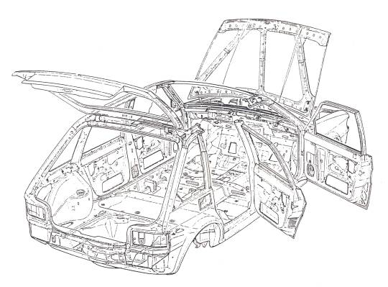
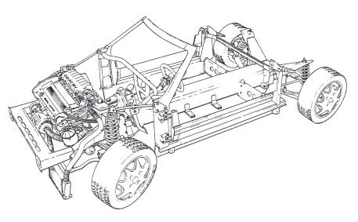
Figure 24: Composite Construction Showing a Lutus Elan Chassis before fitting the Body

Figure 25: Complete Body Assembly of Austin Maestro

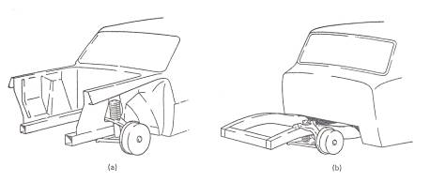
Figure 26: Front End Construction (a) integral or Mono and (b) Composite
The suspension members have very much the same appearance as the conventional chassis frame from the underside, but the front suspension members end at the cowl or bulkhead and the rear suspension members end just forward of the rear boot floor. With the floor pan, side rails and reinforcements welded to them, the suspension members become an integral part of the underbody and they form the supports for the engine, front and rear suspension units and chassis components. In the integral body the floor pan area is usually of heavier gauge metal than in the composite body and has one or more box sections and several channel sections which may run across the floor either from side to side or from front to rear, this variety of underbody construction is due largely to the difference in wheelbase, length and weight of the car involved. A typical upper body for an integral constructed car is very much the same as the conventional composite body shell; the major differences lie in the rear seat area and the construction which joins the front wings to the front bulkhead or cowl assembly. The construction in the area to the rear of the back seat is much heavier in an integral body than in a composite body. The same is true of the attaching members for the front wings, front bulkhead and floor assembly, as these constructions give great strength and stability to the overall body structure.
Semi-Integral Methods of Construction
In some forms of integral or mono assemblies, the entire front end or subframe forward of the bulkhead is joined to the cowl assembly with bolts. With this construction, the bolts can be easily removed and the entire front (or in some cases rear) subframe can be replaced as one assembly in the event of extensive damage.

Glass Fibre Composite Construction
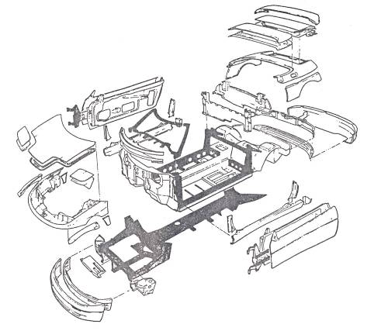
This method of producing complex shapes involves applying layers of glass fibre and resin in a prepared mould. After hardening, a strong moulding is produced with a smooth outer surface requiring little maintenance. Among the many shapes available in this composite material are lorry cabs, bus front canopies, container vehicles and the bodies of cars such as the Reliant Scimitar. The Italian designer, Michelotti, styled the Scimitar body so that separately moulded body panels could be used and overlapped to hide then attachment points. This allows the panels to be bolted directly to the supporting square-section steel tube armatures located on the main chassis frame. The inner body, which rests directly on the chassis frame and which forms the base for all internal trim equipment, is complex GRP moulding. The windscreen aperture is moulded as a part of the inner body, and incorporates steel reinforcing hoops which are braced directly to the chassis. The boot compartment is also a separate hand-laid GRP moulding, as are the doors and some of the other panels. Most of the body panels are secured by self-tapping bolts which offer very positive location and a useful saving in assembly time.
Figure 27: Motor Body Panel Assembly using GRP: Loyus Elan
Galvanized Body Shell Clad Entirely with Composite Skin Panels
Renault have designed a high-rise car which has a skeletal steel body shell, clad entirely with composite panels. After assembly the complete body shell is immersed in a bath of molten zinc, which applies an all-over 6.5 micron (millionth of a metre) coating. The process gives anti-rust protection, while the chemical reaction causes a molecular change in the steel can therefore be used without sacrificing strength, resulting in a substantial weight saving even with the zinc added. Skin panels are formed in reinforced polyester sheet, made of equal parts of resin, fiberglass and mineral filler. The panels are joined to the galvanized frame and doors by rivets or bonding as appropriate. The one-piece high-rise tailgate is fabricated entirely from polyester with internal steel reinforcements. Damage to panels through impact shocks is contained locally and absorbed through destruction of the material, unlike the steel sheet which transmits deformation. Accident damage and consequent repair costs are thus reduced.

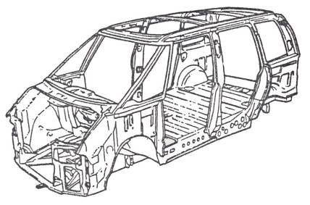
Figure 28: Espace High-Rise Car with Galvanized Skeletal Steel Body Shell
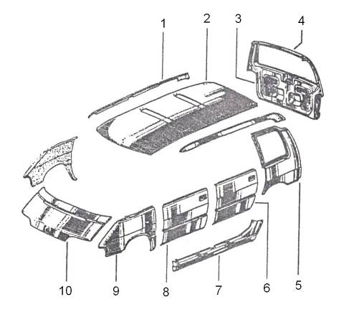
Figure 29: Espace High-Rise Car showing Composite Panel Cladding
Plastic parts are made form a composite material based on polyester resin: pre-impregnated type (SMC) for parts 1, 4, 5, 6, 7, 8, 9, 10; injected resin type for parts 2, 3.
Parts Bonded to Chassis |  | Detachable Parts
1 | Body top | 3 | Tailgate lining
2 | Roof | 4 | Tailgate outer panel
5 | Rear wing | 6 | Rear door panel
9 | Front wing | 8 | Front door panel
7 | Sill | 10 | Bonnet

Variations in Body Shape
Among the motor car manufacturers there are variations in constructional methods which result in different body types and styles, figure 30 illustrates four types of body shell – a saloon with a boot, a hatchback, an estate car and a light van.
Coach-built limousine of extremely high quality, built on a Rolls-Royce Silver Spirit chassis by the coach-builders Hooper & Co. this vehicle has been designed for the use of heads of state and world-ranking VIPs.
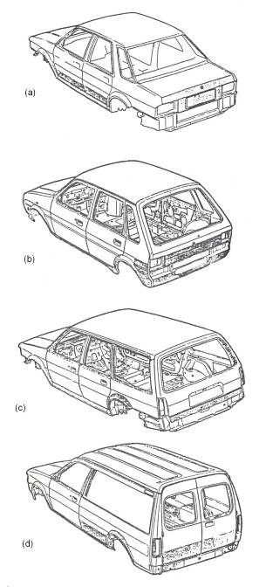

Figure 30: Body Shell Variations
(a) Saloon with boot (b) Hatchback (c) Estate car (d) Light van
1.13 Basic Body Construction
A typical four-door saloon body can be likened to a hollow tube with holes cut in the sides. The bulkhead towards the front and rear completes the box-like form and assists in providing torsional stability. The roof, even if it has to accommodate a sunshine roof, is usually a quite straightforward and stable structure; the curved shape of the roof panel prevents lozenging (going out of alignment in a diamond shape). The floor is a complete panel from front to rear when assembled and is usually fitted with integral straightening ribs to prevent lozenging. With its bottom sides or sill panels, wheel arches, cross members and heelboard, it is the strongest part of the whole body. The rear bulkhead, mainly in the form of a rear squab panel, is again a very stable structure. However, the scuttle or forward bulkhead is a complex structure in a private motor car. Owing to the awkward shape of the scuttle and the accommodation required for much of the vehicle’s equipment, it requires careful designing to obtain sufficient strength. Body sides with thin pillars, large windows and door openings are inherently weak, requiring reinforcing with radiusing corners to the apertures to give them sufficient constructional strength.
A designer in a small coach building firm will consider methods necessary to build the body complete with trim and other finishing processes. The same job in a mass production factory may be done by a team of designers and engineers all experts in their own particular branch of the project. The small manufacturer produces bodies with skilled labour and a minimum number of jigs, while the mass producer uses many jigs and automatic processes to achieve the necessary out-put. However, the problems are basically the same: to maintain strength and stability, a good standard of finish and ease of production.
Figure 31 shows the build up details of a four door saloon, from the main floor assembly to the complete shell assembly. In the figure the main floor unit (1), commencing at the front, comprises a toeboard or pedal panel, although in some case this may become a part of the scuttle or bulkhead. Apart from providing a rest for the front passenger’s feet, it seals off the engine and gearbox from the body and connects the scuttle to the main floor. The main centre floor panel (2) should be sufficiently reinforced to carry the weight of the front seats and passengers. It may be necessary to have a tunnel running the length of the floor in the centre to clear the transmission system from the engine to the rear axle and holes may have to be cut into the floor to allow access to the gearbox, oil filler and dipstick, in which case removable panels or large grommets would be fitted in these access holes (3).
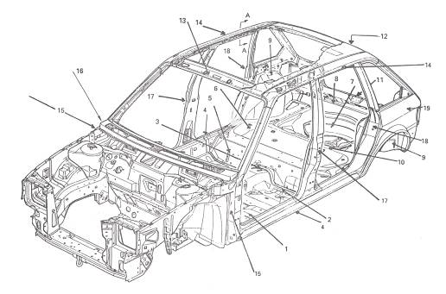
Figure 31: Body Constructional Details of Austin Rover Maestro

1 | Main floor unit | 11 | Boot lid lock striking plate
2 | Main centre floor panel | 12 | Roof structure
3 | Access holes | 13 | Windscreen or canopy rail
4 | Bottom sills | 14 | Cantrails
5 | Rear seat heelboard | 15 | Front standing pillar (A post)
6 | Rear seat panel | 16 | Scuttle
7 | Boot floor | 17 | Centre standing pillar (BC post)
8 | Cross member | 18 | Rear standing pillar (D-post)
9 | Wheel arch panel | 19 | Quarter panels
10 | Rear squabs

The front end of the main floor is fixed to the toeboard panel and the sides of the main centre floor are strengthened by the bottom sills (4) and /or some form of side members which provide the necessary longitudinal strength. The transverse strength is provided by the cross members. The floor panel itself prevents lozenging and the joints between side members and cross members are designed to resist torsional stresses.
The rear end of the floor is stiffened transversely by the rear seat heelboard (5). This heelboard also stiffens the front edges of the rear seat panel. In addition it often provides the retaining lip for the rear seat cushion, which is usually made detachable from the body. The heelboard, together with the rear panel and rear squab panel, forms the platform for the rear seat.
The rear seat panel (6) is reinforced or swaged if necessary to gain enough strength to support the rear passenger. Usually the rear seat panel has to be raised to provide sufficient clearance for the deflection of the rear axle differential housing. The front edge of the rear seat panel is stiffened by the rear seat heelboard and the rear edge of the seat panel is stiffened by the rear squab panel. The rear squab panel completes this unit and provides the rear bulkhead across the car. It seals off the boot or luggage compartment from the main body or passenger compartment.
The boot floor (7), which extends from the back of the rear squab panel to the extreme back of the body, completes the floor unit. In addition to the luggage the spare wheel has to be accommodated here. The front edge of the boot floor is reinforced by the rear squab panel and the rear end by a cross member of some form (8). The sides of the floor are stiffened by vertical boot side panels at the rear, while the wheel arch panels complete the floor and its side members. The wheel arch panels (9) themselves seal the rear road wheels from the body.
In general the floor unit is made up from a series of panels with suitable cross members or reinforcements. The edges of the panels are stiffened either by flanging reinforcing members, or by joining to the adjacent panels. The boot framing is joined at the back to the rear end of the boot floor, at the sides to the boot side panels and at the top to the shelf panel behind the rear squab (10). It has to be sufficiently strong at the point where the boot lid hinges are fitted to carry the weight of the boot lid when this is opened. Surrounding the boot lid opening there is a gutter to carry away rain water to prevent it entering the boot; opposite the hinges, provision is made for the boot lid lock striking plate (11) to be fixed. From the forward edge of the boot, the next unit is the back light and roof structure (12) and this extends to the top of the windscreen or canopy rail (13). The roof is usually connected to the body side frames, which comprise longitudinal rails or stringers and a pair of cantrails which form the door openings (14). Provision in the roof should be made for the interior trimming. The scuttle and windscreen unit, including the front standing pillar or A-post (15), provides the front bulkhead and seals the engine from the passenger compartment.
Accommodation has to be made for the instrumentation of the car, the wiring, radio, windscreen wipers and driving cable, demisters and ducting, steering column, handbrake support and pedals. The scuttle (16) is a complicated structure which needs to be very strong. When the front door is hinged at the forward edge, provision has to be made in the front pillar for the door hinges, door check and courtesy light switches.
The centre standing pillar or BC-post (17) is fixed to the side members of the main floor unit and supports the cantrails of the roof unit. It provides a shut face for the front door, a position for the door lock striking plate and buffers or dovetail, and also a hinge face for the rear door; as with the front hinges and door check. The rear standing pillar or D-post (18) provides the shut face for the rear end of the floor side members at the bottom, whilst the top is fixed to the roof cantrails and forms the front of the quarters.
The quarters (19) are the areas of the body sides between the rear standing pillars and the back light and boot. If the body is six-light saloon there will be a quarter window here with its necessary surrounding framing, but in the case of a four-light saloon this portion will be more simply constructed. Apart from the doors, bonnet, boot lid and front wings this completes the structure of the average body shell.
2.0 Identification of Major Body Pressings
The passenger-carrying compartment of a car is called a body and to it is attached all the doors, wings and such parts required to form a complete body shell assembly.
Outer Construction
This can be likened to the skin of the body and it usually considered as that portion of a panel or panels which is visible from outside of the car.
Inner Construction
This is considered as all the brackets, braces and panel assemblies that are used to give the car strength. In some cases the entire panels are inner construction on one make of car and a combination of inner and outer on another.
Front-end Assembly including Cowl or Dash Panel
The front-end assembly is made up from the two front side member assemblies which are designed to carry the weight of the engine, suspension, steering gear and radiator. The suspension system used will affect the design of the panels, but whatever system is used the loads must be transmitted to the wing valances and on the body panels. The front cross member assembly braces the front of the car and carries the radiator and headlamp units. The side valance assemblies form a housing fro the wheels, a mating edge for the bonnet and a strong box section for attachment of front wings. Both the side frames and valance assemblies are connected to the cowl or dash panel. The front-end assembly is attached to the main floor at the toe panel.
The cowl or dash panel forms the front bulkhead of the body and is usually formed by joining smaller panels (the cowl upper panel and the cowl side panel) by welds to form an integral unit. In some cases the windscreen frame is integral with the cowl panel. The cowl extends upwards around the entire windscreen opening so that the upper edge of the cowl panel forms the front edge of the roof panel. In this case the windscreen pillars, i.e. the narrow sloping construction at either side of the windscreen opening, are merely part of the cowl panel. In other constructions, only a portion of the windscreen pillar is formed as part of the cowl.
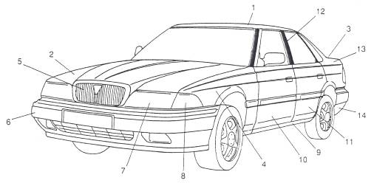
The cowl is sometimes called the fire wall because it is the partition between the passenger and engine compartments and openings in the cowl accommodate the necessary controls, wiring and tubing that extend from one compartment to the other. The instrument panel, which is usually considered as part of the cowl panel although it is a complex panel in itself, provides a mounting for instruments necessary to check the performance of the vehicle during operation. Cowl panels usually have both inner and outer construction, but in certain constructions only the upper portion of the cowl around the windscreen is visible. On many vehicles the front door hinge pillar is also an integral part of the cowl.
Figure 32: Major Body Panels

1 | Roof panel | 8 | Side lamp
2 | Bonnet panel | 9 | Sill panel
3 | Boot lid | 10 | Front door
4 | Front wing | 11 | Rear door
5 | Radiator grille | 12 | Centre pillar
6 | Front bumper bar | 13 | Rear quarter panel
7 | Headlamps | 14 | Rear bumper bar
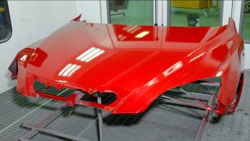

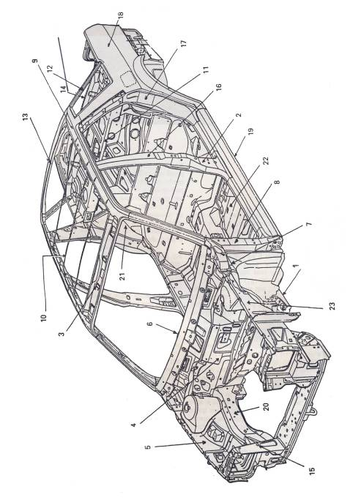
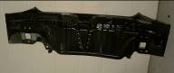
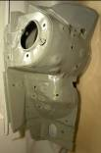

Figure 33: Body Shell Assembly

1 | Underbody assembly
2 | Body side frame assembly
3 | Windscreen upper rail assembly
4 | Cowl and dash panel assembly
5 | Front wheel house complete panel
6 | Instrument panel assembly
7 | Cowl side lower brace
8 | Front body hinge pillar (A-post)
9 | Roof panel assembly
10 | Roof bow assembly
11 | Bulkhead brace assembly
12 | Rear quarter centre panel assembly (back window)
13 | Back window upper rail panel assembly
14 | Rear-end upper panel assembly
15 | Radiator panel complete assembly
16 | Centre pillar (BC-post)
17 | D-post
18 | Rear quarter assembly
19 | Sill panel
20 | Front side member assembly
21 | Rear wheel arch assembly
22 | Main floor assembly
23 | Front valance complete assembly

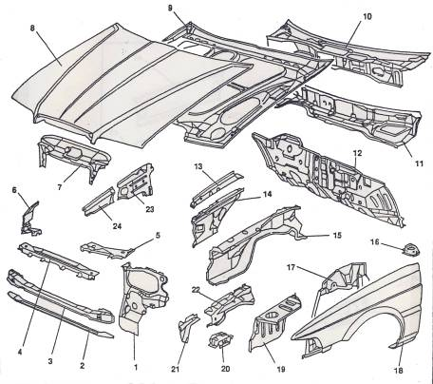
Figure 34: Complete Front-end Assemblies
1 | Headlamp panel RH and LH
2 | Front cross member closing panel
3 | Front cross member
4 | Bonnet lock panel
5 | Headlamp panel reinforcement
6 | Front wing corner piece RH and LH
7 | Bonnet frame extension
8 | Bonnet skin
9 | Bonnet frame
10 | Dash panel
11 | Scuttle panel
12 | Front bulkhead
13 | Chassis leg reinforcement RH and LH
14 | Front inner wing RH and LH
15 | Front chassis leg RH and LH
16 | Subframe mounting RH and LH
17 | Front wheel arch RH and LH
18 | Front wing RH and LH
19 | Battery Tray
20 | Chassis Leg gusset RH and LH
21 | Bumper mounting reinforcement RH and LH
22 | Chassis leg extension RH and LH
23 | A-post rear reinforcement RH and LH
24 | A-post front reinforcement RH and LH
Front Side Member Assembly
This is an integral part of the front-end assembly; it connects the front wing valances to the cowl or dash assembly. It is designed to strengthen the front end; it is part of the crumple zone, giving lateral strength on impact and absorbing energy by deformation during a collision. It also helps to support the engine and suspension units (see figure 34; key figure reference 13, 15, 16, 20, 22).
A-post Assembly
This is an integral part of the body side frame. It is connected to the front end assembly and forms the front door pillar or hinge post. It is designed to carry the weight of the front bulkhead assembly
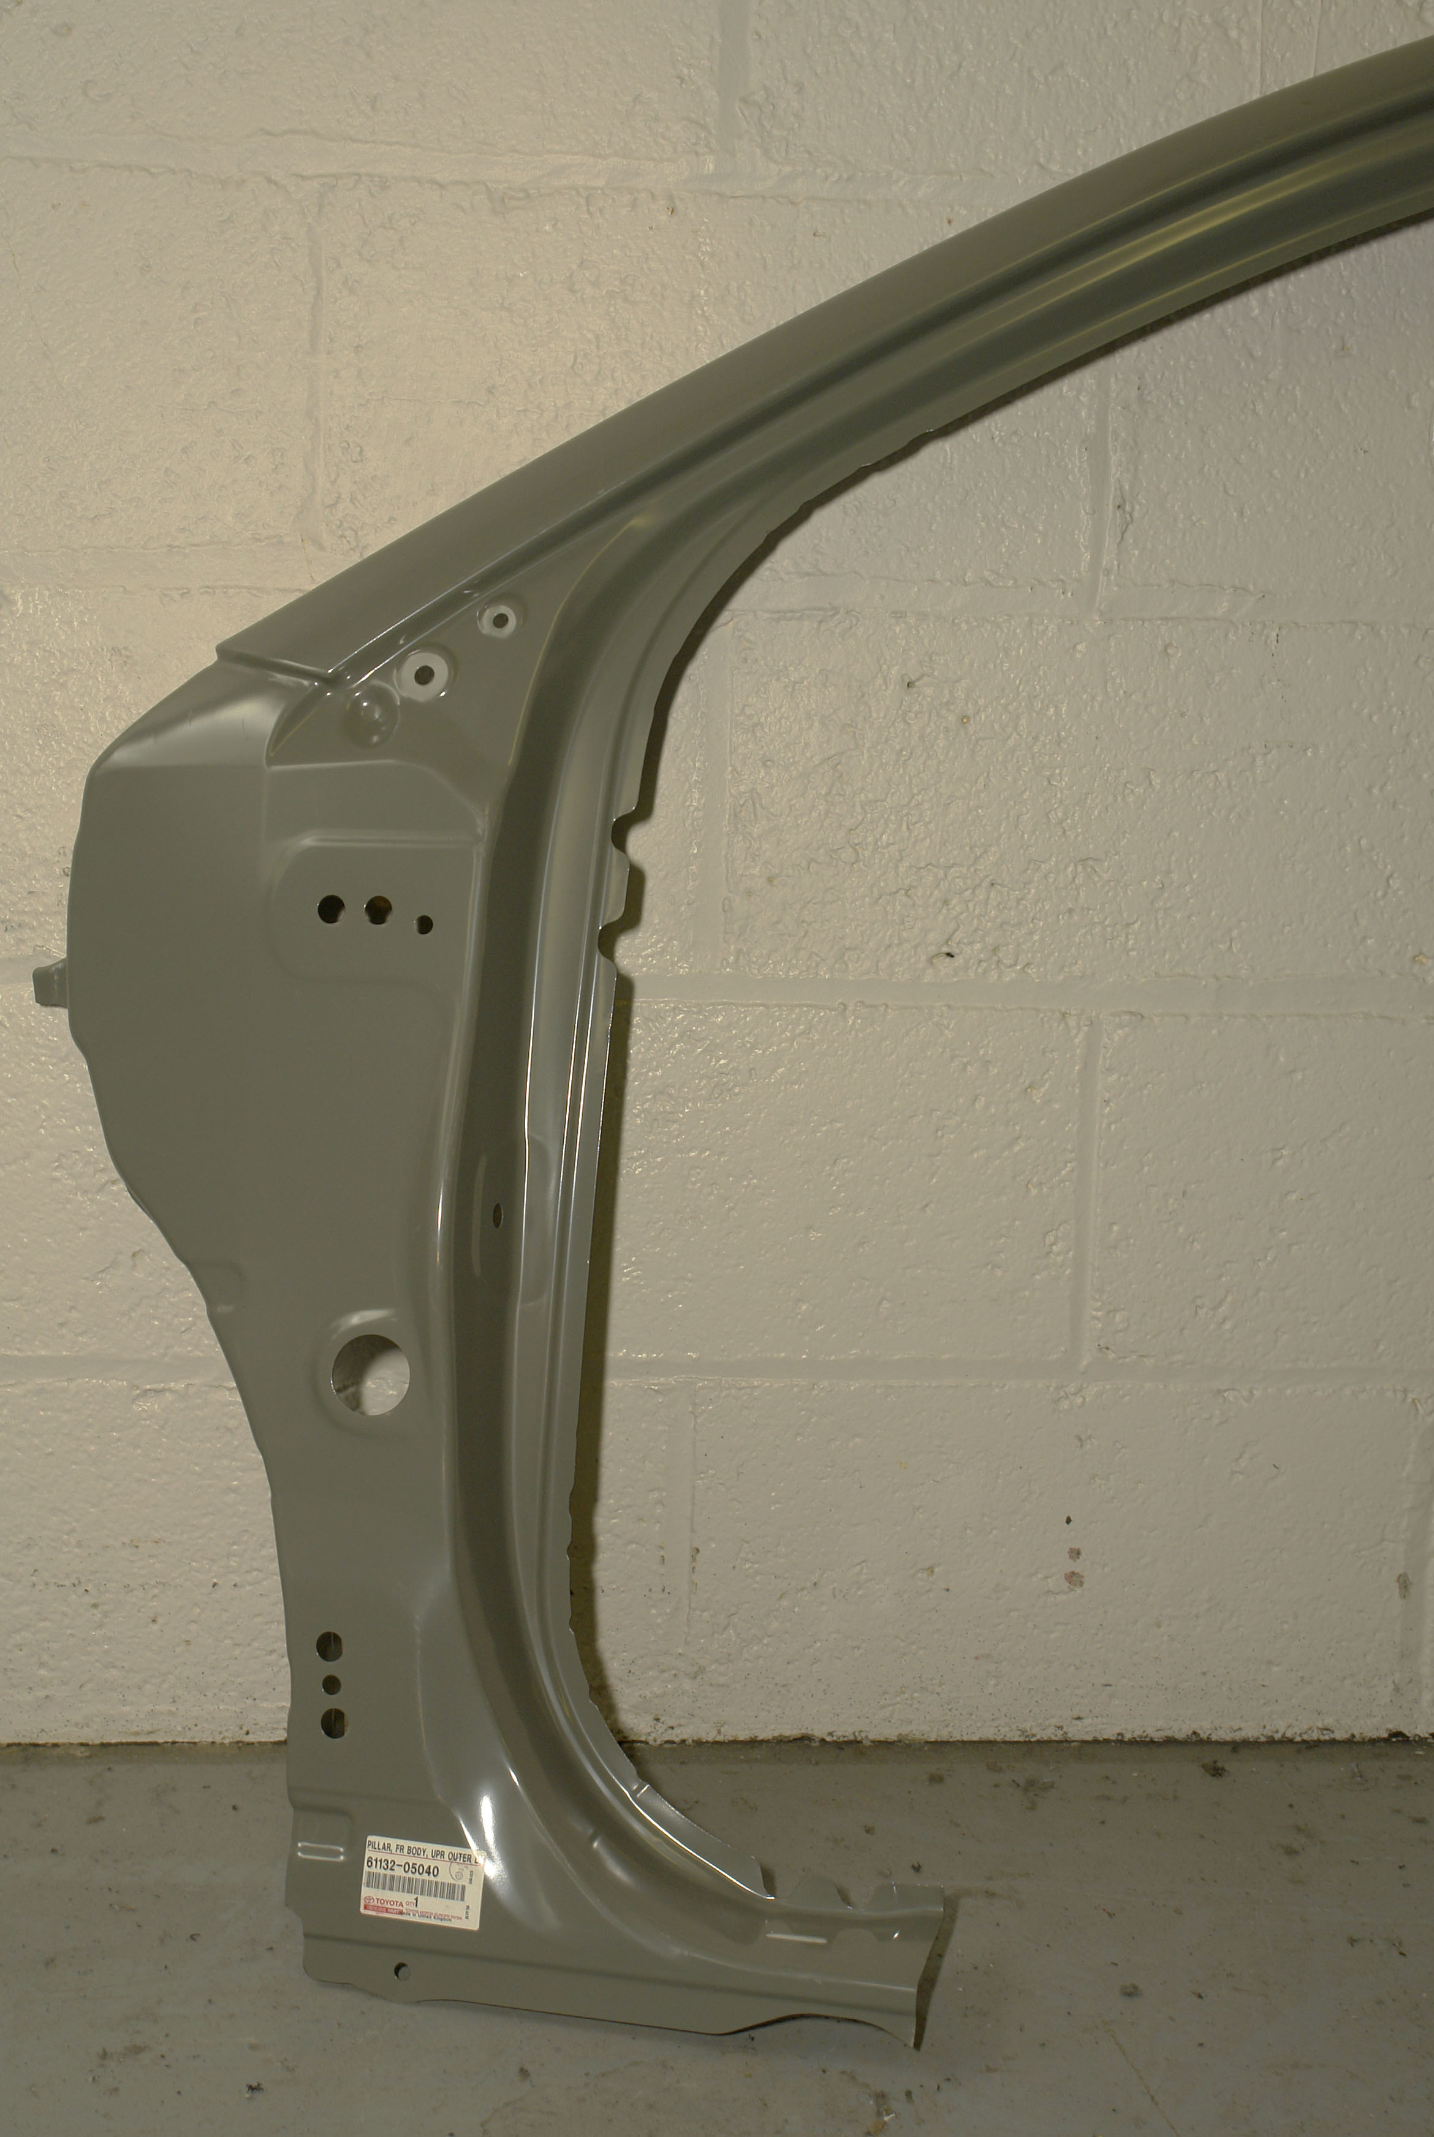
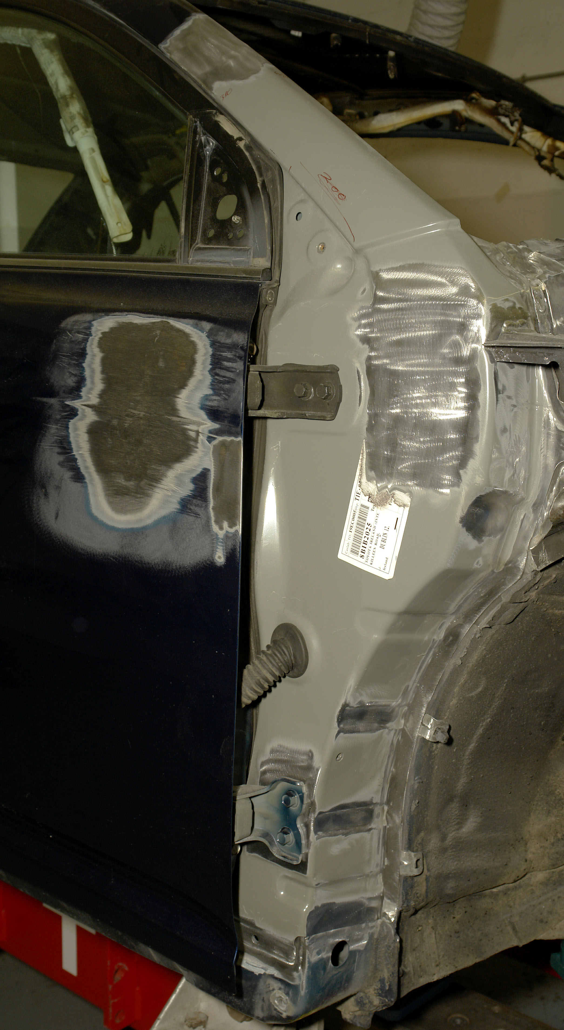

Main Floor Assembly
This is the passenger-carrying section of the main floor. It runs backwards from the toe panel to the heelboard or back seat assembly. It is strengthened to carry the two front seats and in some cases may have a transmission tunnel running through its centre. Strength is built into the floor by the transmission tunnel acting like an inverted channel section. The body sill panels provide extra reinforcement in the form of lateral strength. Transverse strength is provided by box sections at right angles to the transmission tunnel, generally in the areas of the front seat and in front of the rear seat. The remaining areas of floor are ribbed below the seats and in foot wells to add stiffness.
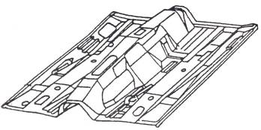

Boot Floor Assembly
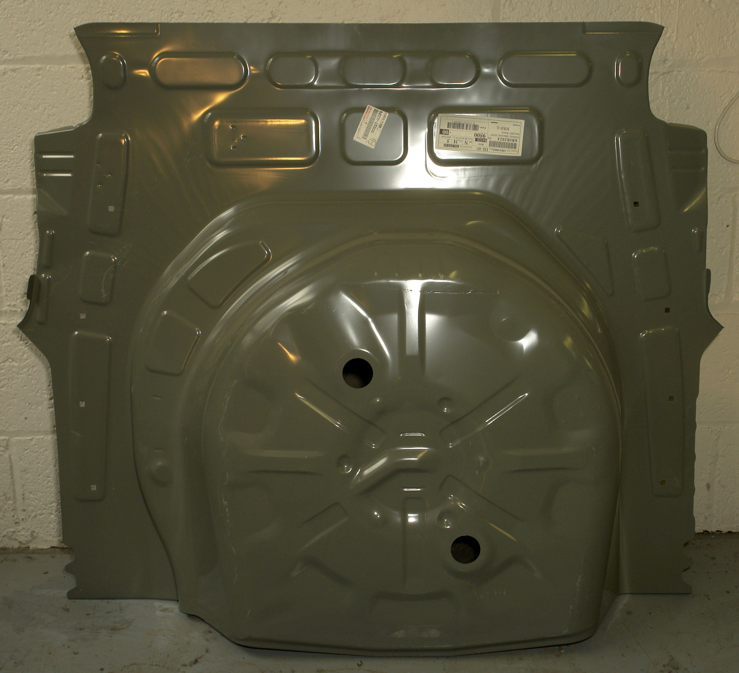
This is a section of the floor between the seat panel and the extreme back of the boot. It is strengthened by the use of cross members to carry the rear seat passengers. This area forms the rear bulkhead between the two rear wheel arches forming the rear seat panel or heelboard and in a saloon body shell can incorporate back seat supports and parcel shelf. The boot floor is also strengthened to become the luggage compartment, carrying the spare wheel and petrol tank. At the extreme back it becomes the panel on to which the door or tailgate closes.
Complete Underbody Assembly
This is commonly called the floor pan assembly and is usually composed of several smaller panels welded together to form a single floor unit. All floor panels are reinforced on the underside body stiffening members or cross members. Most floor pans are irregular in shape for several reasons. They are formed with indentations or heavily swaged areas to strengthen the floor section between the cross members and foot room for the passengers is often provided by these recessed areas in the floor.
Body Side Frame Assembly
On a four-door saloon this incorporates the A-post, the BC-post, the D-post and the rear quarter section. The side frames reinforce the floor pan along the sill sections. The hinge pillar or A-post extends forward to meet the dash panel and front bulkhead to provide strength at this point. The centre pillars or BC-posts connect the body sills to the roof cantrails. They are usually assembled as box sections using a top-hat section and flat plate. These are the flanges which form the attachments for the door openings. The D-post and rear quarter section is integral with the rear wheel arch and can include a rear quarter window.
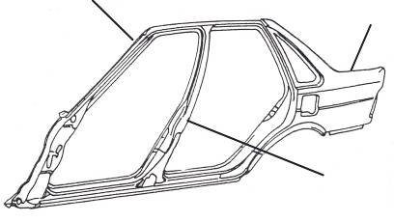
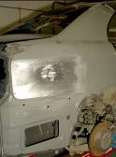

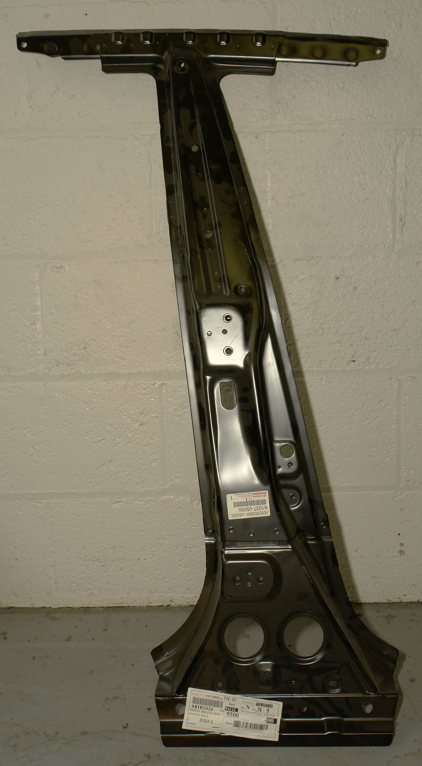

Figure 35: Body Side Assembly

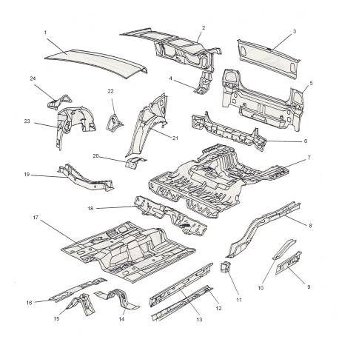
Figure 36: Main Floor and Boot Assemblies
1 | Boot lid skin
2 | Boot lid frame
3 | Boot lid lower skin
4 | Boot lid striker reinforcement
5 | Outer rear panel
6 | Rear panel reinforcement
7 | Boot floor
8 | Rear chassis leg RH and LH
9 | Inner sill rear extension RH and LH
10 | Chassis leg reinforcement RH and LH
11 | Rear suspension mounting
12 | Centre chassis leg RH and LH
13 | Inner sill RH and LH
14 | Centre cross member
15 | Main floor centre reinforcement
16 | Centre tunnel reinforcement
17 | Main floor
18 | Heelboard
19 | Rear suspension cross member
20 | Rear seatbelt upper mounting RH and LH
21 | Outer rear wheel arch RH and LH
22 | Wheel arch gusset RH and LH
23 | Inner rear wheel arch RH and LH
24 | Rear suspension turret capping RH and LH
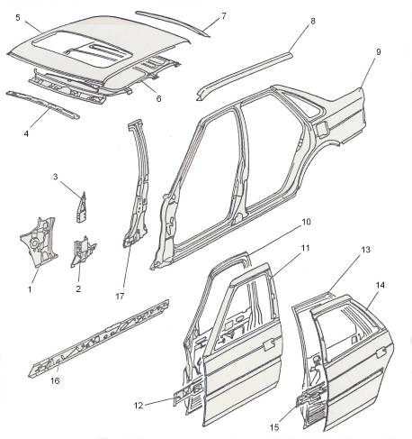
Figure 37: Body Side Assemblies, Roof, BC-Post, Front and Rear Doors
1 | A-post RH and LH
2 | A-post lower reinforcement RH and LH
3 | A-post upper reinforcement RH and LH
4 | Header rail
5 | Roof panel
6 | Sunroof frame
7 | Roof rear cross member
8 | Cantrail RH and LH
9 | Body side assembly RH and LH
10 | Front door frame RH and LH
11 | Front door skin RH and LH
12 | Front door crash rail RH and LH
13 | Rear door frame RH and LH
14 | Rear door skin RH and LH
15 | Rear door crash rail RH and LH
16 | Intermediate sill RH and LH
17 | B-post reinforcement RH and LH

Roof Panel
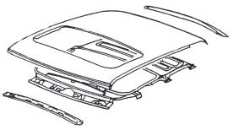
The roof panel is one of the largest of all major body panels and it is also one of the simplest in construction. The area which the roof covers varies between different makes and models of cars. On some cars, the roof panel extends downwards around the windscreen so that the windscreen opening is actually in the roof. On some cars the roof ends above the rear window, while on others it extends downwards so that the rear window opening is in the lower rear roof. When this is the case the roof panel forms the top panel around the rear boot opening. Some special body designs incorporate different methods of rear window construction, which affects the roof panel; this is particularly true for estate cars, hatchbacks and hardtop convertibles. Alternatively the top is joined to the rear quarter panel by another smaller panel which is part of the roof assembly.
The stiffness of the roof is built in by the nature given to it by the forming presses, while reinforcements, consisting of small metal strips placed crosswise to the roof at intervals along the inside surface, serve to stiffen the front and rear edges of the windscreen and rear window frames. In some designs the roof panel may have a sliding roof built in or a flip-up detachable sunroof incorporated.

Rear Quarter Panel or Tonneau Assembly
This is integral with the side frame assembly and has both inner and outer construction. The inner construction comprises the rear wheel arch and the rear seat heelboard assembly. This provides the support for the rear seat squab in a saloon car; if the vehicle is a hatchback or estate car, the two back seats will fold flat and the seat squabs will need no support. This area is known as the rear bulkhead of the car; it gives additional transverse strength between the wheel arch sections and provides support from the rear seat. The rear bulkhead also acts as a partition between the luggage and passenger compartments.
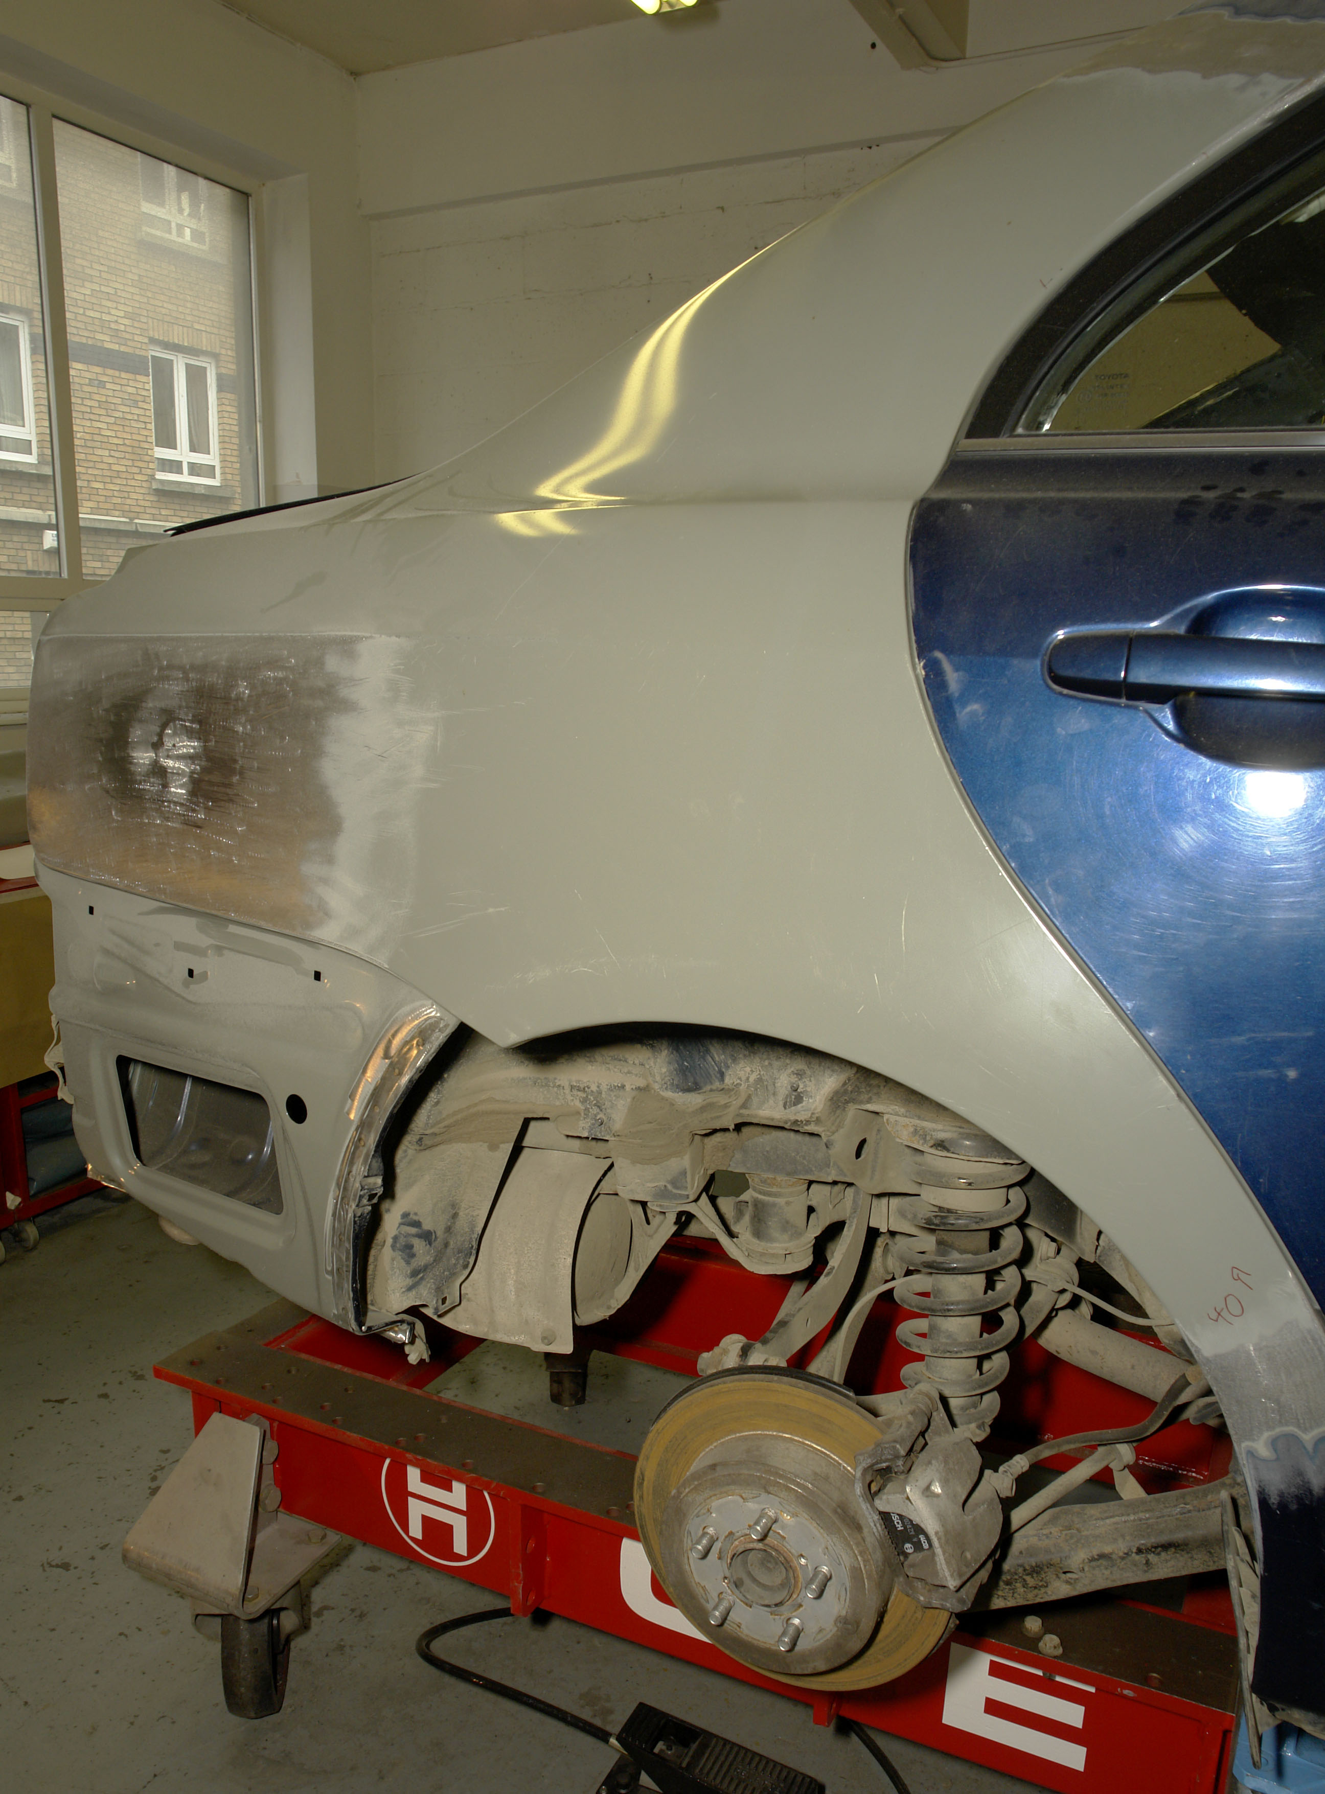
Rear Wheel Arch Assembly
This assembly is constructed as an integral part of the inner construction of the rear quarter panel. It is usually a two-piece construction comprising the wheel arch and the quarter panel, which are welded together.

Wings
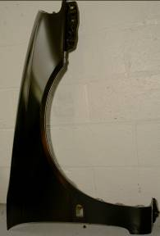
A wing is a part of the body which covers the wheel. Apart from covering the suspension construction, the wing prevents water and mud from being thrown up on to the body by the wheels. The front wings (or the fender assembly) are usually attached to the wing valance of the front end assembly by means of a flange the length of the wing, which is turned inwards from the outer surface and secured by either welding or bolts. Adjustment for the front wing is usually provided for by slotting the bolt holes so that the wing can be moved either forwards or back wards by loosening the attaching bolts. This adjustment cannot be made if the wing is welded to the main body structure. In some models the headlights and sidelights are recessed into the front wing and fastened in place by flanges and reinforcement rims on the wing. Any trim or chrome which appears on the side of the wing is usually held in place by special clips or fasteners which allow easy removal of the trim.
The unsupported edges of the wing are swaged edges known as beads. The bead is merely a flange which is turned inwards on some cars and then up to form a U-section with a rounded bottom. It not only gives strength but prevents cracks developing in the edges of the wing due to vibration and it provides a smooth finished appearance to the edge of the wing.
In general the rear wing is an integral part of the body side frame assembly and rear quarter panel. When the wing forms an integral part of the quarter panel, the inner construction is used to form part of the housing around the wheel arch. The wheel arch is welded to the rear floor section and is totally concealed by the rear quarter panel, while the outer side of the wheel arch is usually attached to the quarter panel around the wheel opening. This assembly prevents road dirt being thrown upwards between the outer panel and inner panel construction.

Doors
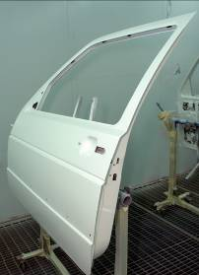
Several types of door are used on each vehicle built, although the construction of the various doors is similar regardless of the location of the door on the vehicle. The door is composed of two main panels, an outer and an inner panel, both being of all-steel construction. The door derives most of its strength from the inner panel since this is constructed mainly to act as a frame for the door. The outer panel flanges over the inner panel around all its edges to form a single unit, which is then spot welded or, in some cases, bonded with adhesives to the frame.
The inner panel has holes or apertures for the attachment of door trim. This trim consists of the window regulator assembly and the door locking mechanism. These assemblies are installed through the large apertures in the middle of the inner panel. Most of the thickness of the door is due to the depth of the inner panel which is necessary to accommodate the door catch and window mechanism. The inner panel forms the lock pillar and also the hinge pillar section of the door. Small reinforcement angles are usually used between the outer and inner panel, both where the lock is inserted through the door and where the hinges are attached to the door. The outer panel is either provided with an opening through which the outside door handle protrudes, or is recessed to give a more streamlined effect and so to create better aerodynamics.
The upper portion of the door has a large opening which is closed by glass. The glass is held rigidly by the window regulator assembly and when raised it slides in a channel in the opening between the outer and inner panels in the upper portion of the door. When fully closed the window sits tightly in this channel, effectively sealing out the weather.
Boot Lid or Tailgate
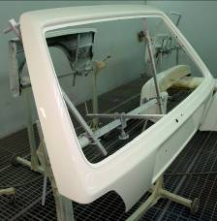
This is really another door which allows access to the luggage compartment in the rear of the car. A boot lid is composed of an outer and an inner panel. These panels are spot welded along their flanged edges to form a single unit in the single unit in the same manner as an ordinary door. The hatchback and estate car have a rear window built into the boot lid, which is then known as a tailgate. Some manufacturers use external hinges, while others use concealed hinges attached to the inner panel only. A catch is provide at the lower rear edge of the boot lid or tailgate and is controlled by an external handle or locking mechanism. This mechanism may be concealed from the eye under a moulding or some type of trim. In some models there is no handle or external locking mechanism; instead the hinges are spring loaded or use gas-filled piston supports, so that when the lid is unlocked internally it automatically rises and held in the open position by these mechanisms.

Trims
The details of exterior and interior trims are shown in figures 38 and 39.
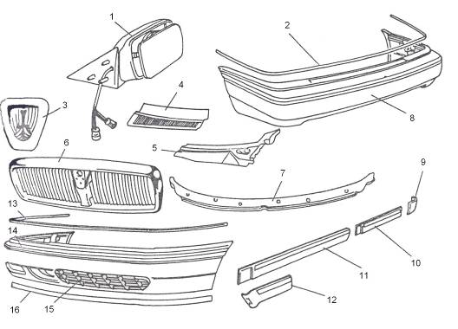
Figure 38: Exterior Trim
1 | Door mirror assembly
2 | Rear bumper insert (moulding)
3 | Motif
4 | Scuttle grill
5 | Scuttle moulding
6 | Front grill
7 | Lower screen moulding
8 | Rear bumper
9 | Rear wing waist moulding
10 | Rear door waist moulding
11 | Front door waist moulding
12 | Front wing waist moulding
13 | Bumper crome insert
14 | Bumper
15 | Lower front grill
16 | Front spoiler

Bonnet
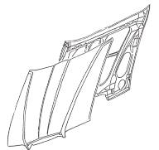
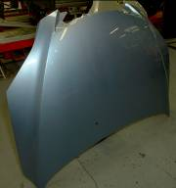
The bonnet is the panel which covers the engine compartment where this is situated at the front of the vehicle, or the boot compartment of a rear-engined vehicle. Several kinds of bonnet are in use on different makes of cars. The bonnet consists of an outer panel and an inner reinforcement constructed in the H or cruciform pattern which is spot welded to the outer skin panel at the flanged edges of the panels. The reinforcement is basically a top-hat section, to give rigidity to the bonnet. In some cases the outer panel is bonded to the inner panel using epoxy resins. This system avoids the dimpling effect on the outer surface of the bonnet skin which occurs in spot welding. Early models used a jointed type of bonnet which was held in place by bolts through the centre section of the top of the bonnet into the body of the cowl and into the radiator. A piano type hinge was used where the bonnet hinged both at the centre and at the side. The most commonly used bonnet on later constructions known as the mono or one-piece type, and can be opened by a variety of methods. On some types it is hinged at the front so that the rear end swings up when the bonnet is open. Others are designed so that they can be opened from either side, or unlatched from both sides and removed altogether. Most bonnets, however, are of the alligator pattern, which is hinged at the rear so that the front end swings up when opened.
The type of bonnet catch mechanism depends on the type of bonnet used. When a bonnet opens from the rear the catch mechanism is also at the rear. When it opens from either side the combination hinge and catch are provided at each side. The alligator bonnets have their catches are controlled from inside the car.
Bonnets are quite large and to make opening easier the hinges are usually counterbalanced by means of tension or torsion springs. Where smaller bonnets are used the hinges are not counterbalanced and the bonnet is held in place by a bonnet stay from side of the wing to the bonnet. Adjustment of the bonnet position is sometimes possible by moving the hinges.
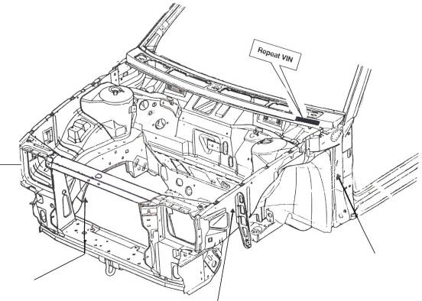
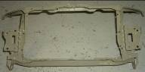
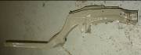
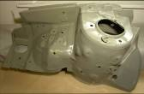
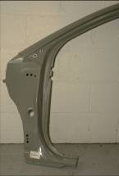
1

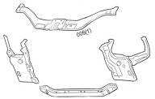
3
4

2

1. Front radiator panel complete assembly
2. Chassis Leg
3. Front valance
4. Front standing pillar (A-post)

Figure 39: Major Body panels
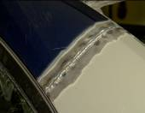
2

1 3
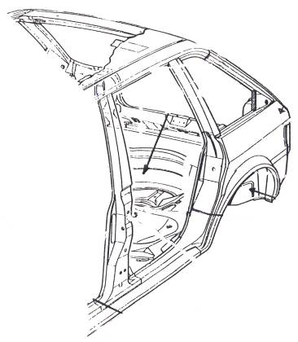

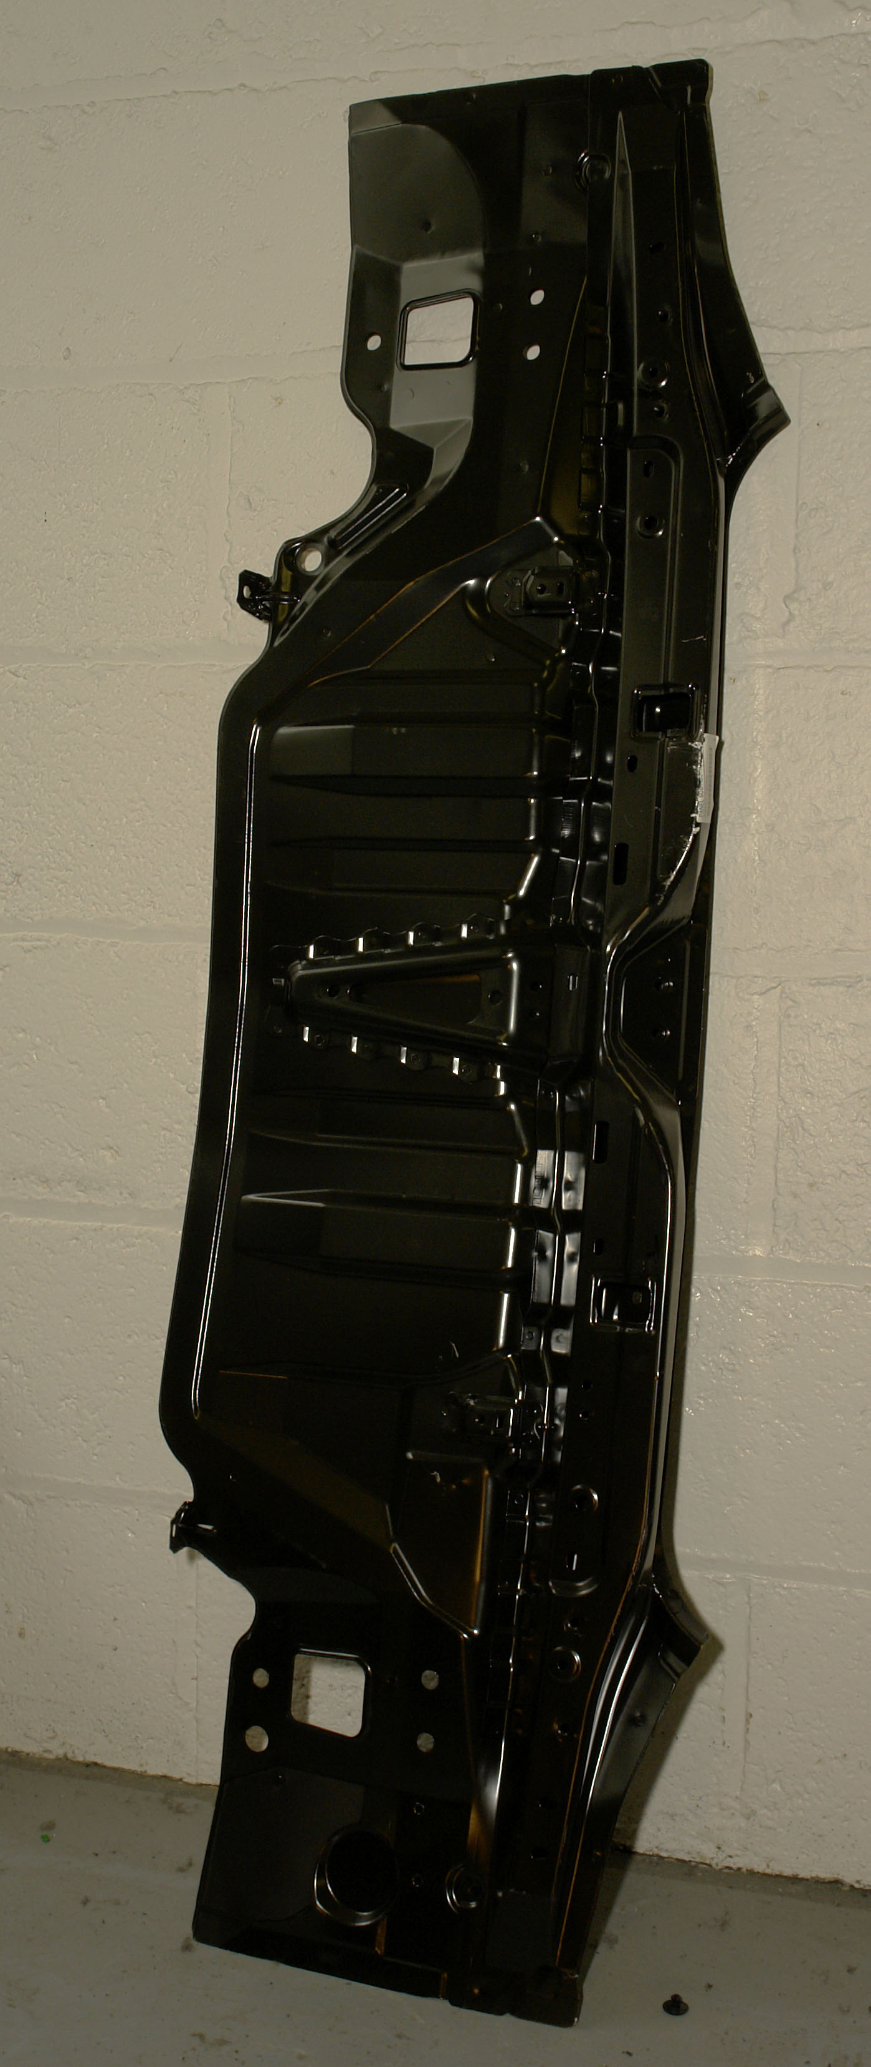

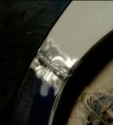

4
6 5
1. Roof ¼ panel joint
2. Rear quarter assembly
3. Boot floor assembly
4. Rear end panel assembly
5. Dog leg joint
6. Centre pillar (B post)
Figure 40: Major Body Panels
Front End Panel Repair
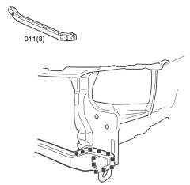
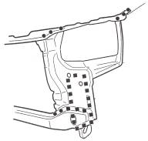

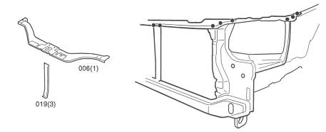
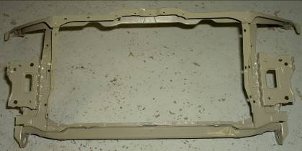
Figure 41: Front End Panel Repairs

2.1 Front End Panel Operations
Front Chassis Leg Section
During removal, cut the panel at 1 in figure 42. Cut out spot welds at 2 and remove panel bulk. In replacement, trim the new panel to form a seam welded butt joint with the existing panel at 1. Drill or punch holes in the new panel for plug welding at 2 due to excessive metal thickness.
NB. This is one example always follow manufacturers instructions when fitting panels or thatchem methods manuals.
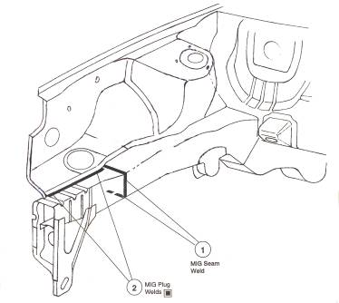

Figure 42: Front Chassis Leg Section
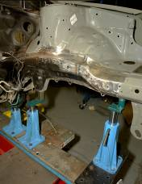
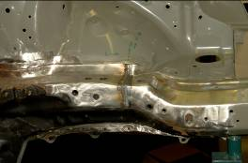
Front Inner Wing Assembly and Reinforcement
During removal, cut out the production welds at 1, 2, 3, 4, 5, 6, 7 and 8 in figure 43. It is necessary to drill out the spot welds at 1 from inside the vehicle. Remove panel bulk. In replacement, drill and punch holes in the new panels for plug welding at 4, 5, 8 and 9 as there is no spot welding access at these points. Make further plug welds at 6 due to excessive metal thickness and reinstate the production seam welds at 7. In cases where a RH front inner wing is undergoing replacement, it is necessary to plug weld to the main engine mounting bracket at 2 and 3 as there is no access for a spot welder and also to plug weld at 1 using the holes left by the spot weld cutter.
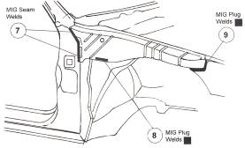
Associated panels to be removed and replaced: Front wing, Front door.
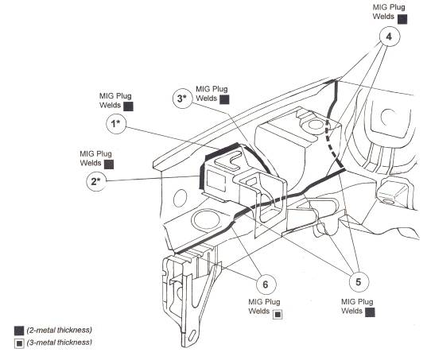
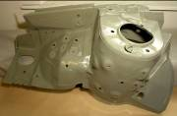

Figure 43: Front Inner Wing Assembly and Reinforcement

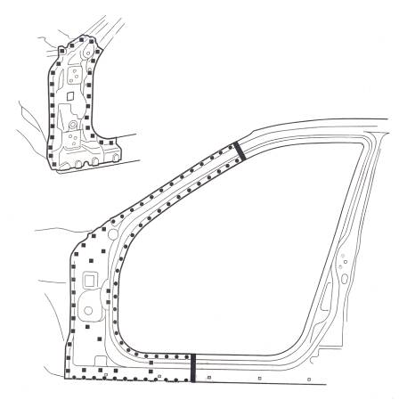
Figure 44: ‘A’ Post Repair

Centre Pillar Bodyside Panel Operations
Outer ‘B’ post/sill panel section (C):
During removal, cut the panel at 1, 2 and 3 in figure 45, taking care to avoid damaging the ‘A’ post inner reinforcement when making the cut at 3. Cut out spot welds and remove panel bulk. In replacement, cut and trim the new panel to form seam welded butt joints with the existing panel at 1, 2, and 3. Drill or punch holes in the outer and forward faces for plug welding to the inner reinforcement at 4 as there is no access for spot welding in these areas.
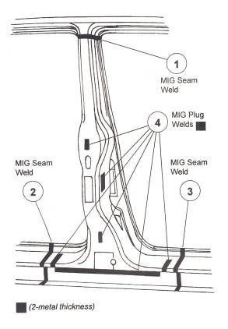

Figure 45: Outer ‘B’ Post/Sill Panel Section

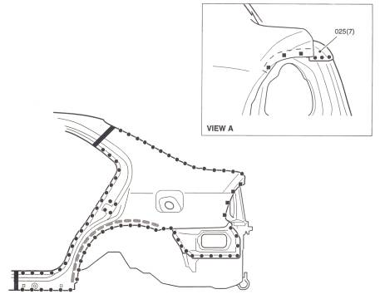
Figure 46: Rear wing Repairs
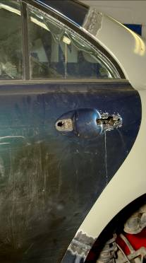

2.2 Rear End Panel Operations
Lower Rear Panel Assembly:
In replacement, drill or punch holes in the new panel for plug welding at 1 in figure 47 due to excessive metal thickness, also at the boot floor rear edge and chassis legs at 2 as there is no spot welding access these points. Make further plug welds at 3 using the holes left by the spot weld cutter.
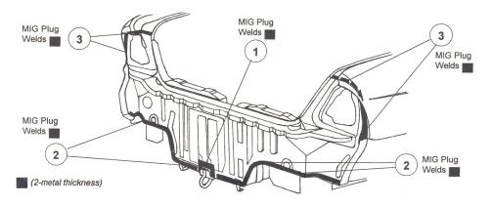

Figure 47: Lower Rear Panel Assembly

Bootfloor Section (D)
During removal, cut the boot floor 15mm behind the rear flange of the rear suspension crossmember as shown in figure 48. Cut out remaining spot welds and remove panel bulk. In replacement, discard the front section of the new panel and trim to form a seam weld and plug welded lap joint with the existing panel at 1 (see also inset diagram). Drill or punch holes in the new panel for plug welding at 2 and at the forward sections of the chassis legs at 3 as there is no access for spot welding at these points.
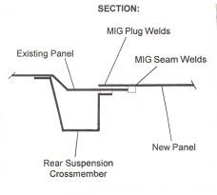
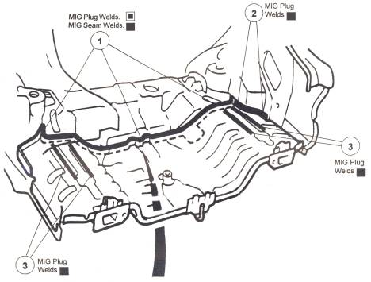

Figure 48: Boot Floor Section
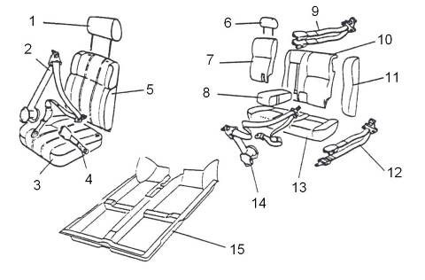
Interior Trim
1 | Front seat headrest
2 | Front seatbelt assembly
3 | Front seat cushion
4 | Front seatbelt centre stalk
5 | Front seat back rest
6 | Front seat head rest
7 | Rear seat back rest small section
8 | Rear seat centre arm rest
9 | Rear seatbelt buckle assembly
10 | Rear seat back rest large section
11 | Rear seat side bolster
12 | Rear seatbelt lap assembly
13 | Rear seat cushion
14 | Rear seatbelt assembly
15 | Main floor carpet
Figure 49: Interior Trim

2.3 Vehicle identification Numbers

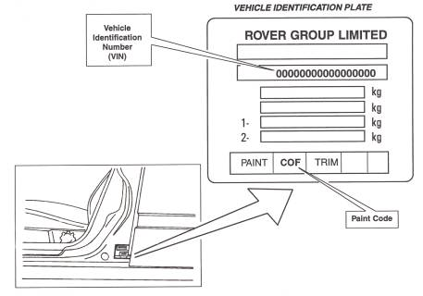
The vehicle identification number (VIN) is stamped on a plate located typically inside the engine compartment or on a door pillar. The figure also shows the paint and trim codes which are usually included on the VIN plate. The car body number is proved separately in the engine or boot compartment.

Figure 50: Vehicle Identification Numbers
Summary
Early vehicles were very simple timber structures made by hand; manufacturers did not have the luxury of computers or wind tunnels to aid design. They were unreliable boneshakers but in the early twentieth century things started to improve greatly and the vehicles where being made of steel, but the biggest problem of all even into the eighties was rust, as the all-steel body was not properly zinc coated to protect it from rust.
Nowadays cars have more on board computerised technology than the first passenger aircraft.

Self Assessment
Questions – Module 3. unit 4
1. Why was the earliest motor vehicle bodies made almost entirely of wood?
2. When and why did manufacturers commence to use metal for the construction of vehicle bodies?
3. What is meant by monocoque construction and why has it become so popular in the motor vehicle manufacturer?
4. State the location and function on a vehicle body of the following section: B post.
5. State the reasons for swaging certain areas of a vehicle floor pan.

6. How are vehicles made safe against side impact involvement?
7. Explain how the airbag system works in a vehicle.
8. Explain the VIN number and why it is used.
9. What is the most common form of vehicle body construction?
10. What are the alternatives to integral construction?
11. What is a crumple zone?

Answers to Questions 1-11. Module 3. Unit 4
1.
Because the technology was not there to build steel bodies.
2.
1927
3.
Monocoque or unity means components welded together to form one piece.

4.
It’s the pillar between the front and rear door on a four door vehicle.

5.
To give strength

6.
By fitting side impact bars inside the doors.
7.
A control module detects deceleration and fires the airbag.
8.
Vehicle identification number is a reference number to identify the vehicle and to be used to order parts if necessary.

9.
Mono unity or integral.
10.
Composite
11.
A section on a chassis that is designed to give way on impact.

Training Resources
- Classroom
- Visual aids

27-33 Upper Baggot Street
Dublin 4

