TRADE OF
VEHICLE BODY REPAIR

PHASE 2

Module 5

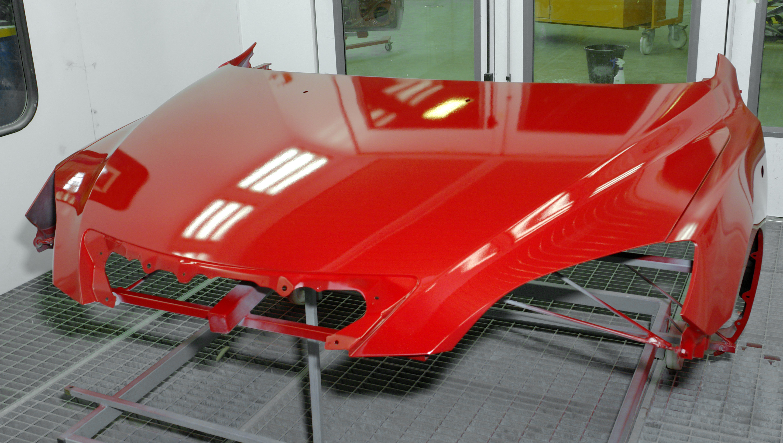
UNIT: 7
Post Paint Treatment

Produced by

In cooperation with subject matter expert:
Maurice Stack
Some material courtesy of CDX Global and
FENC – Further Education National Consortium.
© SOLAS 2014

Table of Contents
Introduction 4

Unit Objective 5

Post Paint Treatment 5

1.0 Accurately and Efficiently Burnish a Painted Panel by Wet and Dry Methods 6
1.1 Correct use of Abrasives during Wet Flat Burnishing 6
1.2 Dry Flat Burnishing Techniques 8
2.0 Rectification Methods for Common Paint Faults 10
2.1 Common Paint Finish Faults 10
2.2 Correct use of Abrasives during Wet Flat Burnishing 10
3.0 Polishing a Burnished Panel using a Mechanical Polisher 12
3.1 Correct use of Mechanical Polishers 12
3.2 Foam, Lambs Wool and Mutton Cloth Polishing Materials 13
3.3 Silicone Free Rubbing Compounds and Polishes 13
3.4 Paint Finish Evaluation 15
Summary 16
Self Assessment 17
Suggested Exercise
Training Resources
Introduction
Whether badly damaged or just slightly scraped, when a car is damaged, the owner wants it back on the road, the way it was before, quickly as possible.
Quality of final finish is of the utmost importance because the whole job is judged on the paint finish most of the time.
The trade depends on high standards of workmanship and methods of working to achieve this.

Unit Objective
Post Paint Treatment
By the end of this unit each apprentice will be able to:
- Select appropriate rectification methods for common paint faults
- Accurately and efficiently burnish a painted panel by wet and dry methods
- Polish a burnished panel to a deep lustre by using a mechanical polisher

Key Learning Points:
- Common paint finish faults
- Rectification methods for common paint faults
- Correct use of abrasives during wet flat burnishing
- Dry flat burnishing techniques
- Foam, lambs wool and mutton cloth polishing materials
- Correct use of mechanical polishers
- Silicon free rubbing compounds and polishers
- Paint finish evaluation
- Communication skills

1.0 Accurately and Efficiently Burnish a Painted Panel by Wet and Dry Methods
1.1 Correct use of Abrasives during Wet Flat Burnishing

Wet flatting with hand block to remove imperfections.
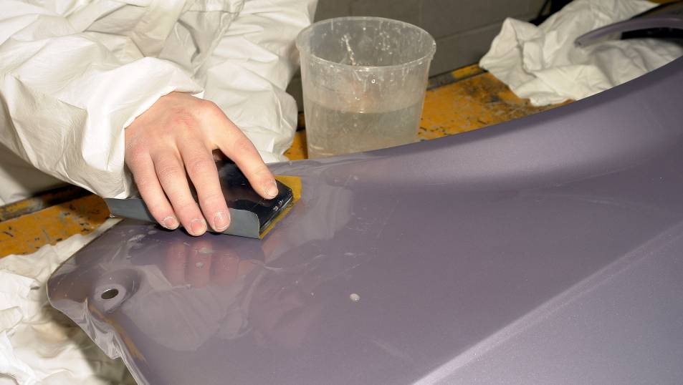

Apply rubbing compound to a flatted area.
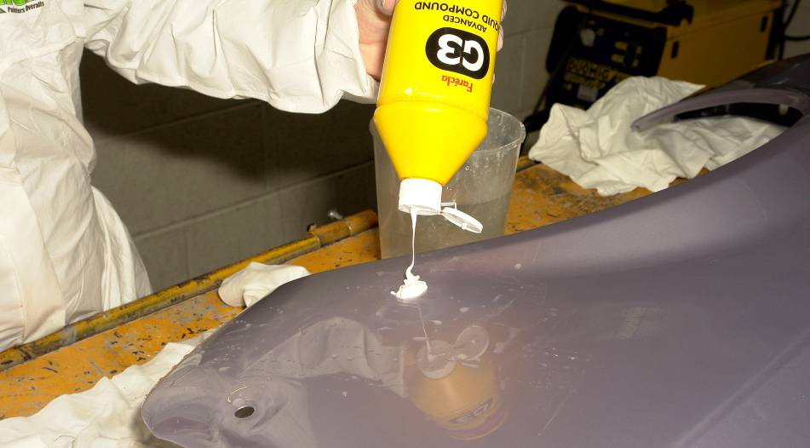

Hand burnish paint with compound.
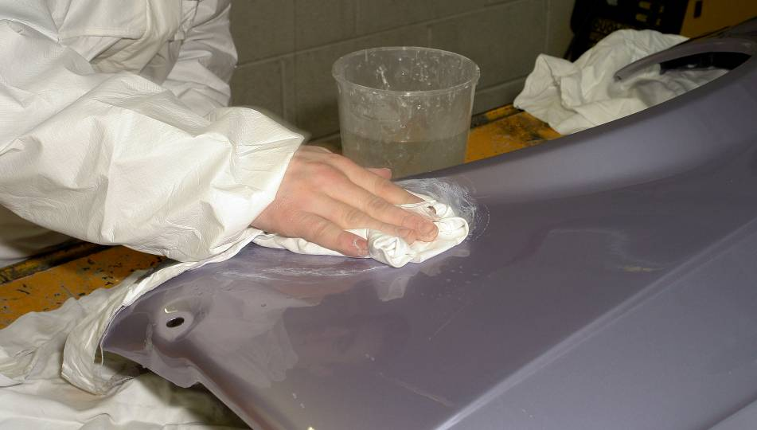

Hand burnish paint with polish.
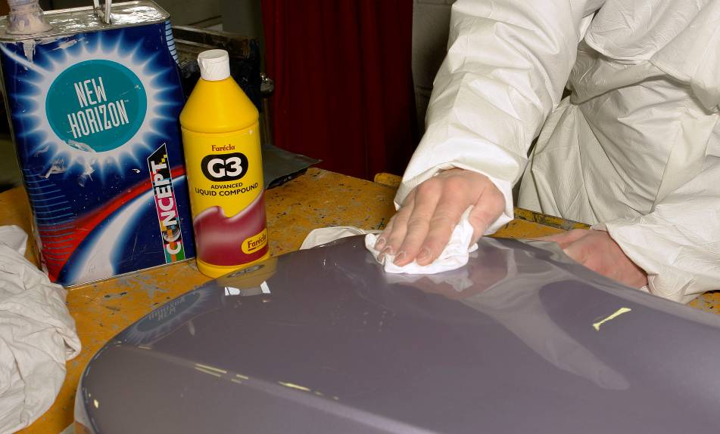

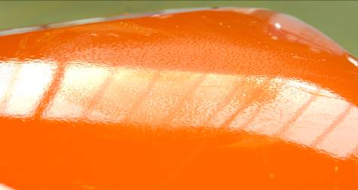
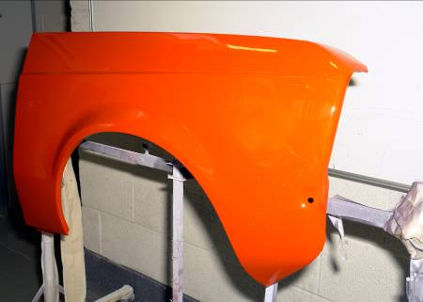
Original shine restored to area and surrounding paint work.

1.2 Dry Flat Burnishing Techniques

Dry Flat with sanding machine to remove imperfections.
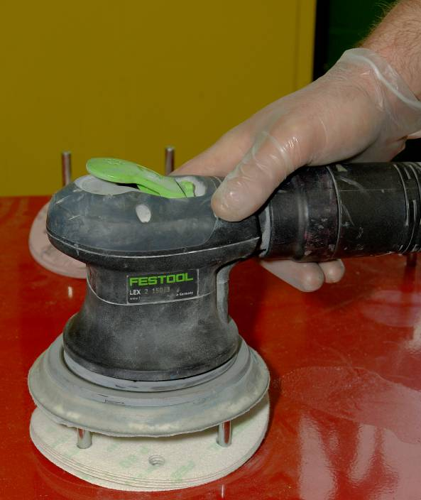

Apply rubbing compound to flatted area.

Machine burnish paint with compound then machine burnish paint with polish.
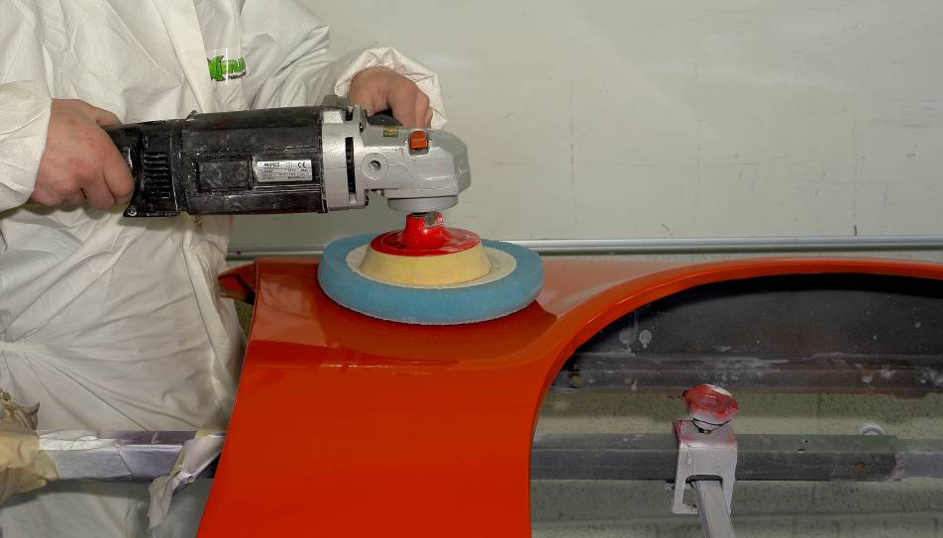

Original shine restored to area and surrounding paint.
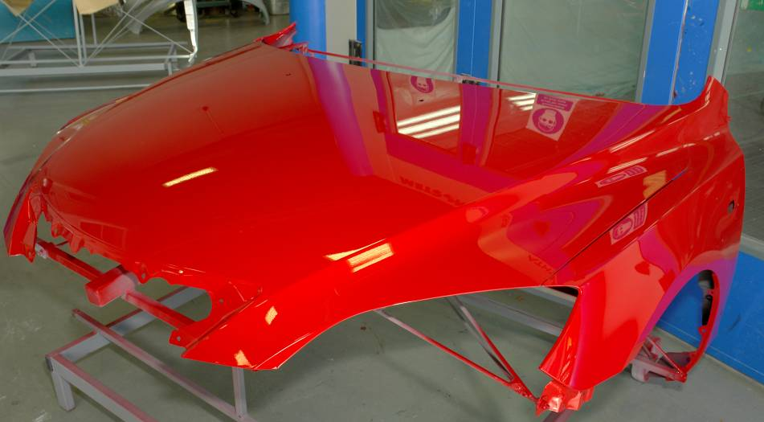
2.0 Rectification Methods for Common Paint Faults
2.1 Common Paint Finish Faults
See Module 5. Spray Painting
Most common paint finish faults can be rectified by the following procedure:
- Identify the fault
- Choose rectification method (wet or dry sand)

2.2 Correct use of Abrasives during Wet Flat Burnishing
The correct selection of grade paper and sequence when burnishing is very important, because incorrect methods may result in damage and costly re-working and re-painting, so care should be taken.

Abrasive Selection Wet Sanding
P1500 – P2000 to remove imperfections
P2500 – P3000 to restore paint condition
Compound up the shine
Polish up the shine

Abrasive Selection Dry Sanding
P500 to key for painting
P1000 to key for blending
P100 – P1500 to remove paint defects
P2000 – P3000 to restore paint to original finish
Disc Manufacturer | Disc | P Grade | Application
Kovax | Tolex | 1000 | Paint Rectification
Kovax | Black Buflex | 3000 | Paint Rectification
Kovax | Green buflex | 2500 | Paint Rectification
SIA | Velvet | 500 | Key for Painting
SIA | Velvet | 1000 | Blending
SIA | Velvet | 2000 | Paint Rectification
SIA | Carat | 500 | Key for Ceramic Painting
SIA | Carat | 1000 | Blending Ceramic
3M | Trizact | 1000 | Paint Blending

3.0 Polishing a Burnished Panel using a Mechanical Polisher
3.1 Correct use of Mechanical Polishers
- Handle can be fitted to suit left or right hand use
- Hold machine firmly with light pressure on pad
- When correct pressure is applied, you will find a pulling force at the handle when in use
- Use water to keep work cool
- Foam pads may be used
- Lambs wool pad may be used (better heat application)

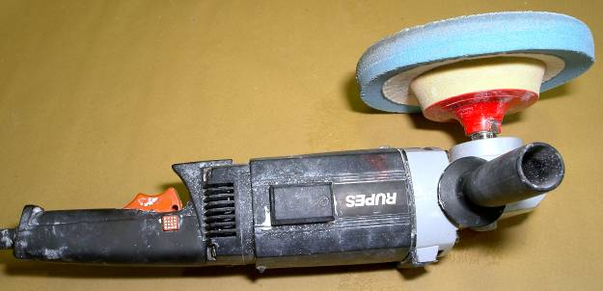
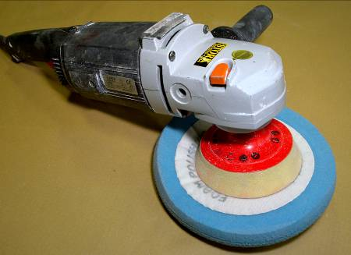

Machine Polishing
Machine polishing requires quite a lot of skill. The operator must take care to keep the mop on the move – preventing the generation of too much heat which can soften or burn some finishes. He must also be careful to avoid sharp edges and awkward curves, where the finish can easily be removed.

Polishing mops must be kept clean. Excessive compound and paint residues in a mop increase friction and the tendency to burn the finish. Lambs wool mops can be washed with warm water and soap and then returned to the machine and spun dry.
- Removes compounding swirl marks
- Eliminates haze
- Produces just painted finish
- Particularly effective on dark colours

3.2 Foam, Lambs Wool and Mutton Cloth Polishing Materials
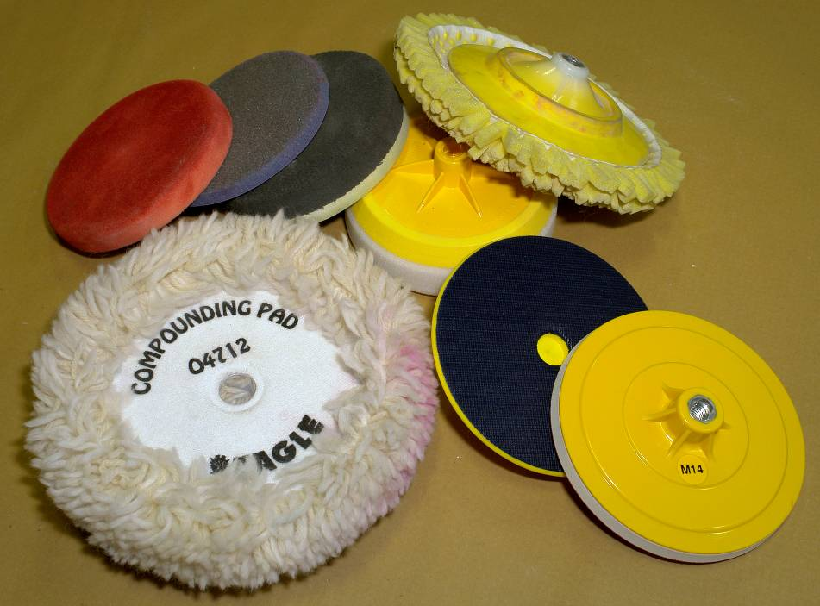
3.3 Silicone Free Rubbing Compounds and Polishes
Rubbing Compounds
Rubbing compounds are like flatting papers: the coarser grades cut faster but produce deeper scratches. So the finest grade capable of doing the job should be used.
Heavy polishing should not be carried out on thin final coats. In some colours, if a breakthrough occurs and the previous coat is exposed, a dark ring will become apparent.

Particular care is needed when compounding metallic finishes. If the final coat is removed and the previous coat is exposed, a defect called shearing is produced, and this can only be rectified by re-painting.
Avoid Substitutes
Rubbing and polishing compounds are formulated carefully from materials which will not harm the finish. Use must be avoided of alternatives such as metal polishes which may contain strong solvents, alkalis and ungraded abrasive particles.
Polishes
Always use silicone free products in the work shop and the surface to be polished must be free from dust and dirt, with the compound applied to a small area at a time, using a soft open mesh cloth which easily becomes impregnated with compound. The cloth may be dampened before use, or the compound thinned with water before application: but solvents or petrol must never be used.
The compound can be applied by hand or by mechanical polishing mop with a greater pressure at first, gradually easing up as the compound dries and the desired effect is obtained.
With hand rubbing, straight strokes must be used following the lines of the bodywork.

Fast Cut Compound
- Removes scratches faster
- For HS, MS or original paints
- Revives oxidised paintwork
- Minimal sling, high gloss finish
Polishes Finishing Glaze
- Showroom finish
- Ultimate protection
- Deeper, longer lasting gloss
- Economical, cost effective
- Silicone wax causes fisheyes

3.4 Paint Finish Evaluation
- Evaluate paint by sight and touch
- Paint should have even uniform appearance
- Paint finish should match surrounding texturePaint finish should be free from imperfections such as runs, sags, dirt, orange peel, dry spots, bleaching, striping, etc
- Manufacturer’s recommendations should be followed
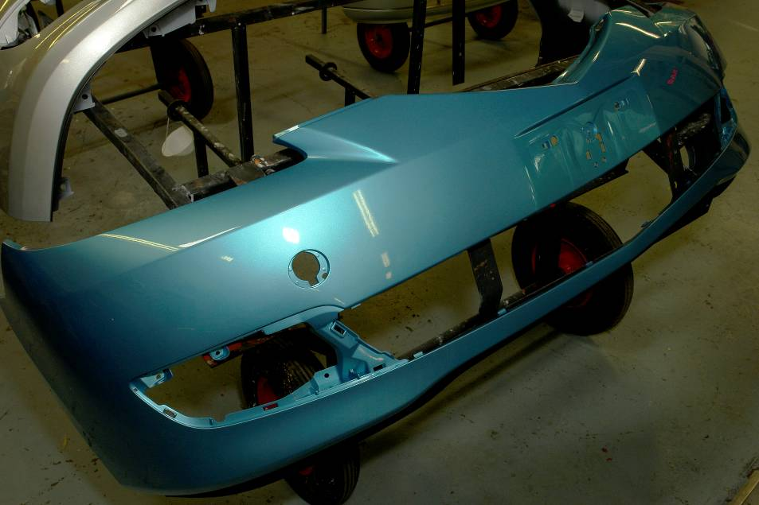
Quality Paint Finish

Summary
Newly applied lacquer finishes should never be compounded or polished until they are thoroughly hard and a substantial proportion of the solvents have evaporated. Compounding too soon will result in loss of gloss (hazing) and the finish may be permanently impaired.
Wax polishes must never be used until the finish is at least four weeks old, by which time all solvents will have evaporated from the film. Otherwise the wax can migrate into the finish causing softness, loss of gloss, and a tendency to watermark.

Self Assessment
Questions – Module 5. Unit 7
  - Why use a rubber block when wet flatting?
2. What safety precautions need to be addressed when dry sanding?
3. How do you remove small runs in paint work?
4. What P grade of paper would you use to key a panel for blending when dry sanding?
5. How should the polishing machine be held when in use?

6. What does fast cut compound do?
7. How do you evaluate paint finish?
8. Why is it most important to use fine grade compound?
9. Why is care to be taken when polishing near swage lines?
10. Does it matter if you do not use water when compounding?

Answers to Questions 1-10. Module 5. Unit 7
1.
To achieve a true flat surface
2.
Use dust mask, dust extraction, P.P.E
3.
Sand down run and burnish
4.
P 1.000
5.
Hold machine firmly with light pressure on pad

6.
Removes scratches fast
7.
Sight and touch
8.
To protect from causing swirl marks

9.
Not to break through the paint film
10.
Yes it matters if you do not use water when compounding because the panel will get too hot.

Suggested Exercise

- On a pre-painted panel identify any paint faults if present. If there are any sag present remove with file section. Wet flat panel with p.1500 and then p.2000 grade water paper. Compound using rubbing compound with foam mop head on a mechanical polisher taking care not to burn paint surface. Polish compounded panel with a silicon free polish to deep lustre. Exercise caution when compounding and polishing panel edges.
Instructions:
- On a pre-painted fully cured panel identify paint faults
- Wet flat with P.1500 and then P.2000 grade water paper
- Compound with rubbing compound with a foam mop head on a mechanical polisher
- Polish compounded panel with silicon free polish with lambs wool mop on a mechanical polisher
Tools and Materials:
- Pre-painted panels
- Assortment of burnishing abrasives
- Rubbing compounds and silicon free polish
- Mechanical polisher with foam compounding mop head and lambs wool polishing mop head

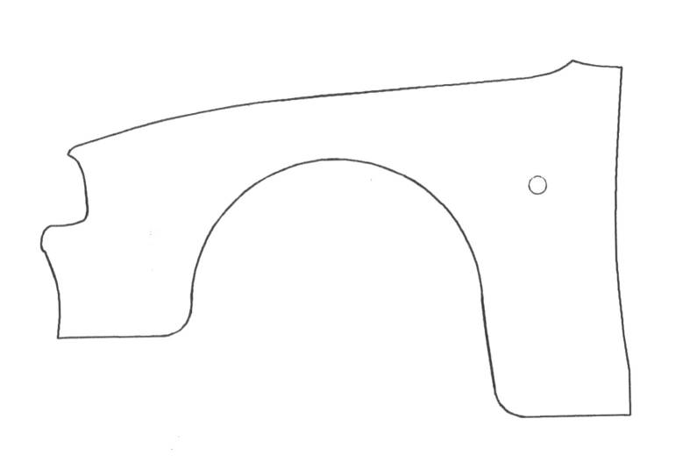

BURNISH AND POLISH A PANEL

Standards
Work carried out in a manner that is unlikely to cause injury to apprentice or colleagues. Panel burnished and polished to a deep lustre with no breaking through to basecoat or primer.

Training Resources
- Classroom/workshop with visual aids
- Various pre-painted cured panels
- Assortment of Burnishing abrasives (wet and dry)
- Variety of rubbing compounds and polishes (silicon free)
- DA sander with dust extraction and mechanical polisher with compounding polishing mop heads
- Fine toothed body file blade cut to 50mm lengths

27-33 Upper Baggot Street
Dublin 4
By preparing the substrate properly you lay the foundations for prefect results

